**Practical No.:**1

**Aim**: Program to take database backup

**Code:**

import java.io.FileWriter;

import java.sql.Connection;

import java.sql.DriverManager;

public class backup extends javax.swing.JFrame {

/**

* Creates new form backup

*/

public backup() {

initComponents();

}

/**

* This method is called from within the constructor to initialize the form.

* WARNING: Do NOT modify this code. The content of this method is always

* regenerated by the Form Editor.

*/

@SuppressWarnings("unchecked")

// <editor-fold defaultstate="collapsed" desc="Generated Code">

private void initComponents() {

jLabel1 = new javax.swing.JLabel();

jLabel3 = new javax.swing.JLabel();

jLabel9 = new javax.swing.JLabel();

jLabel10 = new javax.swing.JLabel();

jLabel11 = new javax.swing.JLabel();

jLabel12 = new javax.swing.JLabel();

jLabel13 = new javax.swing.JLabel();

jLabel2 = new javax.swing.JLabel();

jTextField1 = new javax.swing.JTextField();

jTextField2 = new javax.swing.JTextField();

jTextField3 = new javax.swing.JTextField();

jTextField4 = new javax.swing.JTextField();

jTextField5 = new javax.swing.JTextField();

jTextField6 = new javax.swing.JTextField();

jButton1 = new javax.swing.JButton();

jButton2 = new javax.swing.JButton();

jLabel1.setText("jLabel1");

setDefaultCloseOperation(javax.swing.WindowConstants.EXIT_ON_CLOSE);

jLabel9.setText("My SQl path:");

jLabel10.setText("My SQL user:");

jLabel11.setText("My SQL password:");

jLabel12.setText("Database name:");

jLabel13.setText("Backup Path:");

jLabel2.setText("Backup file name:");

jTextField3.addActionListener(new java.awt.event.ActionListener() {

public void actionPerformed(java.awt.event.ActionEvent evt) {

jTextField3ActionPerformed(evt);

}

});

jTextField4.addActionListener(new java.awt.event.ActionListener() {

public void actionPerformed(java.awt.event.ActionEvent evt) {

jTextField4ActionPerformed(evt);

}

});

jTextField5.addActionListener(new java.awt.event.ActionListener() {

public void actionPerformed(java.awt.event.ActionEvent evt) {

jTextField5ActionPerformed(evt);

}

});

jTextField6.addActionListener(new java.awt.event.ActionListener() {

public void actionPerformed(java.awt.event.ActionEvent evt) {

jTextField6ActionPerformed(evt);

}

});

jButton1.setText("Backup");

jButton1.addActionListener(new java.awt.event.ActionListener() {

public void actionPerformed(java.awt.event.ActionEvent evt) {

jButton1ActionPerformed(evt);

}

});

jButton2.setText("Clear");

jButton2.addActionListener(new java.awt.event.ActionListener() {

public void actionPerformed(java.awt.event.ActionEvent evt) {

jButton2ActionPerformed(evt);

}

});

javax.swing.GroupLayout layout = new javax.swing.GroupLayout(getContentPane());

getContentPane().setLayout(layout);

layout.setHorizontalGroup(

layout.createParallelGroup(javax.swing.GroupLayout.Alignment.LEADING)

.addGroup(layout.createSequentialGroup()

.addContainerGap()

.addGroup(layout.createParallelGroup(javax.swing.GroupLayout.Alignment.LEADING)

.addGroup(layout.createSequentialGroup()

.addGroup(layout.createParallelGroup(javax.swing.GroupLayout.Alignment.LEADING)

.addGroup(layout.createSequentialGroup()

.addComponent(jLabel11)

.addGap(18, 18, 18)

.addComponent(jTextField3, javax.swing.GroupLayout.PREFERRED_SIZE, 468, javax.swing.GroupLayout.PREFERRED_SIZE))

.addGroup(layout.createSequentialGroup()

.addGroup(layout.createParallelGroup(javax.swing.GroupLayout.Alignment.LEADING)

.addComponent(jLabel10)

.addComponent(jLabel9)

.addComponent(jLabel12))

.addGap(28, 28, 28)

.addGroup(layout.createParallelGroup(javax.swing.GroupLayout.Alignment.LEADING, false)

.addComponent(jTextField2)

.addComponent(jTextField1)

.addComponent(jTextField5, javax.swing.GroupLayout.DEFAULT_SIZE, 468, Short.MAX_VALUE)

.addComponent(jTextField4))

.addPreferredGap(javax.swing.LayoutStyle.ComponentPlacement.RELATED, 123, Short.MAX_VALUE)

.addComponent(jLabel3)))

.addContainerGap(130, Short.MAX_VALUE))

.addGroup(layout.createSequentialGroup()

.addComponent(jLabel13)

.addContainerGap())

.addGroup(layout.createSequentialGroup()

.addComponent(jLabel2)

.addGap(18, 18, 18)

.addComponent(jTextField6, javax.swing.GroupLayout.PREFERRED_SIZE, 468, javax.swing.GroupLayout.PREFERRED_SIZE)

.addGap(0, 0, Short.MAX_VALUE))))

.addGroup(layout.createSequentialGroup()

.addGap(54, 54, 54)

.addComponent(jButton1)

.addGap(242, 242, 242)

.addComponent(jButton2)

.addGap(0, 0, Short.MAX_VALUE))

);

layout.setVerticalGroup(

layout.createParallelGroup(javax.swing.GroupLayout.Alignment.LEADING)

.addGroup(layout.createSequentialGroup()

.addGap(0, 0, Short.MAX_VALUE)

.addComponent(jLabel3)

.addGap(163, 163, 163))

.addGroup(layout.createSequentialGroup()

.addContainerGap()

.addGroup(layout.createParallelGroup(javax.swing.GroupLayout.Alignment.BASELINE)

.addComponent(jLabel9)

.addComponent(jTextField1, javax.swing.GroupLayout.PREFERRED_SIZE, javax.swing.GroupLayout.DEFAULT_SIZE, javax.swing.GroupLayout.PREFERRED_SIZE))

.addGap(18, 18, 18)

.addGroup(layout.createParallelGroup(javax.swing.GroupLayout.Alignment.BASELINE)

.addComponent(jLabel10)

.addComponent(jTextField2, javax.swing.GroupLayout.PREFERRED_SIZE, javax.swing.GroupLayout.DEFAULT_SIZE, javax.swing.GroupLayout.PREFERRED_SIZE))

.addGap(18, 18, 18)

.addGroup(layout.createParallelGroup(javax.swing.GroupLayout.Alignment.LEADING)

.addComponent(jLabel11)

.addComponent(jTextField3, javax.swing.GroupLayout.PREFERRED_SIZE, javax.swing.GroupLayout.DEFAULT_SIZE, javax.swing.GroupLayout.PREFERRED_SIZE))

.addGap(18, 18, 18)

.addGroup(layout.createParallelGroup(javax.swing.GroupLayout.Alignment.BASELINE)

.addComponent(jTextField4, javax.swing.GroupLayout.PREFERRED_SIZE, javax.swing.GroupLayout.DEFAULT_SIZE, javax.swing.GroupLayout.PREFERRED_SIZE)

.addComponent(jLabel12))

.addGap(18, 18, 18)

.addGroup(layout.createParallelGroup(javax.swing.GroupLayout.Alignment.LEADING)

.addComponent(jLabel13)

.addComponent(jTextField5, javax.swing.GroupLayout.PREFERRED_SIZE, javax.swing.GroupLayout.DEFAULT_SIZE, javax.swing.GroupLayout.PREFERRED_SIZE))

.addGap(18, 18, 18)

.addGroup(layout.createParallelGroup(javax.swing.GroupLayout.Alignment.LEADING)

.addComponent(jLabel2)

.addComponent(jTextField6, javax.swing.GroupLayout.PREFERRED_SIZE, javax.swing.GroupLayout.DEFAULT_SIZE, javax.swing.GroupLayout.PREFERRED_SIZE))

.addPreferredGap(javax.swing.LayoutStyle.ComponentPlacement.RELATED, 31, Short.MAX_VALUE)

.addGroup(layout.createParallelGroup(javax.swing.GroupLayout.Alignment.BASELINE)

.addComponent(jButton1)

.addComponent(jButton2))

.addGap(23, 23, 23))

);

pack();

}// </editor-fold>

private void jButton1ActionPerformed(java.awt.event.ActionEvent evt) {

try {

Class.forName("com.mysql.jdbc.Driver");

Connection con = DriverManager.getConnection("jdbc:mysql://localhost:3306/"+jTextField4.getText(),jTextField2.getText(),jTextField3.getText());

FileWriter fos = new FileWriter( jTextField5.getText()+"\\mycmd.bat");

String cmd = "set path =%path%;" + jTextField1.getText() + ";+\n";

cmd+= "mysqldump -u" + jTextField2.getText() + " -p" + jTextField3.getText() + "" + jTextField4.getText()+">"+ jTextField5.getText()+"\\"+jTextField6.getText();

fos.write(cmd);

fos.close();

Runtime rt = Runtime.getRuntime();

rt.exec("cmd.exe /c start"+jTextField5.getText()+"\\mycmd.bat");

System.out.println("Backup completed successfully");

} catch (Exception e) {

e.printStackTrace();

}

}

private void jButton2ActionPerformed(java.awt.event.ActionEvent evt) {

jTextField1.setText(null);

jTextField2.setText(null);

jTextField3.setText(null);

jTextField4.setText(null);

jTextField5.setText(null);

jTextField6.setText(null);

}

/**

* @param args the command line arguments

*/

public static void main(String args[]) {

/* Set the Nimbus look and feel */

//<editor-fold defaultstate="collapsed" desc=" Look and feel setting code (optional) ">

/* If Nimbus (introduced in Java SE 6) is not available, stay with the default look and feel.

* For details see http://download.oracle.com/javase/tutorial/uiswing/lookandfeel/plaf.html

*/

try {

for (javax.swing.UIManager.LookAndFeelInfo info : javax.swing.UIManager.getInstalledLookAndFeels()) {

if ("Nimbus".equals(info.getName())) {

javax.swing.UIManager.setLookAndFeel(info.getClassName());

break;

}

}

} catch (ClassNotFoundException ex) {

java.util.logging.Logger.getLogger(backup.class.getName()).log(java.util.logging.Level.SEVERE, null, ex);

} catch (InstantiationException ex) {

java.util.logging.Logger.getLogger(backup.class.getName()).log(java.util.logging.Level.SEVERE, null, ex);

} catch (IllegalAccessException ex) {

java.util.logging.Logger.getLogger(backup.class.getName()).log(java.util.logging.Level.SEVERE, null, ex);

} catch (javax.swing.UnsupportedLookAndFeelException ex) {

java.util.logging.Logger.getLogger(backup.class.getName()).log(java.util.logging.Level.SEVERE, null, ex);

}

//</editor-fold>

/* Create and display the form */

java.awt.EventQueue.invokeLater(new Runnable() {

public void run() {

new backup().setVisible(true);

}

});

}

// Variables declaration - do not modify

private javax.swing.JButton jButton1;

private javax.swing.JButton jButton2;

private javax.swing.JLabel jLabel1;

private javax.swing.JLabel jLabel10;

private javax.swing.JLabel jLabel11;

private javax.swing.JLabel jLabel12;

private javax.swing.JLabel jLabel13;

private javax.swing.JLabel jLabel2;

private javax.swing.JLabel jLabel3;

private javax.swing.JLabel jLabel9;

private javax.swing.JTextField jTextField1;

private javax.swing.JTextField jTextField2;

private javax.swing.JTextField jTextField3;

private javax.swing.JTextField jTextField4;

private javax.swing.JTextField jTextField5;

private javax.swing.JTextField jTextField6;

// End of variables declaration

}

Output:

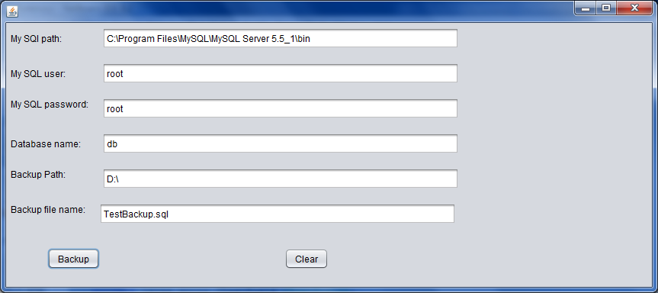

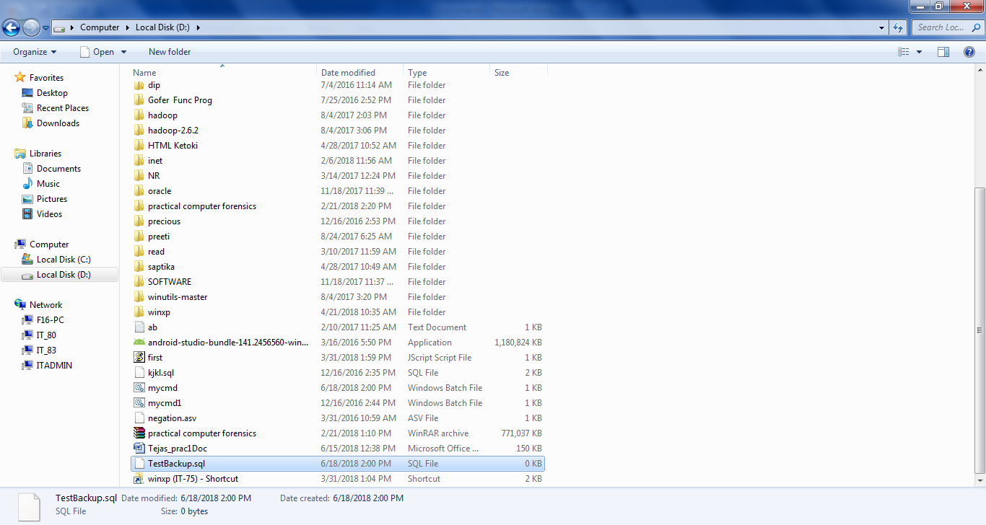

**Practical No.:**2

**Aim:** Program to restore database

**Code:**

import java.io.FileWriter;

import java.sql.*;

import java.util.logging.Level;

import java.util.logging.Logger;

/*

* To change this license header, choose License Headers in Project Properties.

* To change this template file, choose Tools | Templates

* and open the template in the editor.

*/

/**

*

* @author student

*/

public class MySQLRestore extends javax.swing.JFrame {

/**

* Creates new form MySQLBackup

*/

public MySQLRestore() {

initComponents();

}

/**

* This method is called from within the constructor to initialize the form.

* WARNING: Do NOT modify this code. The content of this method is always

* regenerated by the Form Editor.

*/

@SuppressWarnings("unchecked")

// <editor-fold defaultstate="collapsed" desc="Generated Code">

private void initComponents() {

jLabel1 = new javax.swing.JLabel();

jLabel2 = new javax.swing.JLabel();

jLabel3 = new javax.swing.JLabel();

jLabel4 = new javax.swing.JLabel();

jLabel5 = new javax.swing.JLabel();

jLabel6 = new javax.swing.JLabel();

jButton1 = new javax.swing.JButton();

mysqlpath = new javax.swing.JTextField();

mysqluser = new javax.swing.JTextField();

mysqlpass = new javax.swing.JTextField();

dbname = new javax.swing.JTextField();

backuppath = new javax.swing.JTextField();

filename = new javax.swing.JTextField();

jButton2 = new javax.swing.JButton();

setDefaultCloseOperation(javax.swing.WindowConstants.EXIT_ON_CLOSE);

setTitle("MySQL Restore");

jLabel1.setText("MySQL Path :");

jLabel2.setText("MySQL User :");

jLabel3.setText("MySQL Password :");

jLabel4.setText("Database Name :");

jLabel5.setText("Backup Path :");

jLabel6.setText("Backup File Name :");

jButton1.setText("Restore");

jButton1.addActionListener(new java.awt.event.ActionListener() {

public void actionPerformed(java.awt.event.ActionEvent evt) {

jButton1ActionPerformed(evt);

}

});

mysqlpath.addActionListener(new java.awt.event.ActionListener() {

public void actionPerformed(java.awt.event.ActionEvent evt) {

mysqlpathActionPerformed(evt);

}

});

mysqluser.addActionListener(new java.awt.event.ActionListener() {

public void actionPerformed(java.awt.event.ActionEvent evt) {

mysqluserActionPerformed(evt);

}

});

jButton2.setText("Clear");

jButton2.addActionListener(new java.awt.event.ActionListener() {

public void actionPerformed(java.awt.event.ActionEvent evt) {

jButton2ActionPerformed(evt);

}

});

javax.swing.GroupLayout layout = new javax.swing.GroupLayout(getContentPane());

getContentPane().setLayout(layout);

layout.setHorizontalGroup(

layout.createParallelGroup(javax.swing.GroupLayout.Alignment.LEADING)

.addGroup(layout.createSequentialGroup()

.addContainerGap()

.addGroup(layout.createParallelGroup(javax.swing.GroupLayout.Alignment.LEADING, false)

.addGroup(layout.createSequentialGroup()

.addComponent(jLabel1)

.addGap(2, 2, 2)

.addComponent(mysqlpath, javax.swing.GroupLayout.PREFERRED_SIZE, 226, javax.swing.GroupLayout.PREFERRED_SIZE))

.addGroup(layout.createSequentialGroup()

.addComponent(jLabel2)

.addPreferredGap(javax.swing.LayoutStyle.ComponentPlacement.RELATED)

.addComponent(mysqluser))

.addGroup(layout.createSequentialGroup()

.addComponent(jLabel3)

.addPreferredGap(javax.swing.LayoutStyle.ComponentPlacement.RELATED)

.addComponent(mysqlpass))

.addGroup(layout.createSequentialGroup()

.addComponent(jLabel4)

.addPreferredGap(javax.swing.LayoutStyle.ComponentPlacement.RELATED)

.addComponent(dbname))

.addGroup(layout.createSequentialGroup()

.addComponent(jLabel5)

.addPreferredGap(javax.swing.LayoutStyle.ComponentPlacement.RELATED)

.addComponent(backuppath))

.addGroup(layout.createSequentialGroup()

.addComponent(jLabel6)

.addPreferredGap(javax.swing.LayoutStyle.ComponentPlacement.RELATED)

.addComponent(filename))

.addGroup(layout.createSequentialGroup()

.addComponent(jButton1, javax.swing.GroupLayout.PREFERRED_SIZE, 161, javax.swing.GroupLayout.PREFERRED_SIZE)

.addGap(18, 18, 18)

.addComponent(jButton2, javax.swing.GroupLayout.PREFERRED_SIZE, 165, javax.swing.GroupLayout.PREFERRED_SIZE)))

.addContainerGap(javax.swing.GroupLayout.DEFAULT_SIZE, Short.MAX_VALUE))

);

layout.setVerticalGroup(

layout.createParallelGroup(javax.swing.GroupLayout.Alignment.LEADING)

.addGroup(layout.createSequentialGroup()

.addContainerGap()

.addGroup(layout.createParallelGroup(javax.swing.GroupLayout.Alignment.BASELINE)

.addComponent(jLabel1)

.addComponent(mysqlpath, javax.swing.GroupLayout.PREFERRED_SIZE, javax.swing.GroupLayout.DEFAULT_SIZE, javax.swing.GroupLayout.PREFERRED_SIZE))

.addPreferredGap(javax.swing.LayoutStyle.ComponentPlacement.UNRELATED)

.addGroup(layout.createParallelGroup(javax.swing.GroupLayout.Alignment.BASELINE)

.addComponent(jLabel2)

.addComponent(mysqluser, javax.swing.GroupLayout.PREFERRED_SIZE, javax.swing.GroupLayout.DEFAULT_SIZE, javax.swing.GroupLayout.PREFERRED_SIZE))

.addPreferredGap(javax.swing.LayoutStyle.ComponentPlacement.UNRELATED)

.addGroup(layout.createParallelGroup(javax.swing.GroupLayout.Alignment.BASELINE)

.addComponent(jLabel3)

.addComponent(mysqlpass, javax.swing.GroupLayout.PREFERRED_SIZE, javax.swing.GroupLayout.DEFAULT_SIZE, javax.swing.GroupLayout.PREFERRED_SIZE))

.addPreferredGap(javax.swing.LayoutStyle.ComponentPlacement.UNRELATED)

.addGroup(layout.createParallelGroup(javax.swing.GroupLayout.Alignment.BASELINE)

.addComponent(jLabel4)

.addComponent(dbname, javax.swing.GroupLayout.PREFERRED_SIZE, javax.swing.GroupLayout.DEFAULT_SIZE, javax.swing.GroupLayout.PREFERRED_SIZE))

.addPreferredGap(javax.swing.LayoutStyle.ComponentPlacement.UNRELATED)

.addGroup(layout.createParallelGroup(javax.swing.GroupLayout.Alignment.BASELINE)

.addComponent(jLabel5)

.addComponent(backuppath, javax.swing.GroupLayout.PREFERRED_SIZE, javax.swing.GroupLayout.DEFAULT_SIZE, javax.swing.GroupLayout.PREFERRED_SIZE))

.addPreferredGap(javax.swing.LayoutStyle.ComponentPlacement.UNRELATED)

.addGroup(layout.createParallelGroup(javax.swing.GroupLayout.Alignment.BASELINE)

.addComponent(jLabel6)

.addComponent(filename, javax.swing.GroupLayout.PREFERRED_SIZE, javax.swing.GroupLayout.DEFAULT_SIZE, javax.swing.GroupLayout.PREFERRED_SIZE))

.addPreferredGap(javax.swing.LayoutStyle.ComponentPlacement.UNRELATED)

.addGroup(layout.createParallelGroup(javax.swing.GroupLayout.Alignment.BASELINE)

.addComponent(jButton1)

.addComponent(jButton2))

.addContainerGap(javax.swing.GroupLayout.DEFAULT_SIZE, Short.MAX_VALUE))

);

pack();

}// </editor-fold>

private void mysqlpathActionPerformed(java.awt.event.ActionEvent evt) {

// TODO add your handling code here:

}

private void mysqluserActionPerformed(java.awt.event.ActionEvent evt) {

// TODO add your handling code here:

}

private void jButton1ActionPerformed(java.awt.event.ActionEvent evt) {

String db=dbname.getText();

String user=mysqluser.getText();

String pass=mysqlpass.getText();

String backupPath=backuppath.getText();

String path=mysqlpath.getText();

String fname=filename.getText();

try {

Class.forName("com.mysql.jdbc.Driver");

Connection con=DriverManager.getConnection("jdbc:mysql://localhost:3306/"+db,user,pass);

FileWriter fos=new FileWriter(backupPath+"\\mycmd.bat");

String cmd="set path=%path%;"+path+";\n";

cmd+="mysql -u"+user+ " -p"+pass+" "+db+"<"+ backupPath+"\\"+fname;

fos.write(cmd);

fos.close();

Runtime rt=Runtime.getRuntime();

rt.exec("cmd.exe /c start "+backupPath+"\\mycmd.bat");

System.out.println("Restore completed Successfully.");

} catch (Exception ex) {

Logger.getLogger(MySQLBackup.class.getName()).log(Level.SEVERE, null, ex);

}

}

private void jButton2ActionPerformed(java.awt.event.ActionEvent evt) {

// TODO add your handling code here:

mysqlpath.setText("");

mysqluser.setText("");

mysqlpass.setText("");

dbname.setText("");

backuppath.setText("");

filename.setText("");

}

/**

* @param args the command line arguments

*/

public static void main(String args[]) {

/* Set the Nimbus look and feel */

//<editor-fold defaultstate="collapsed" desc=" Look and feel setting code (optional) ">

/* If Nimbus (introduced in Java SE 6) is not available, stay with the default look and feel.

* For details see http://download.oracle.com/javase/tutorial/uiswing/lookandfeel/plaf.html

*/

try {

for (javax.swing.UIManager.LookAndFeelInfo info : javax.swing.UIManager.getInstalledLookAndFeels()) {

if ("Nimbus".equals(info.getName())) {

javax.swing.UIManager.setLookAndFeel(info.getClassName());

break;

}

}

} catch (ClassNotFoundException ex) {

java.util.logging.Logger.getLogger(MySQLBackup.class.getName()).log(java.util.logging.Level.SEVERE, null, ex);

} catch (InstantiationException ex) {

java.util.logging.Logger.getLogger(MySQLBackup.class.getName()).log(java.util.logging.Level.SEVERE, null, ex);

} catch (IllegalAccessException ex) {

java.util.logging.Logger.getLogger(MySQLBackup.class.getName()).log(java.util.logging.Level.SEVERE, null, ex);

} catch (javax.swing.UnsupportedLookAndFeelException ex) {

java.util.logging.Logger.getLogger(MySQLBackup.class.getName()).log(java.util.logging.Level.SEVERE, null, ex);

}

//</editor-fold>

/* Create and display the form */

java.awt.EventQueue.invokeLater(new Runnable() {

public void run() {

new MySQLRestore().setVisible(true);

}

});

}

// Variables declaration - do not modify

private javax.swing.JTextField backuppath;

private javax.swing.JTextField dbname;

private javax.swing.JTextField filename;

private javax.swing.JButton jButton1;

private javax.swing.JButton jButton2;

private javax.swing.JLabel jLabel1;

private javax.swing.JLabel jLabel2;

private javax.swing.JLabel jLabel3;

private javax.swing.JLabel jLabel4;

private javax.swing.JLabel jLabel5;

private javax.swing.JLabel jLabel6;

private javax.swing.JTextField mysqlpass;

private javax.swing.JTextField mysqlpath;

private javax.swing.JTextField mysqluser;

// End of variables declaration

}

**Output :**

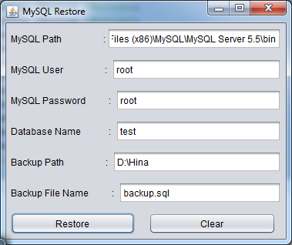

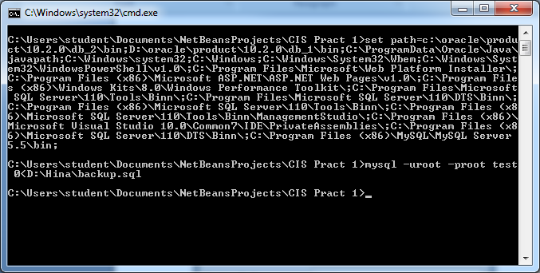

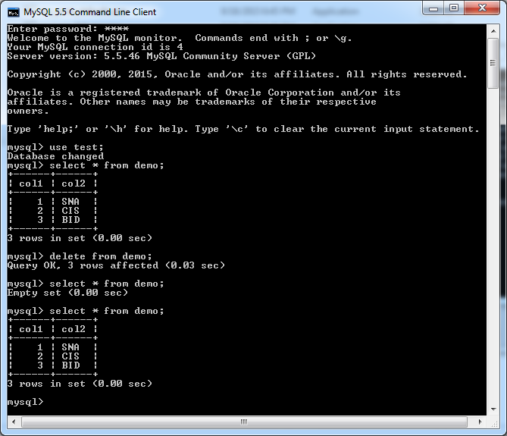

**Practical No.:** 3

**Aim:** Use of driveImageXml to take backup and restore data

**Code:**

**Steps for Backup:**

1. Choose drive to take Backup.

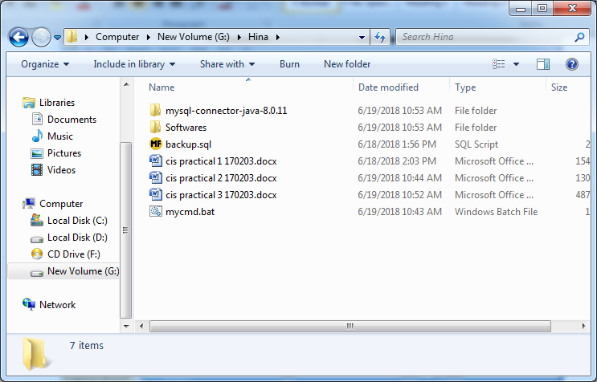

2. Open DriveImage XML software and select target drive.

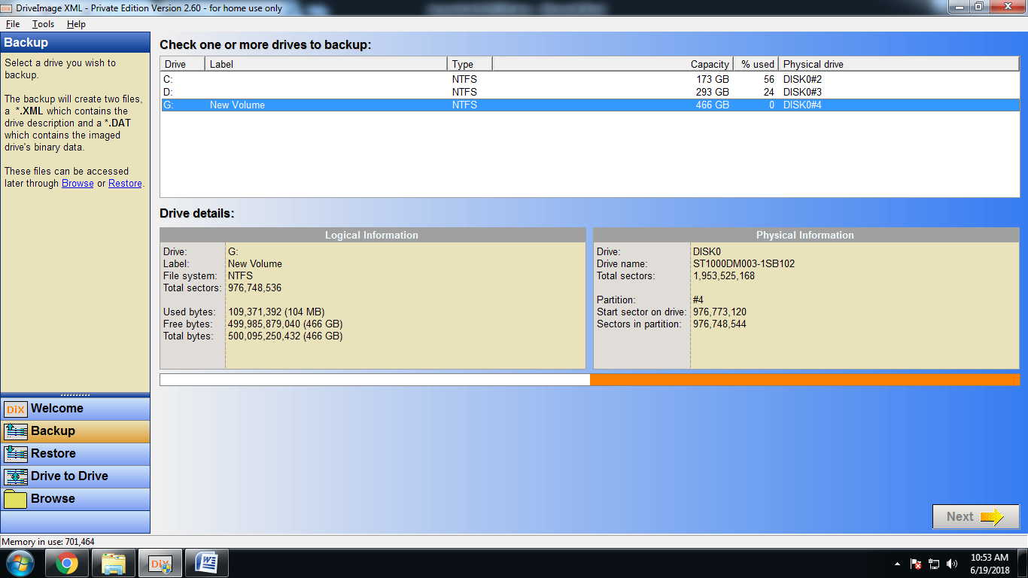

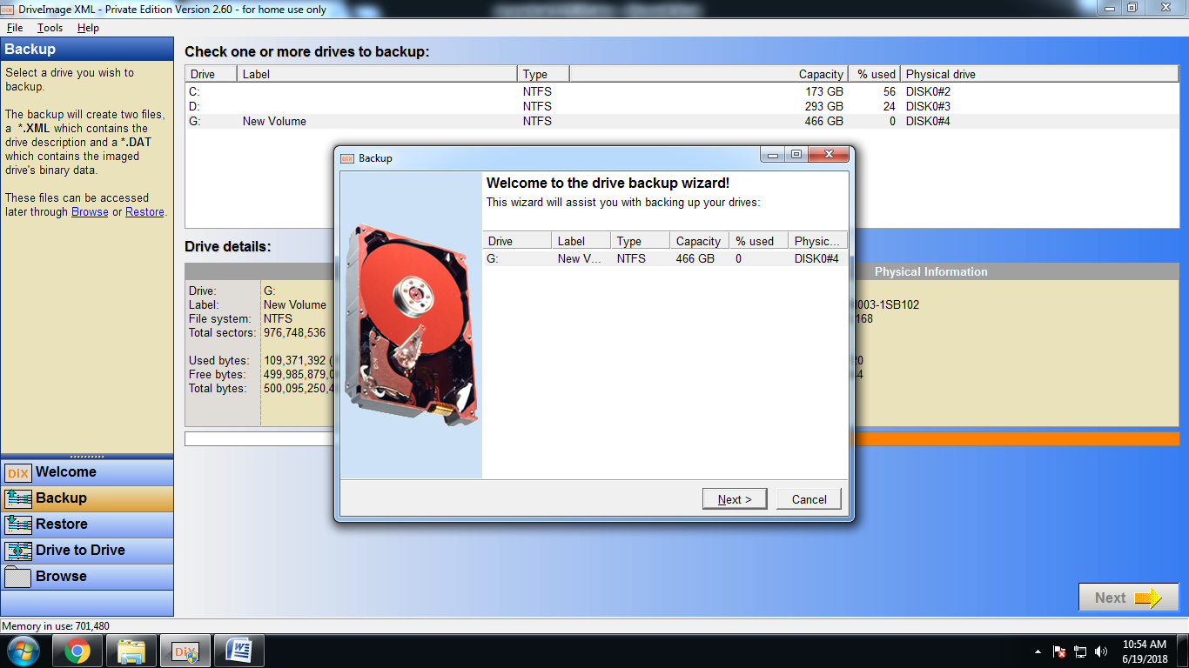

3. Rename backup file name if needed.

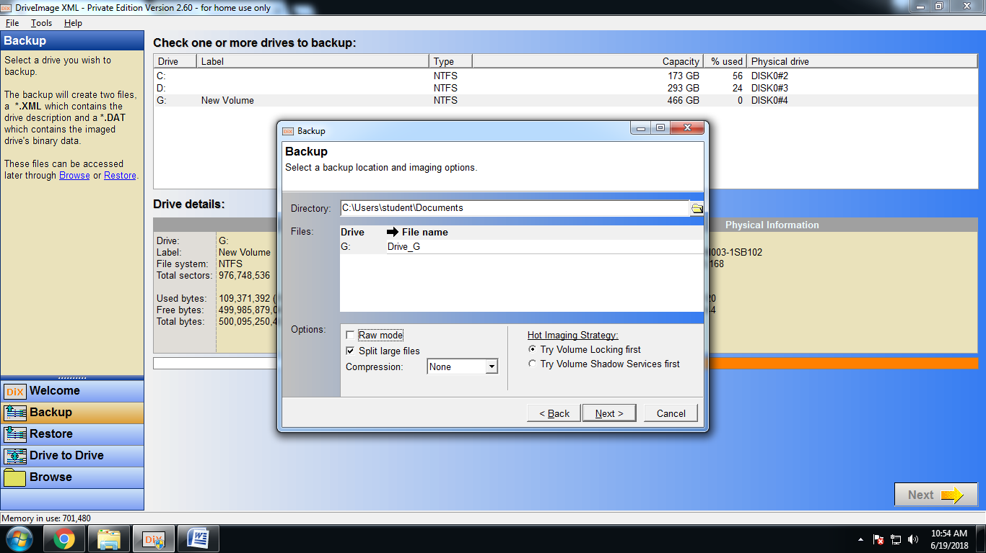

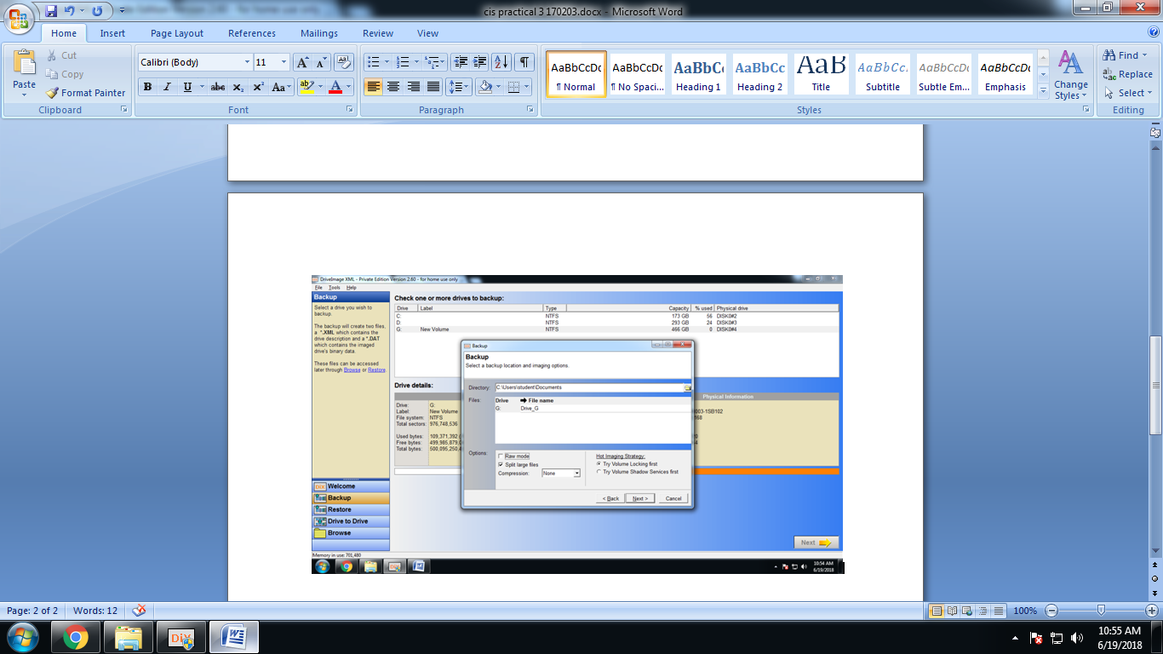

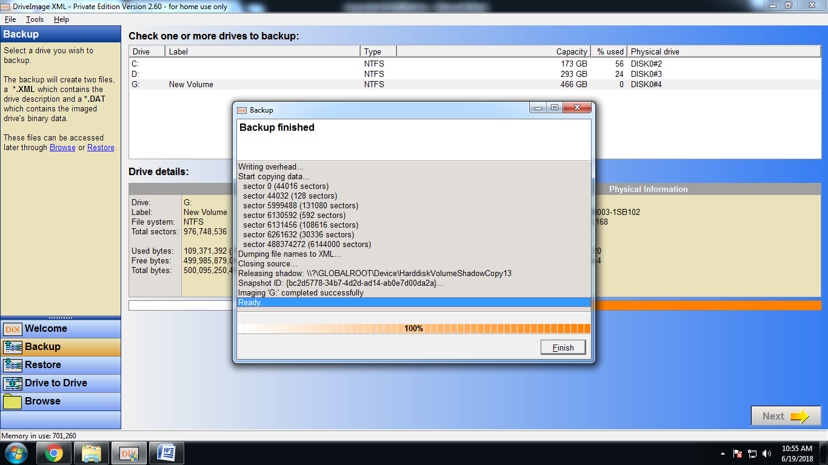

4. Below is the files generated after backup.

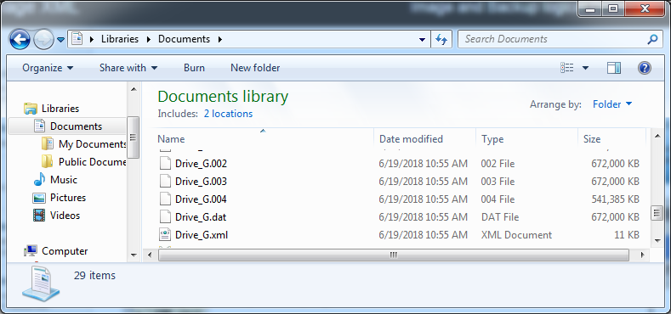

**Steps for Recovery of Drive :**

Here we are deleting all the contents of drive and then restoring the same.

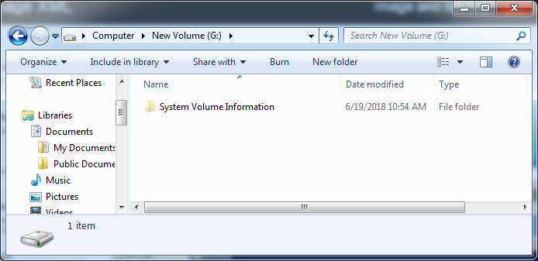

1. Click Restore option in DriveImage XML software and select target Disk.

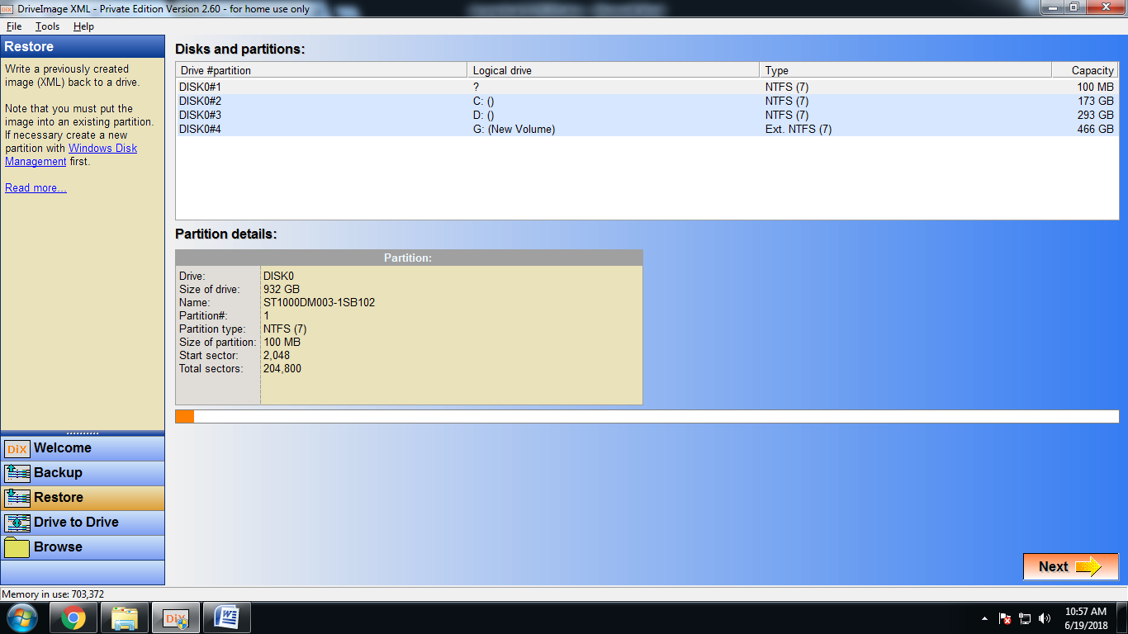

2. Select the backup file path and click next.

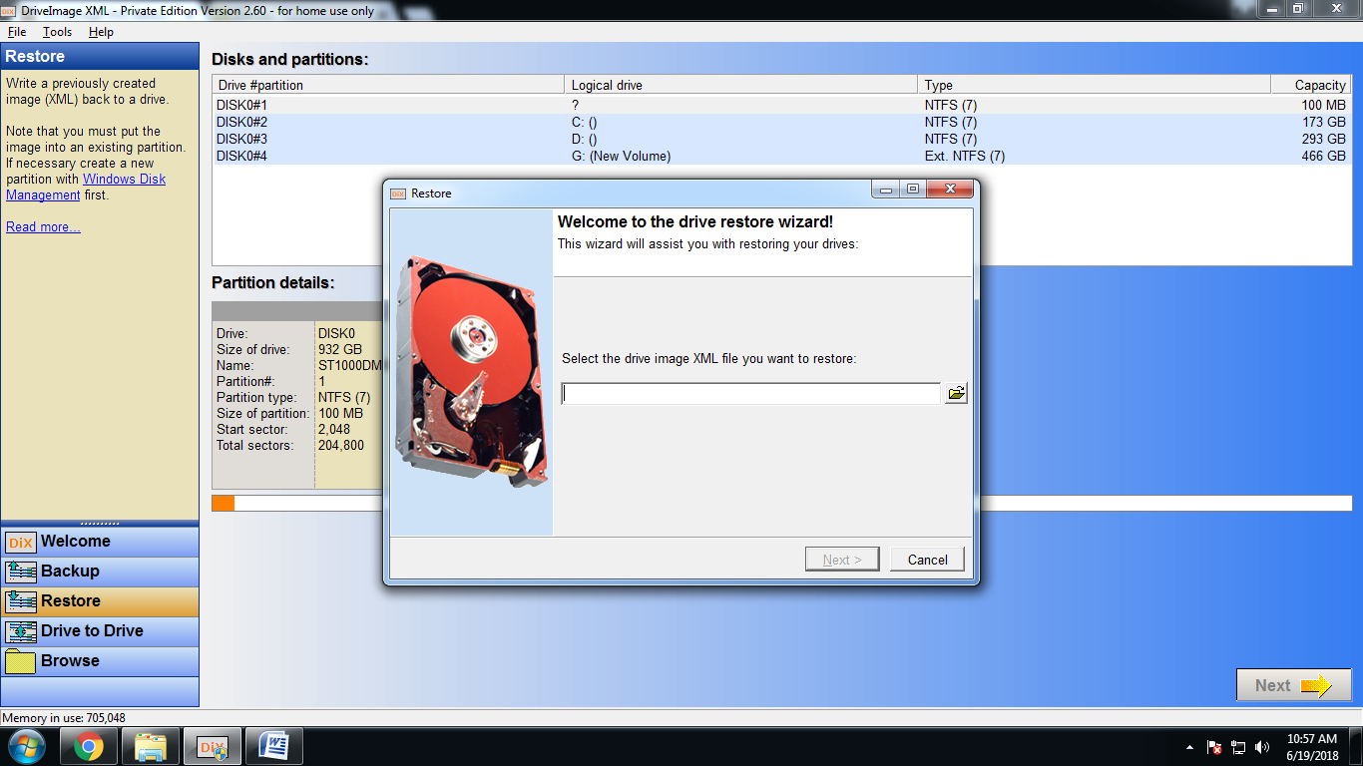

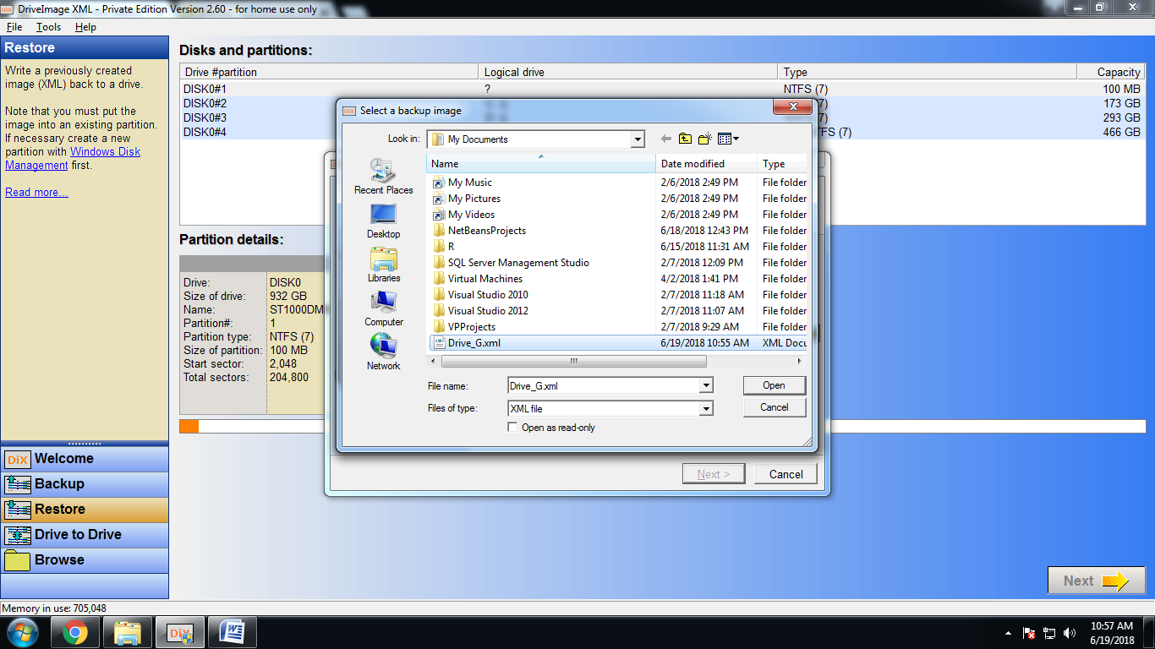

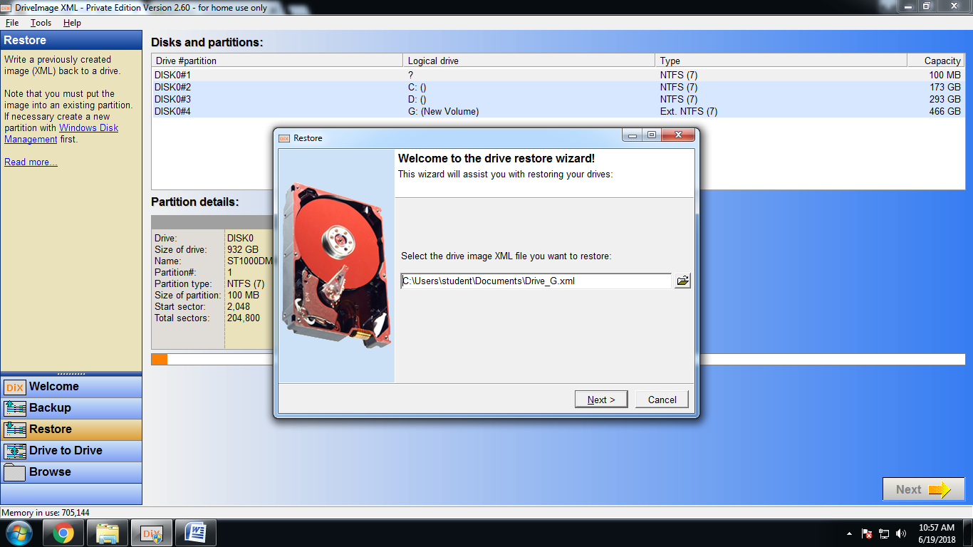

3. Then select targeted drive and click next.

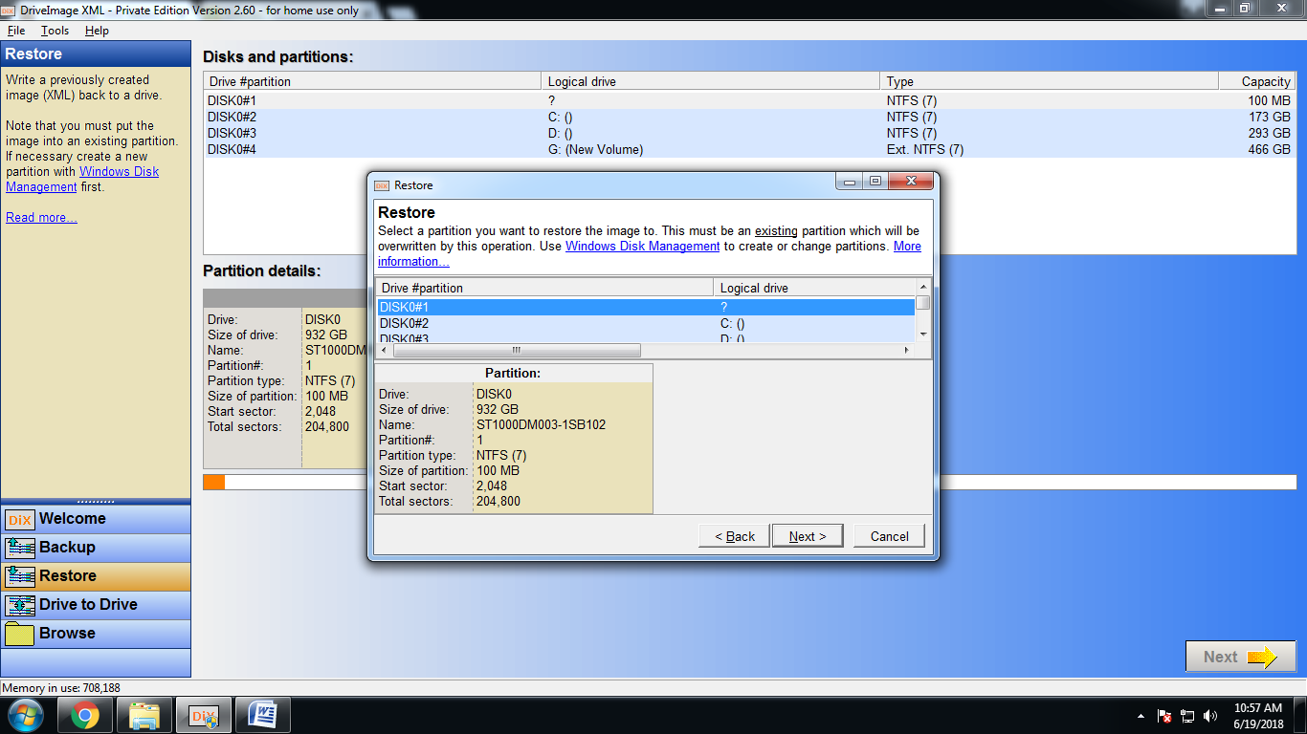

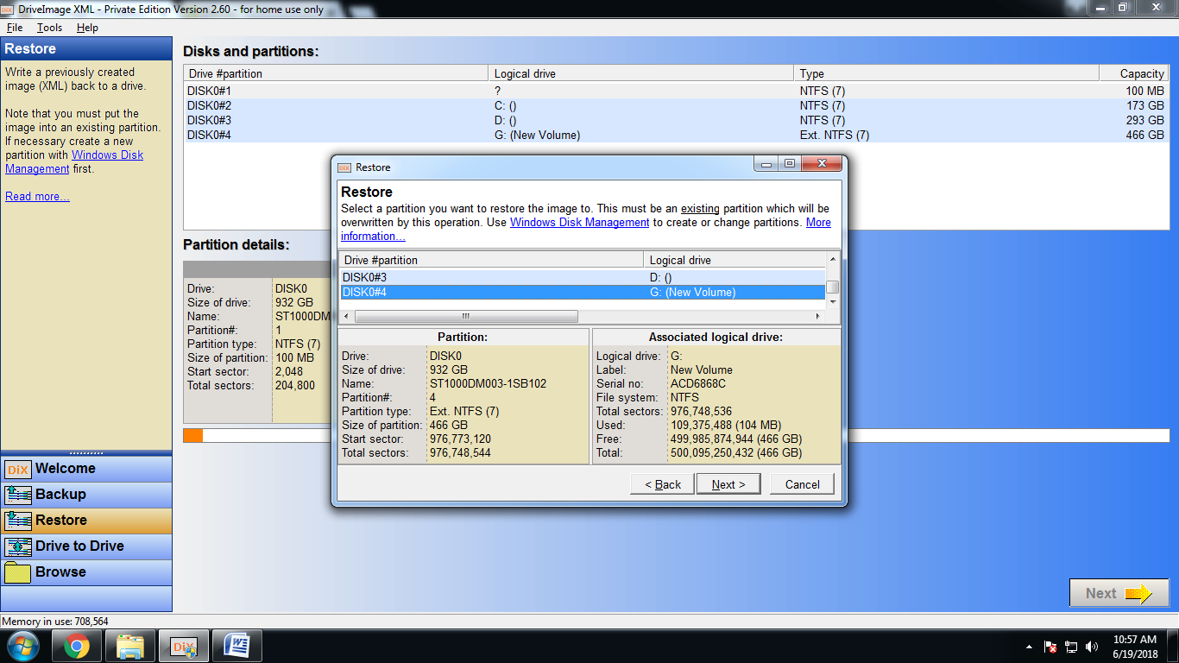

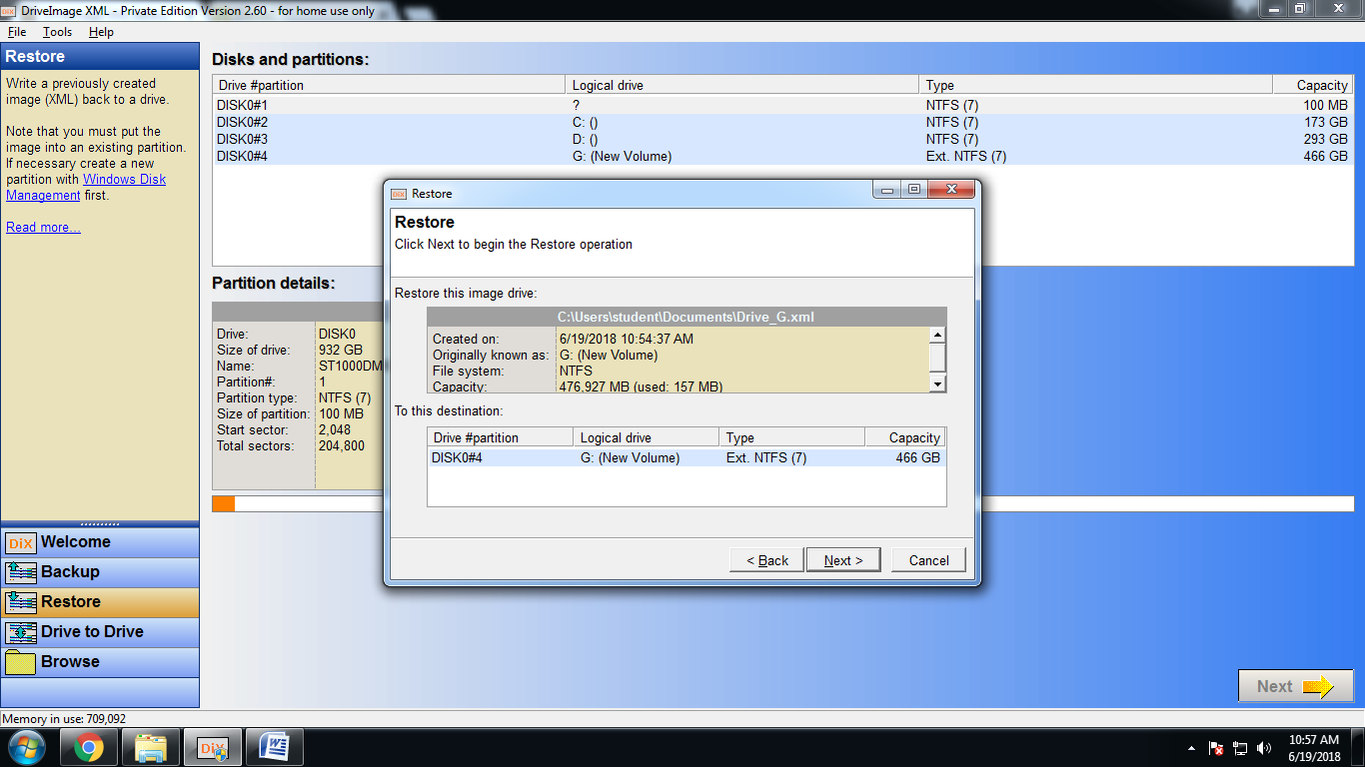

4. Enter Disk name in the dialog box and click Ok.

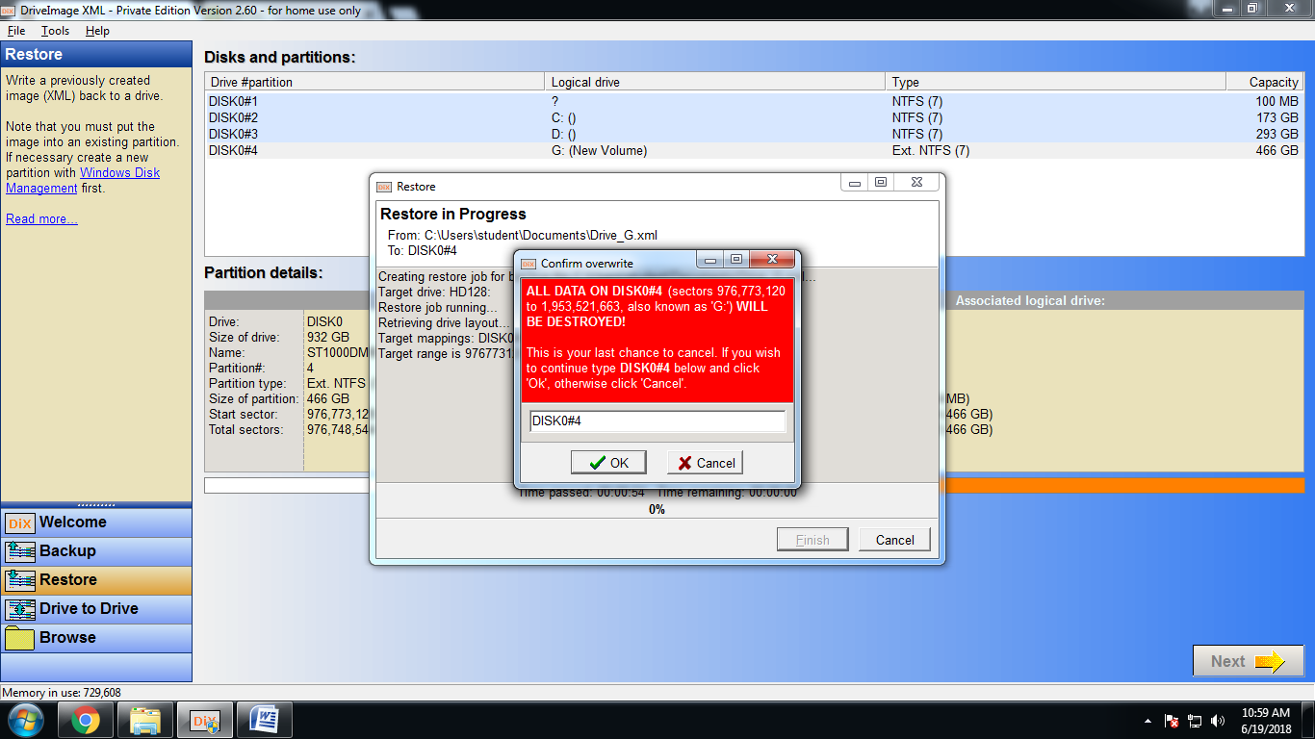

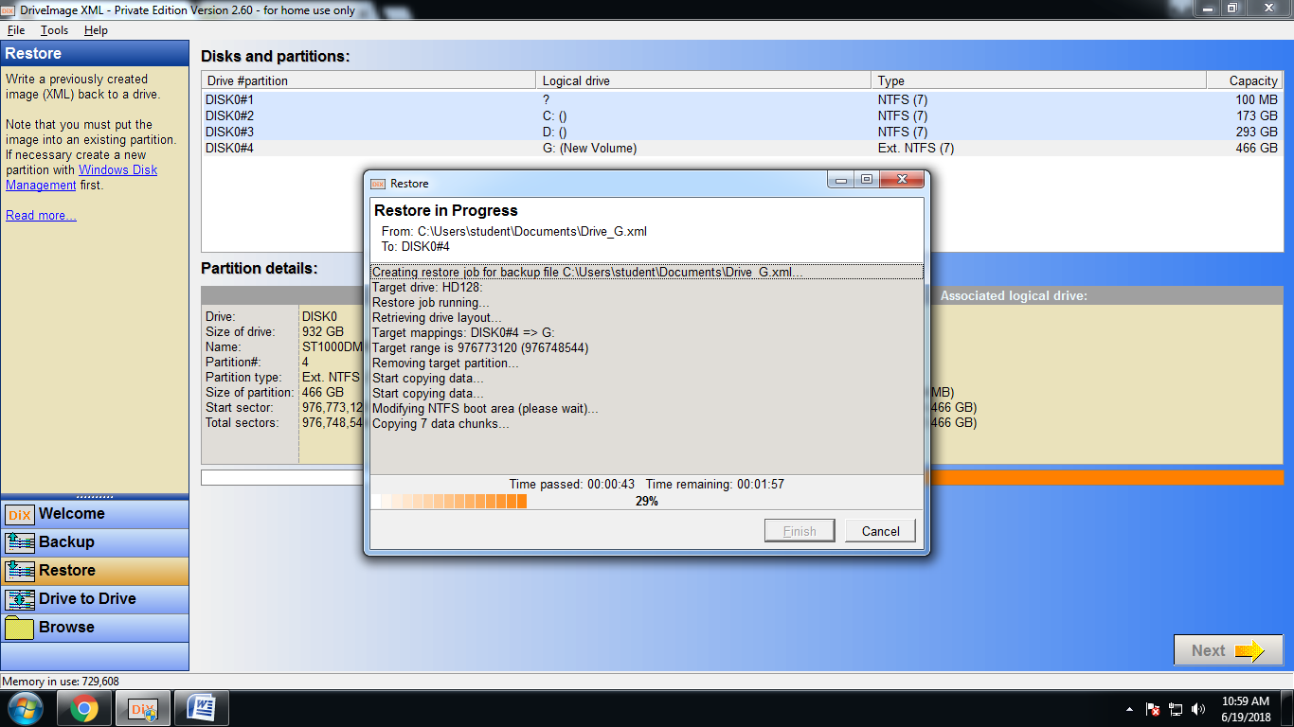

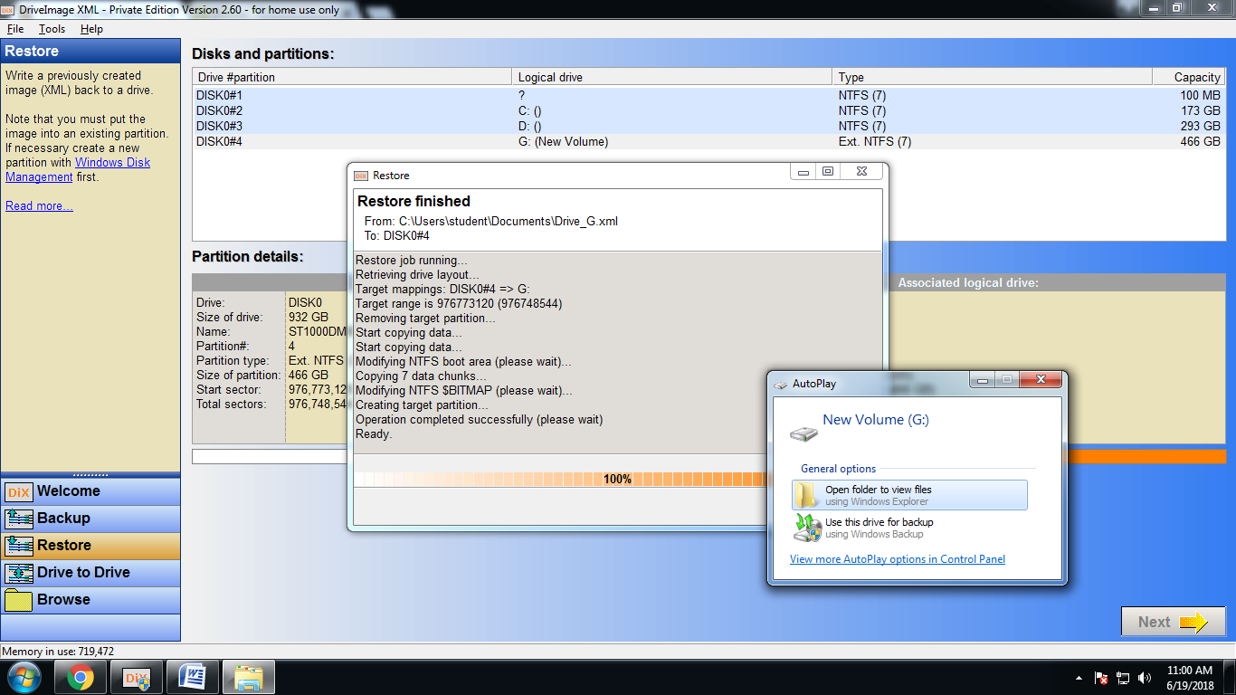

Drive contents has been restored.

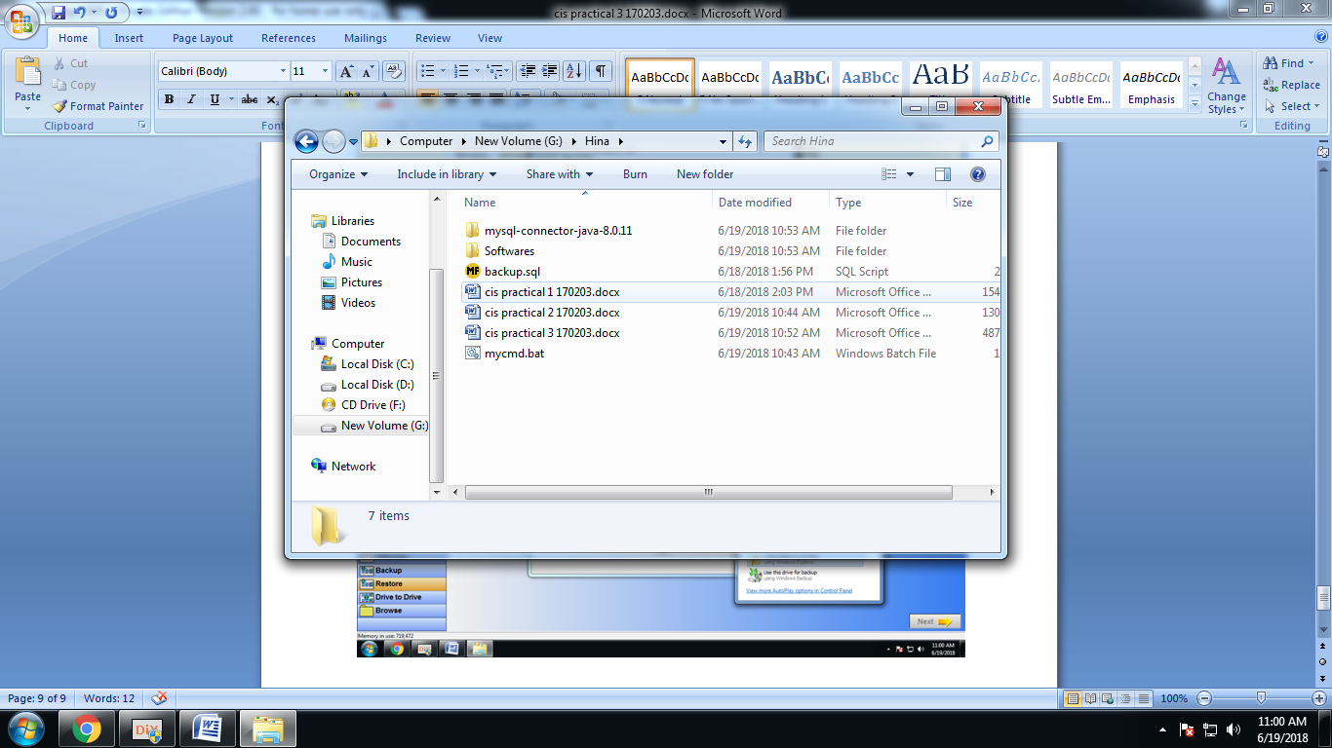

**Practical No.: 4**

**Aim:** Write a program to log files

**Code:**

import java.io.FileWriter;

class createlog

{

public static void main(String s[])

{

try

{

String cmd="WMIC /OUTPUT:D:\\LIST2.html PROCESS get name,processid,creationdate /format:hform";

FileWriter fos=new FileWriter("D:\\mycmd.bat");

fos.write(cmd);

fos.close();

Runtime rt=Runtime.getRuntime();

rt.exec("cmd.exe /c start D:\\mycmd.bat");

}

catch(Exception e)

{

e.printStackTrace();

}

}

}

**Output:**

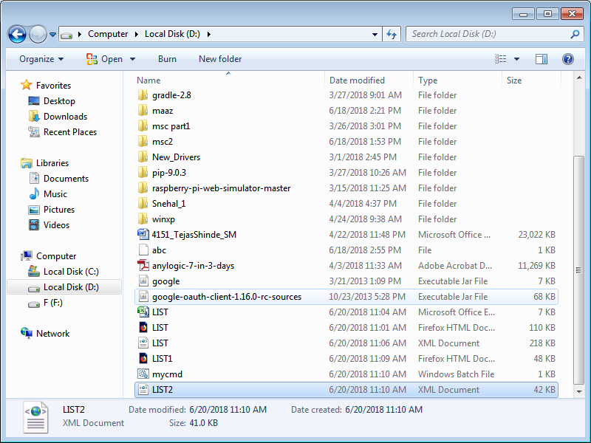

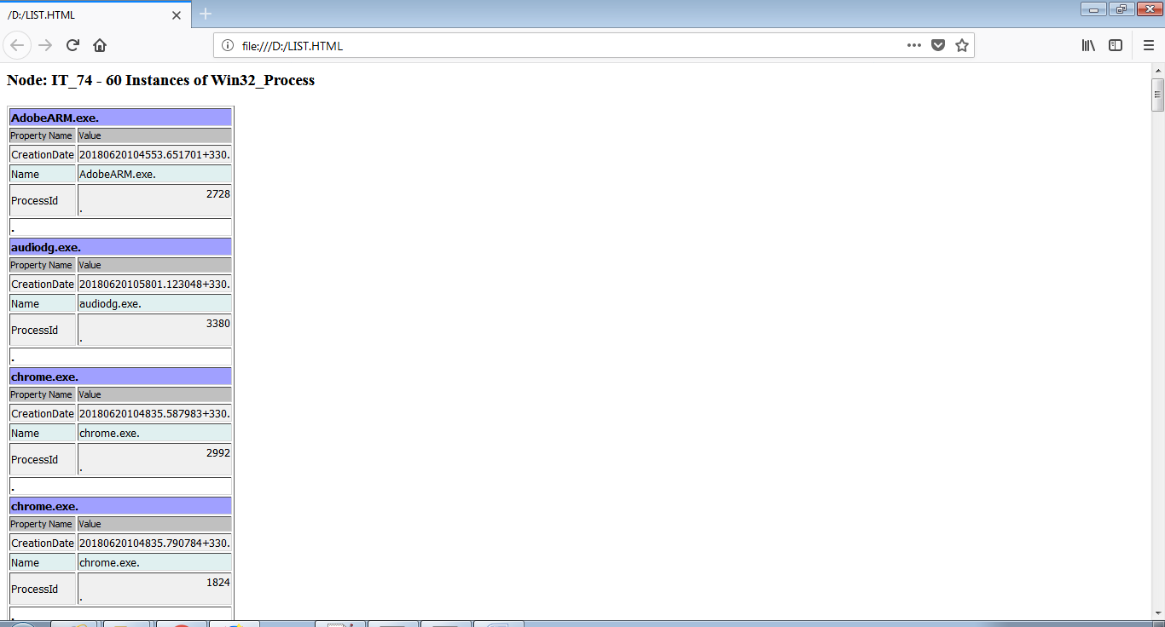

**Practical No.: 5**

**Aim:** Program to display filepath in directory

**Code:**

/*

* To change this license header, choose License Headers in Project Properties.

* To change this template file, choose Tools | Templates

* and open the template in the editor.

*/

import java.io.File;

import java.util.ArrayList;

/**

*

* @author Abhishek

*/

public class filesearch extends javax.swing.JFrame {

String fileName;

File dir;

/**

* Creates new form filesearch

*/

public filesearch() {

initComponents();

}

/**

* This method is called from within the constructor to initialize the form.

* WARNING: Do NOT modify this code. The content of this method is always

* regenerated by the Form Editor.

*/

@SuppressWarnings("unchecked")

// <editor-fold defaultstate="collapsed" desc="Generated Code">

private void initComponents() {

jLabel1 = new javax.swing.JLabel();

jLabel2 = new javax.swing.JLabel();

jTextField1 = new javax.swing.JTextField();

jTextField2 = new javax.swing.JTextField();

jButton1 = new javax.swing.JButton();

jButton2 = new javax.swing.JButton();

jScrollPane1 = new javax.swing.JScrollPane();

jTextArea1 = new javax.swing.JTextArea();

setDefaultCloseOperation(javax.swing.WindowConstants.EXIT_ON_CLOSE);

jLabel1.setText("Enter directory to be searched");

jLabel2.setText("Enter file to be searched");

jButton1.setText("Search");

jButton1.addActionListener(new java.awt.event.ActionListener() {

public void actionPerformed(java.awt.event.ActionEvent evt) {

jButton1ActionPerformed(evt);

}

});

jButton2.setText("Clear");

jButton2.addActionListener(new java.awt.event.ActionListener() {

public void actionPerformed(java.awt.event.ActionEvent evt) {

jButton2ActionPerformed(evt);

}

});

jTextArea1.setColumns(20);

jTextArea1.setRows(5);

jScrollPane1.setViewportView(jTextArea1);

javax.swing.GroupLayout layout = new javax.swing.GroupLayout(getContentPane());

getContentPane().setLayout(layout);

layout.setHorizontalGroup(

layout.createParallelGroup(javax.swing.GroupLayout.Alignment.LEADING)

.addGroup(layout.createSequentialGroup()

.addContainerGap()

.addGroup(layout.createParallelGroup(javax.swing.GroupLayout.Alignment.LEADING)

.addComponent(jScrollPane1)

.addGroup(layout.createSequentialGroup()

.addGroup(layout.createParallelGroup(javax.swing.GroupLayout.Alignment.LEADING)

.addComponent(jLabel1)

.addComponent(jLabel2))

.addGap(18, 18, 18)

.addGroup(layout.createParallelGroup(javax.swing.GroupLayout.Alignment.LEADING)

.addComponent(jTextField1)

.addComponent(jTextField2, javax.swing.GroupLayout.DEFAULT_SIZE, 215, Short.MAX_VALUE)))

.addGroup(layout.createSequentialGroup()

.addComponent(jButton1)

.addGap(27, 27, 27)

.addComponent(jButton2)

.addGap(0, 0, Short.MAX_VALUE)))

.addContainerGap())

);

layout.setVerticalGroup(

layout.createParallelGroup(javax.swing.GroupLayout.Alignment.LEADING)

.addGroup(layout.createSequentialGroup()

.addContainerGap()

.addGroup(layout.createParallelGroup(javax.swing.GroupLayout.Alignment.BASELINE)

.addComponent(jLabel1)

.addComponent(jTextField1, javax.swing.GroupLayout.PREFERRED_SIZE, javax.swing.GroupLayout.DEFAULT_SIZE, javax.swing.GroupLayout.PREFERRED_SIZE))

.addPreferredGap(javax.swing.LayoutStyle.ComponentPlacement.RELATED)

.addGroup(layout.createParallelGroup(javax.swing.GroupLayout.Alignment.LEADING)

.addComponent(jLabel2)

.addComponent(jTextField2, javax.swing.GroupLayout.PREFERRED_SIZE, javax.swing.GroupLayout.DEFAULT_SIZE, javax.swing.GroupLayout.PREFERRED_SIZE))

.addGap(42, 42, 42)

.addGroup(layout.createParallelGroup(javax.swing.GroupLayout.Alignment.BASELINE)

.addComponent(jButton1)

.addComponent(jButton2))

.addGap(18, 18, 18)

.addComponent(jScrollPane1, javax.swing.GroupLayout.PREFERRED_SIZE, 132, javax.swing.GroupLayout.PREFERRED_SIZE)

.addContainerGap(28, Short.MAX_VALUE))

);

pack();

}// </editor-fold>

private void jButton1ActionPerformed(java.awt.event.ActionEvent evt) {

jTextArea1.setText("");

dir = new File(jTextField1.getText());

search(dir);

}

private void jButton2ActionPerformed(java.awt.event.ActionEvent evt) {

jTextField1.setText("");

jTextField2.setText("");

jTextArea1.setText("");

}

public void search(File file) {

fileName = jTextField2.getText();

if (file.isDirectory()) {

for (File temp : file.listFiles()) {

if (temp.isDirectory()) {

search(temp);

} else {

if (fileName.equals(temp.getName().toLowerCase())) {

jTextArea1.append(temp.getAbsoluteFile().toString() + "\n");

}

}

}

} else {

System.out.println(file.getAbsoluteFile() + "Permission denied");

}

}

/**

* @param args the command line arguments

*/

public static void main(String args[]) {

/* Set the Nimbus look and feel */

//<editor-fold defaultstate="collapsed" desc=" Look and feel setting code (optional) ">

/* If Nimbus (introduced in Java SE 6) is not available, stay with the default look and feel.

* For details see http://download.oracle.com/javase/tutorial/uiswing/lookandfeel/plaf.html

*/

try {

for (javax.swing.UIManager.LookAndFeelInfo info : javax.swing.UIManager.getInstalledLookAndFeels()) {

if ("Nimbus".equals(info.getName())) {

javax.swing.UIManager.setLookAndFeel(info.getClassName());

break;

}

}

} catch (ClassNotFoundException ex) {

java.util.logging.Logger.getLogger(filesearch.class.getName()).log(java.util.logging.Level.SEVERE, null, ex);

} catch (InstantiationException ex) {

java.util.logging.Logger.getLogger(filesearch.class.getName()).log(java.util.logging.Level.SEVERE, null, ex);

} catch (IllegalAccessException ex) {

java.util.logging.Logger.getLogger(filesearch.class.getName()).log(java.util.logging.Level.SEVERE, null, ex);

} catch (javax.swing.UnsupportedLookAndFeelException ex) {

java.util.logging.Logger.getLogger(filesearch.class.getName()).log(java.util.logging.Level.SEVERE, null, ex);

}

//</editor-fold>

/* Create and display the form */

java.awt.EventQueue.invokeLater(new Runnable() {

public void run() {

new filesearch().setVisible(true);

}

});

}

// Variables declaration - do not modify

private javax.swing.JButton jButton1;

private javax.swing.JButton jButton2;

private javax.swing.JLabel jLabel1;

private javax.swing.JLabel jLabel2;

private javax.swing.JScrollPane jScrollPane1;

private javax.swing.JTextArea jTextArea1;

private javax.swing.JTextField jTextField1;

private javax.swing.JTextField jTextField2;

// End of variables declaration

}

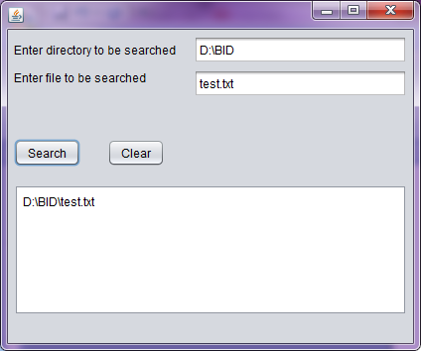

**Practical No.:**6

**Aim**: Program to find word and its occurrence inside a file

**Code:**

/*

* To change this license header, choose License Headers in Project Properties.

* To change this template file, choose Tools | Templates

* and open the template in the editor.

*/

import java.io.*;

import javax.swing.*;

/**

*

* @author Abhishek

*/

public class wordsearch extends javax.swing.JFrame {

/**

* Creates new form wordsearch

*/

public wordsearch() {

initComponents();

}

/**

* This method is called from within the constructor to initialize the form.

* WARNING: Do NOT modify this code. The content of this method is always

* regenerated by the Form Editor.

*/

@SuppressWarnings("unchecked")

// <editor-fold defaultstate="collapsed" desc="Generated Code">

private void initComponents() {

jLabel1 = new javax.swing.JLabel();

jLabel2 = new javax.swing.JLabel();

jTextField1 = new javax.swing.JTextField();

jTextField2 = new javax.swing.JTextField();

jButton1 = new javax.swing.JButton();

jButton2 = new javax.swing.JButton();

setDefaultCloseOperation(javax.swing.WindowConstants.EXIT_ON_CLOSE);

jLabel1.setText("Enter the path to the file:");

jLabel2.setText("Enter the String to find:");

jButton1.setText("Search");

jButton1.addActionListener(new java.awt.event.ActionListener() {

public void actionPerformed(java.awt.event.ActionEvent evt) {

jButton1ActionPerformed(evt);

}

});

jButton2.setText("Clear");

jButton2.addActionListener(new java.awt.event.ActionListener() {

public void actionPerformed(java.awt.event.ActionEvent evt) {

jButton2ActionPerformed(evt);

}

});

javax.swing.GroupLayout layout = new javax.swing.GroupLayout(getContentPane());

getContentPane().setLayout(layout);

layout.setHorizontalGroup(

layout.createParallelGroup(javax.swing.GroupLayout.Alignment.LEADING)

.addGroup(layout.createSequentialGroup()

.addContainerGap()

.addGroup(layout.createParallelGroup(javax.swing.GroupLayout.Alignment.LEADING)

.addGroup(layout.createSequentialGroup()

.addComponent(jLabel1)

.addPreferredGap(javax.swing.LayoutStyle.ComponentPlacement.RELATED)

.addComponent(jTextField1))

.addGroup(layout.createSequentialGroup()

.addComponent(jLabel2)

.addPreferredGap(javax.swing.LayoutStyle.ComponentPlacement.UNRELATED)

.addComponent(jTextField2))

.addGroup(layout.createSequentialGroup()

.addComponent(jButton1)

.addGap(18, 18, 18)

.addComponent(jButton2)

.addGap(0, 240, Short.MAX_VALUE)))

.addContainerGap())

);

layout.setVerticalGroup(

layout.createParallelGroup(javax.swing.GroupLayout.Alignment.LEADING)

.addGroup(layout.createSequentialGroup()

.addContainerGap()

.addGroup(layout.createParallelGroup(javax.swing.GroupLayout.Alignment.BASELINE)

.addComponent(jLabel1)

.addComponent(jTextField1, javax.swing.GroupLayout.PREFERRED_SIZE, javax.swing.GroupLayout.DEFAULT_SIZE, javax.swing.GroupLayout.PREFERRED_SIZE))

.addGap(18, 18, 18)

.addGroup(layout.createParallelGroup(javax.swing.GroupLayout.Alignment.BASELINE)

.addComponent(jLabel2)

.addComponent(jTextField2, javax.swing.GroupLayout.PREFERRED_SIZE, javax.swing.GroupLayout.DEFAULT_SIZE, javax.swing.GroupLayout.PREFERRED_SIZE))

.addGap(47, 47, 47)

.addGroup(layout.createParallelGroup(javax.swing.GroupLayout.Alignment.BASELINE)

.addComponent(jButton1)

.addComponent(jButton2))

.addContainerGap(26, Short.MAX_VALUE))

);

pack();

}// </editor-fold>

private void jButton1ActionPerformed(java.awt.event.ActionEvent evt) {

BufferedReader br = null;

try {

int count = 0, countBuffer = 0, countLine = 0;

String linenumber = "";

String filepath = jTextField1.getText();

String inputsearch = jTextField2.getText();

String line = "";

br = new BufferedReader(new FileReader(filepath));

while ((line = br.readLine()) != null) {

countLine++;

String[] words = line.split(" ");

for (String word : words) {

if (word.equals(inputsearch)) {

count++;

countBuffer++;

}

}

if (countBuffer > 0) {

countBuffer = 0;

linenumber += countLine + " ";

}

}

JOptionPane.showMessageDialog(rootPane, "the word " + inputsearch + " has appeared " + count + " times at line number " + linenumber, "Search Result", JOptionPane.INFORMATION_MESSAGE);

br.close();

} catch (Exception e) {

}

}

private void jButton2ActionPerformed(java.awt.event.ActionEvent evt) {

jTextField1.setText("");

jTextField2.setText("");

}

/**

* @param args the command line arguments

*/

public static void main(String args[]) {

/* Set the Nimbus look and feel */

//<editor-fold defaultstate="collapsed" desc=" Look and feel setting code (optional) ">

/* If Nimbus (introduced in Java SE 6) is not available, stay with the default look and feel.

* For details see http://download.oracle.com/javase/tutorial/uiswing/lookandfeel/plaf.html

*/

try {

for (javax.swing.UIManager.LookAndFeelInfo info : javax.swing.UIManager.getInstalledLookAndFeels()) {

if ("Nimbus".equals(info.getName())) {

javax.swing.UIManager.setLookAndFeel(info.getClassName());

break;

}

}

} catch (ClassNotFoundException ex) {

java.util.logging.Logger.getLogger(wordsearch.class.getName()).log(java.util.logging.Level.SEVERE, null, ex);

} catch (InstantiationException ex) {

java.util.logging.Logger.getLogger(wordsearch.class.getName()).log(java.util.logging.Level.SEVERE, null, ex);

} catch (IllegalAccessException ex) {

java.util.logging.Logger.getLogger(wordsearch.class.getName()).log(java.util.logging.Level.SEVERE, null, ex);

} catch (javax.swing.UnsupportedLookAndFeelException ex) {

java.util.logging.Logger.getLogger(wordsearch.class.getName()).log(java.util.logging.Level.SEVERE, null, ex);

}

//</editor-fold>

/* Create and display the form */

java.awt.EventQueue.invokeLater(new Runnable() {

public void run() {

new wordsearch().setVisible(true);

}

});

}

// Variables declaration - do not modify

private javax.swing.JButton jButton1;

private javax.swing.JButton jButton2;

private javax.swing.JLabel jLabel1;

private javax.swing.JLabel jLabel2;

private javax.swing.JTextField jTextField1;

private javax.swing.JTextField jTextField2;

// End of variables declaration

}

Output:

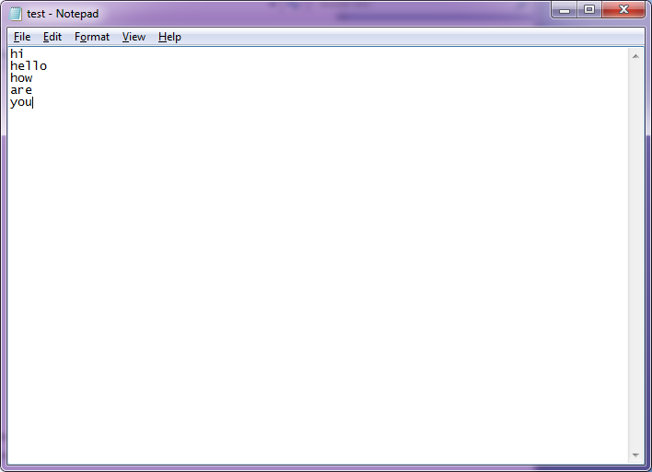

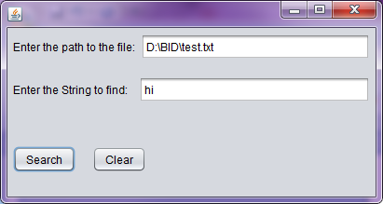

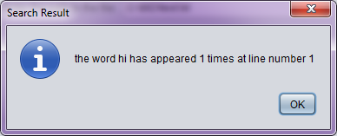

**Practical No.: 7.a**

**Aim:** Use FTK Imager to create image of a computer system

**Code:**

Step1: File-> Create Disk Image

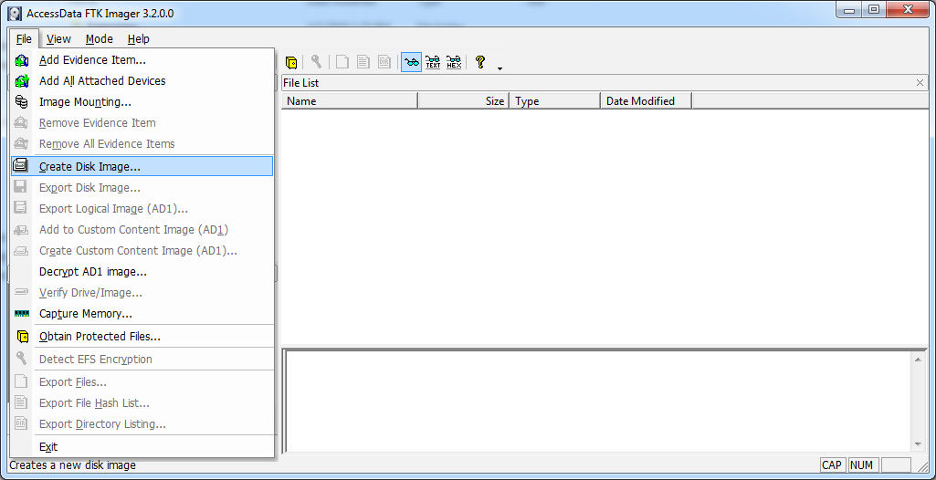

Step2: Select Contents of a folder option from it and click Next>

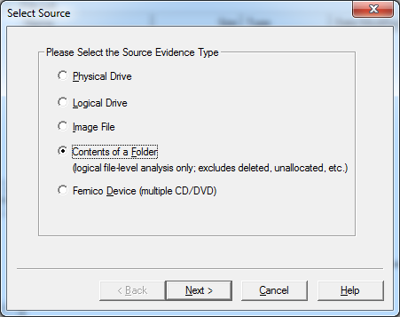

Step3: Click Yes

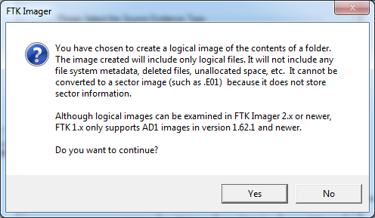

Step4: Select a folder you want to create Image and click on Finish

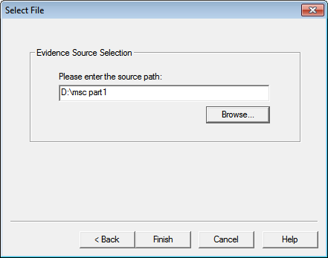

Step5: Select Destination folder by adding button.

Step6: Add Case Details and click on next>

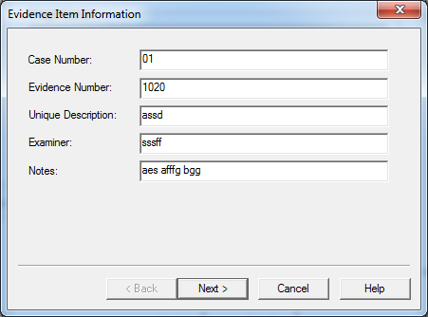

Step7:Add Destination Name AND Image Filename.

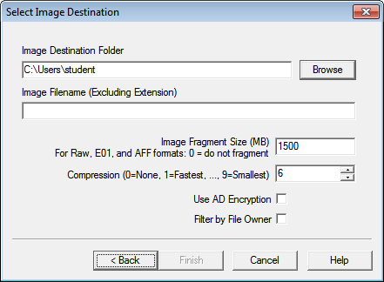

Step 8:Click on Start

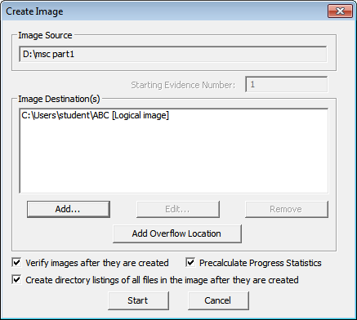

Output:

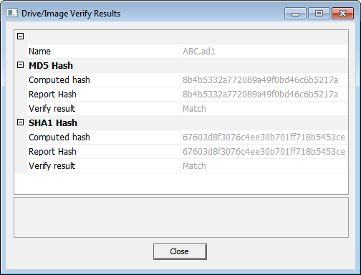

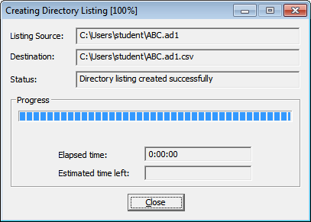

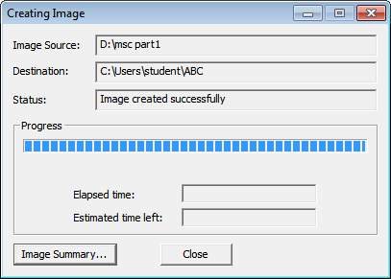

Image Summary:

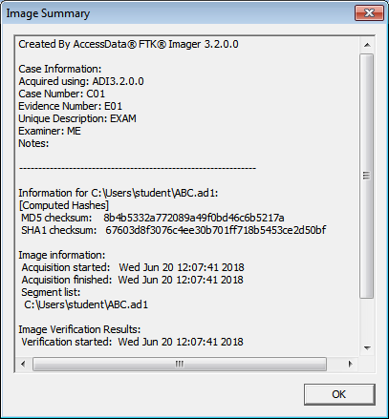

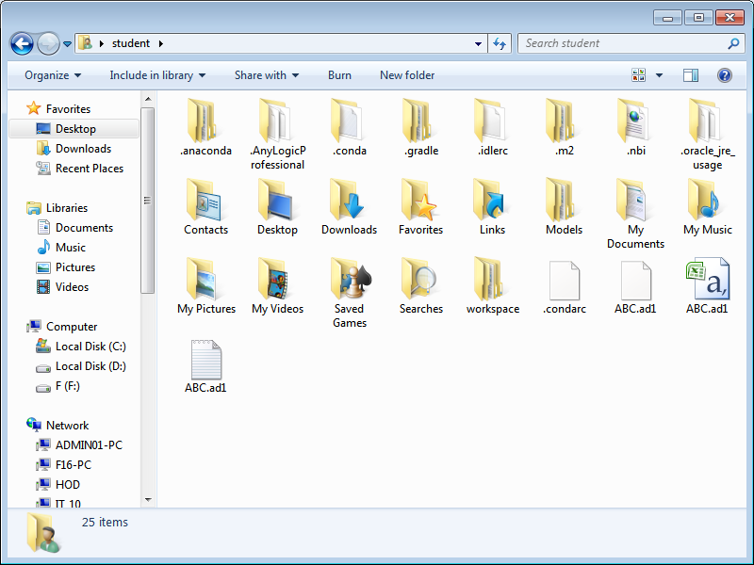

**Practical No.: 7.b**

**Aim:** Create Server Image

**Code:**

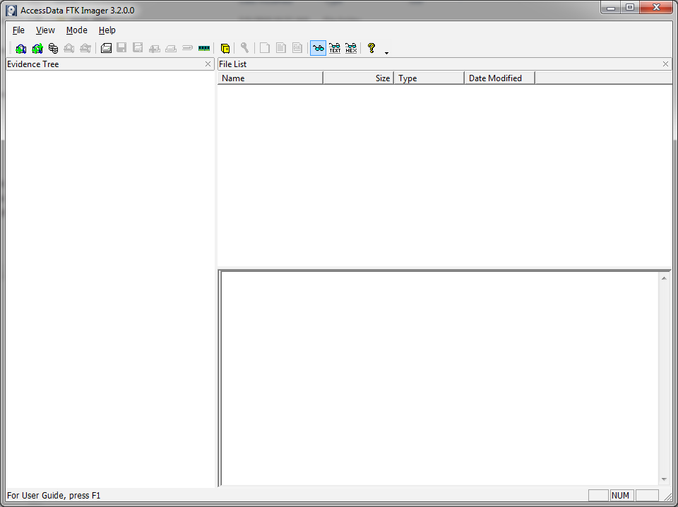

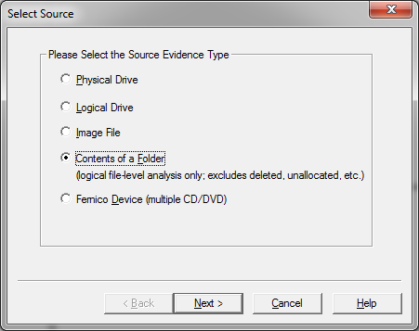

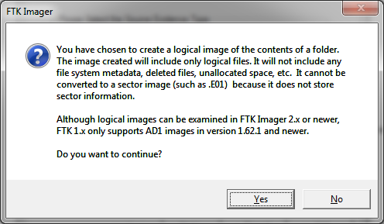

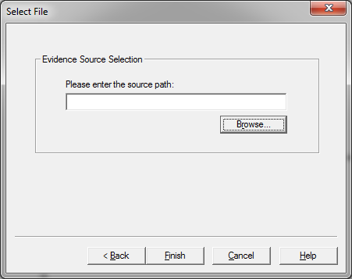

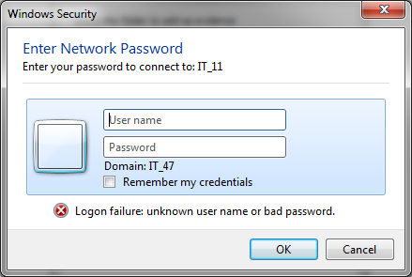

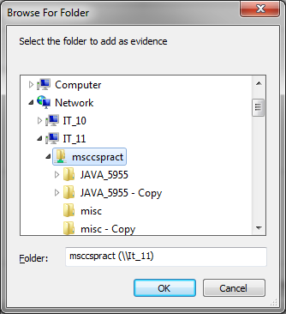

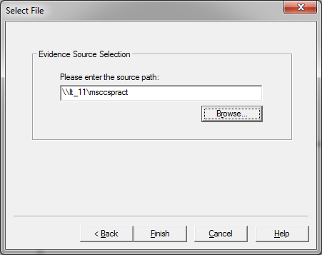

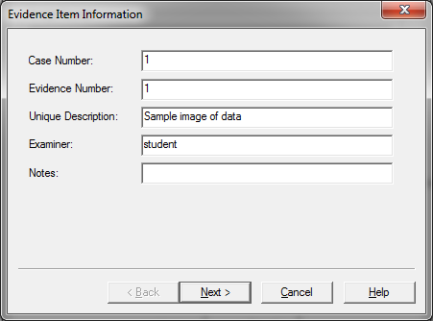

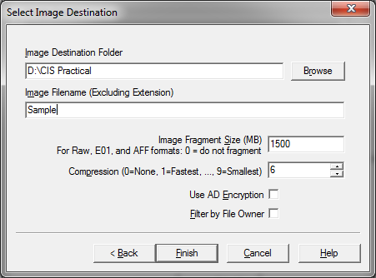

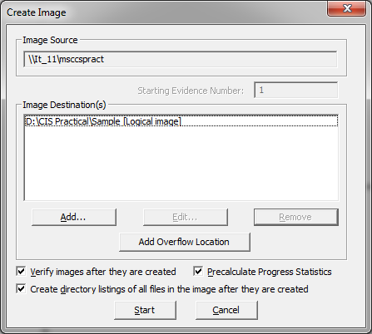

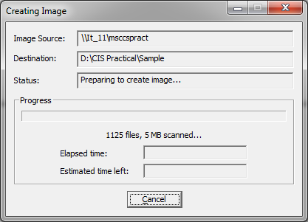

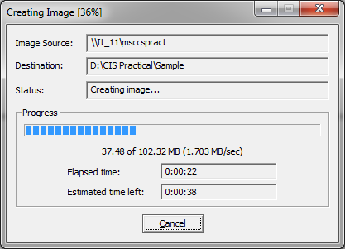

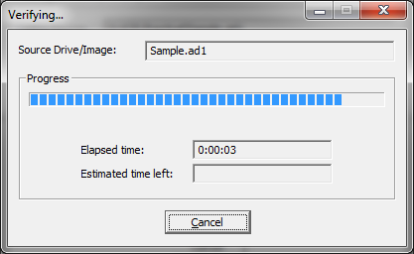

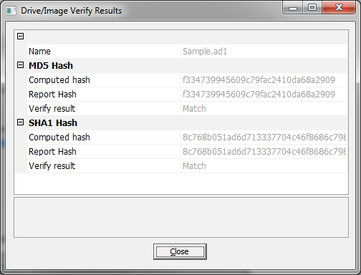

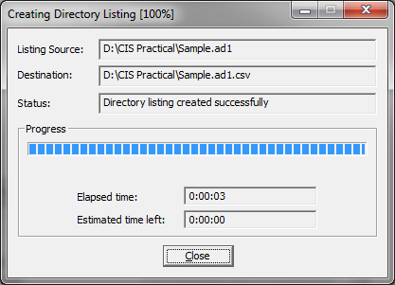

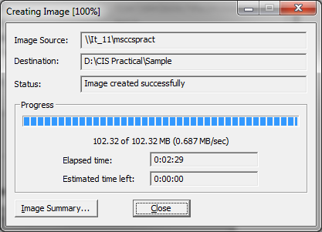

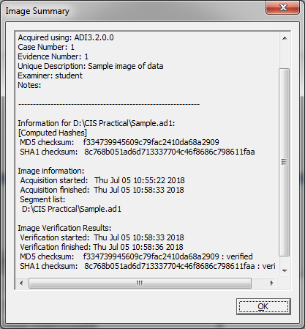

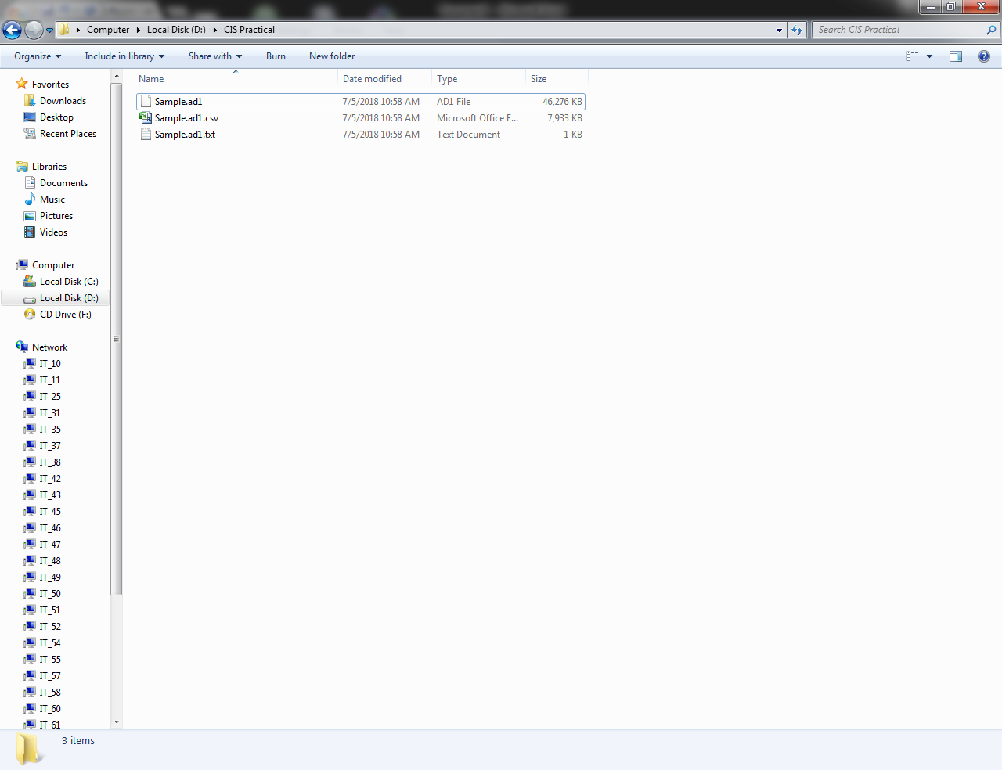

**Practical No.: 7.c**

**Aim:** Create a image of mobile

**Code:**

**Note: A ‘Rooted’ device is needed for the process with superuser permissions.**

1)Allow Usb Debugging in Developer Options in mobile phone for ADB.

2)Open Andriller

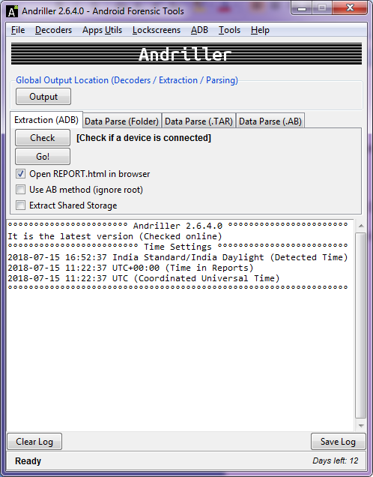

3)Set the output path to the location where the backup is to be taken.

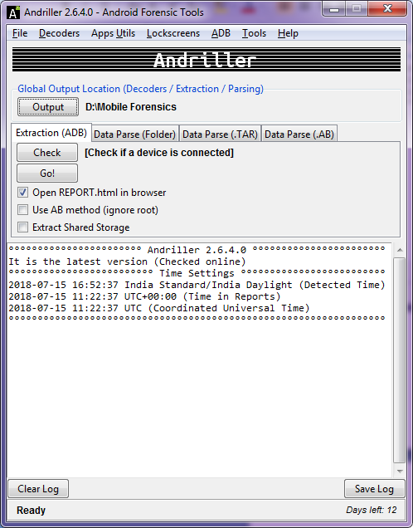

4)Connect the device to the computer using a data cable.

Click on the Check button to connect the mobile device. Serial number of the device is displayed.

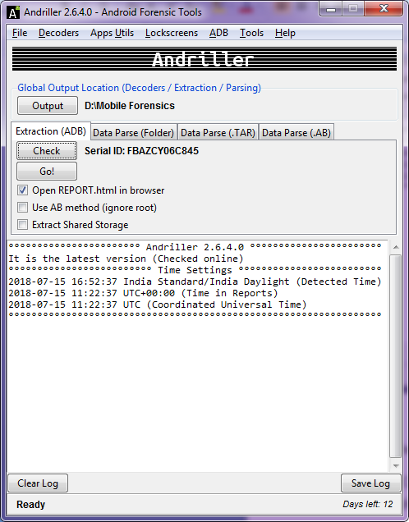

5)Select the ‘Use AB method(ignore root)’ and ‘Extract Shared Storage’ checkboxes.

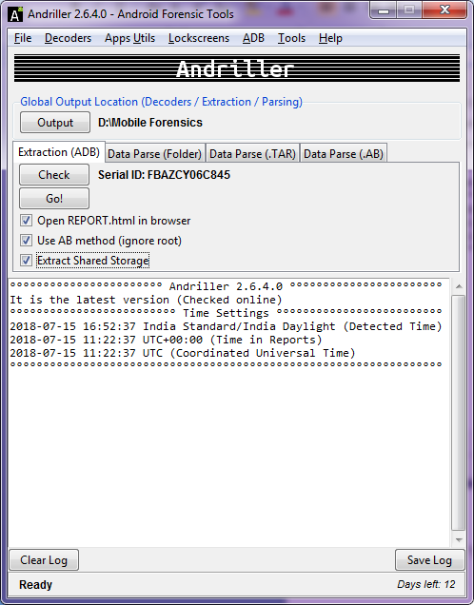

6)Click on ‘GO!’

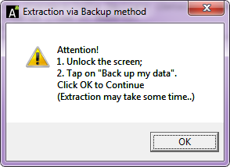

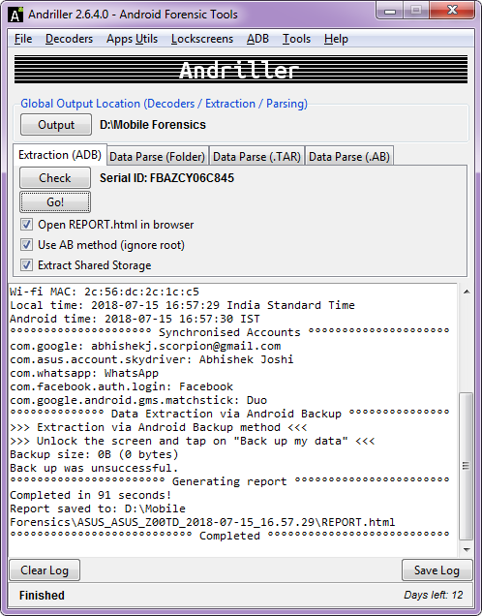

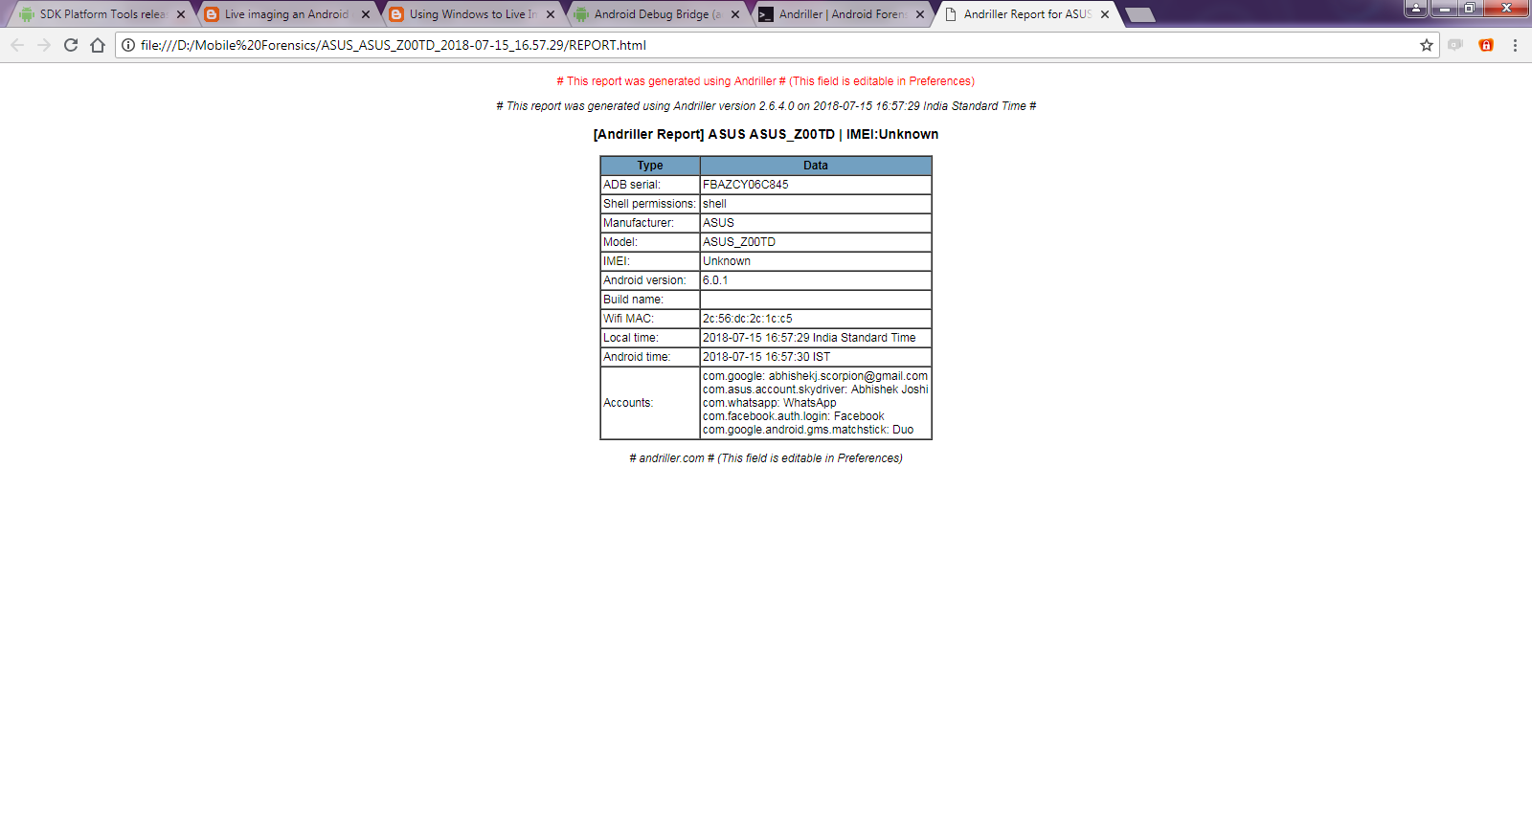

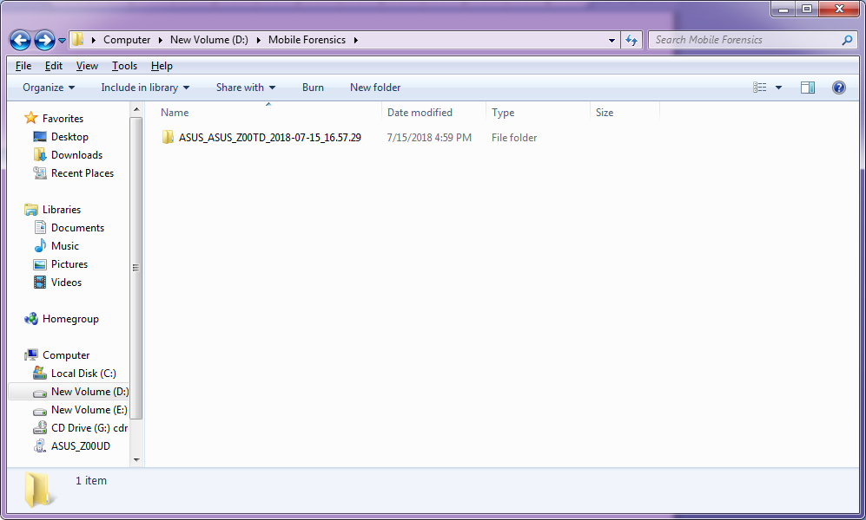

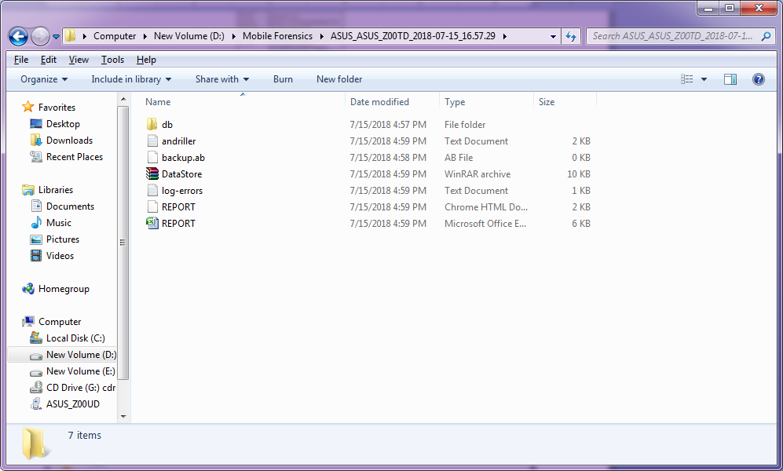

**Practical No.:8**

**Aim:** Practical to perform registry view forensics

**Code:**

**Software** : ProDiscover

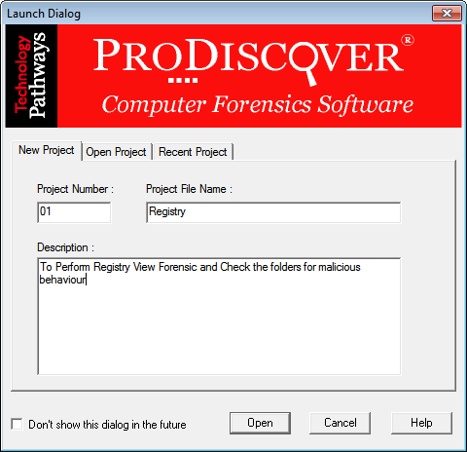

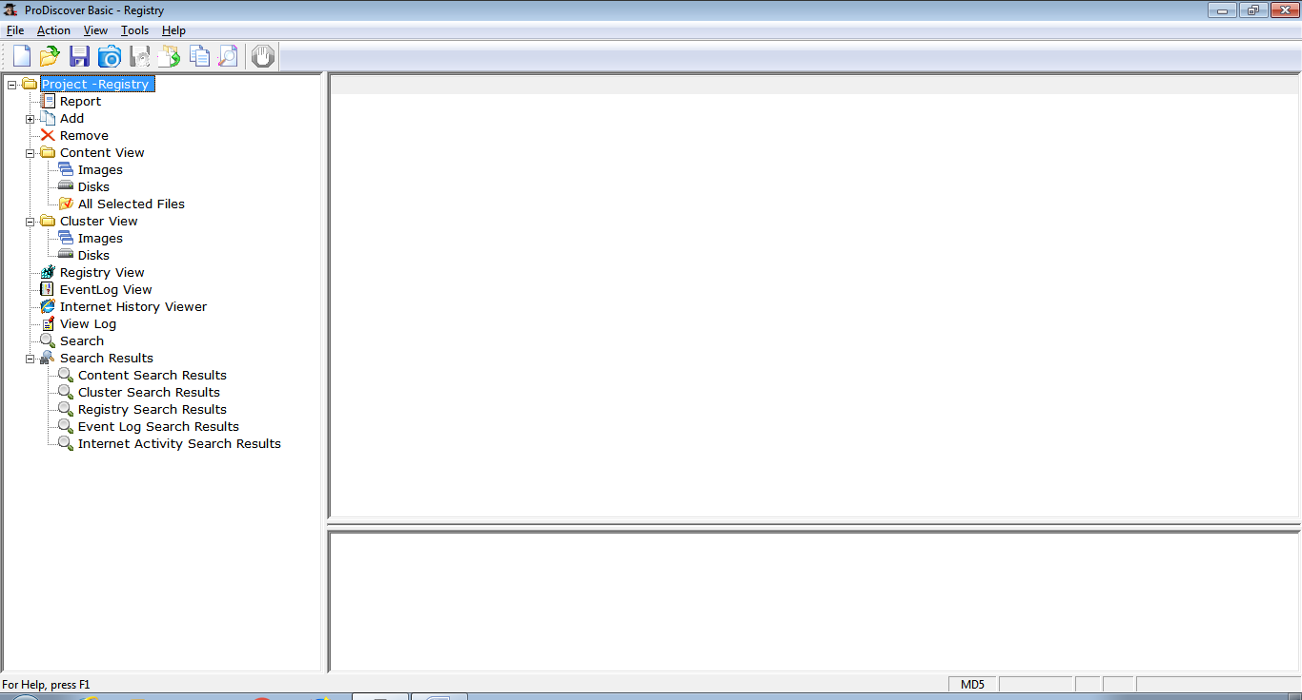

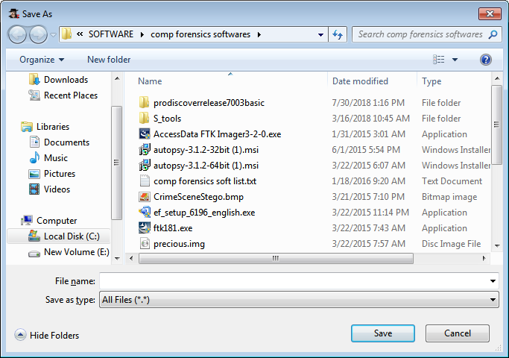

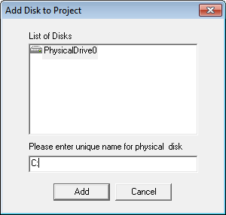

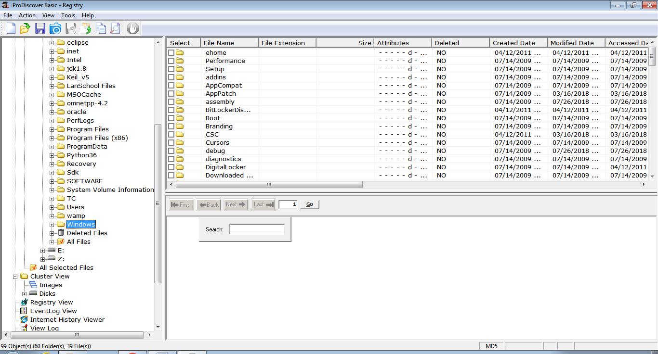

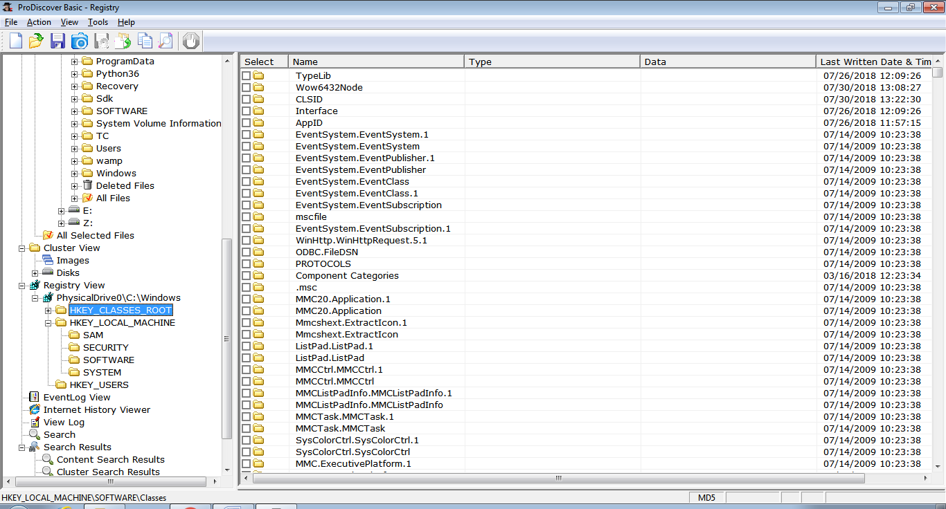

1) Computer Forensic

**HKCU\Software\Microsoft\Windows\CurrentVersion\Explorer\RecentDocs\**

This key shows the recent documents that were opened.

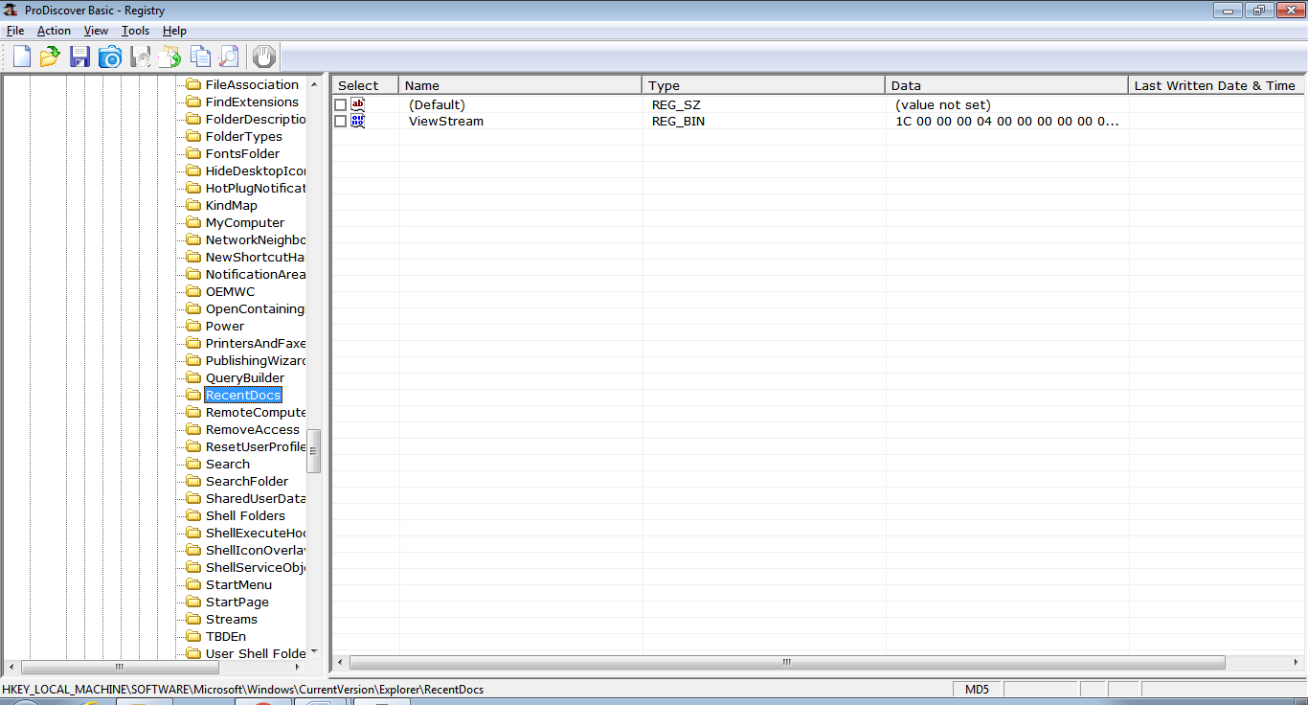

2)Computer Network

**HKEY_LOCAL_MACHINE\SYSTEM\CurrentControlSet\Control\DeviceClasses**

Beneath this key are two other keys of interest:

**{53f56307-b6bf-11d0-94f2-00a0c91efb8b} & {53f5630d-b6bf-11d0-94f2-00a0c91efb8b}**

These are Device Class [GUID](http://www.forensicswiki.org/wiki/Universally_Unique_Identifier) keys for Disks and Volumes, respectively. Beneath the Disk GUID key are several subkeys that appear as follows (the key name is wrapped):

**##?#USBSTOR#Disk&Ven_SanDisk&Prod_U3_Cruzer_Micro&Rev_3.27#0000161511737EFB&0**

**#{53f56307-b6bf-11d0-94f2-00a0c91efb8b}**

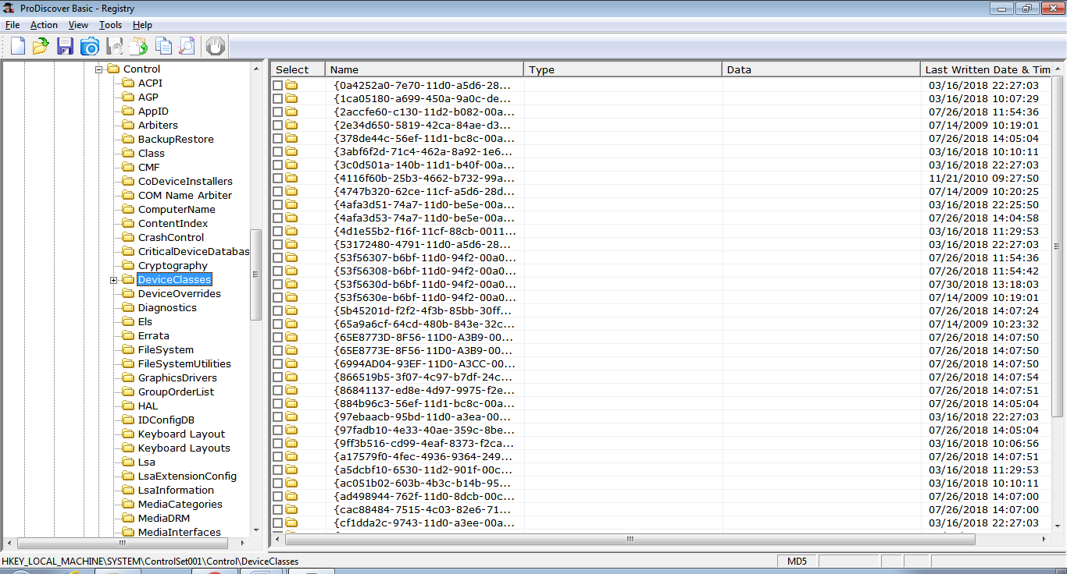

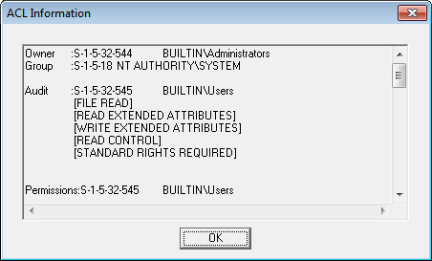

3) Mobile Device

**View the device interface GUID, Hardware Id, and device class information about your device.**

1) Find this registry key and note the **DeviceInstance** value:

**HKEY_LOCAL_MACHINE\SYSTEM\CurrentControlSet\Control\DeviceClasses\**

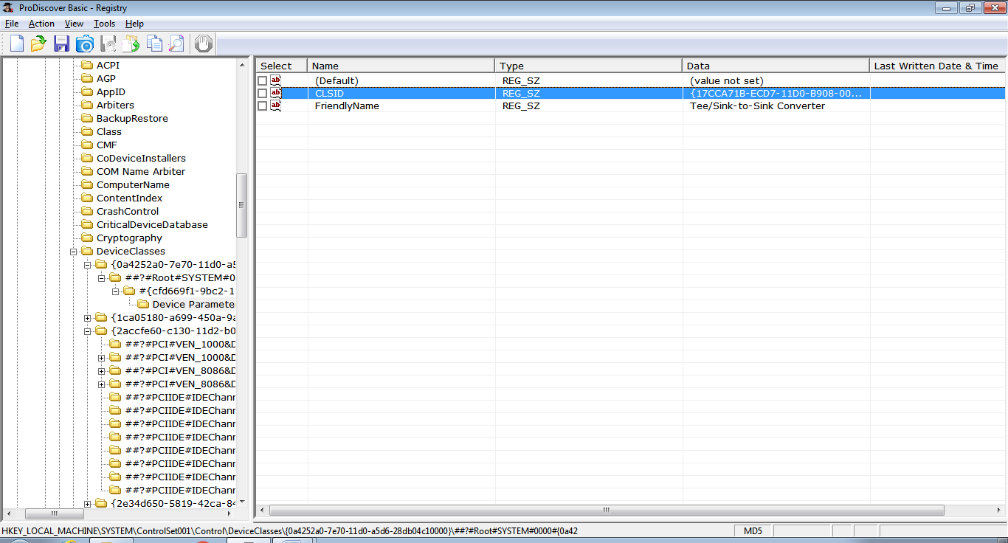

2) Find the device instance registry key and get the device interface GUID:

**HKEY_LOCAL_MACHINE\SYSTEM\CurrentControlSet\Enum\USB\<hardware id>\<instance id>\Device Parameters**

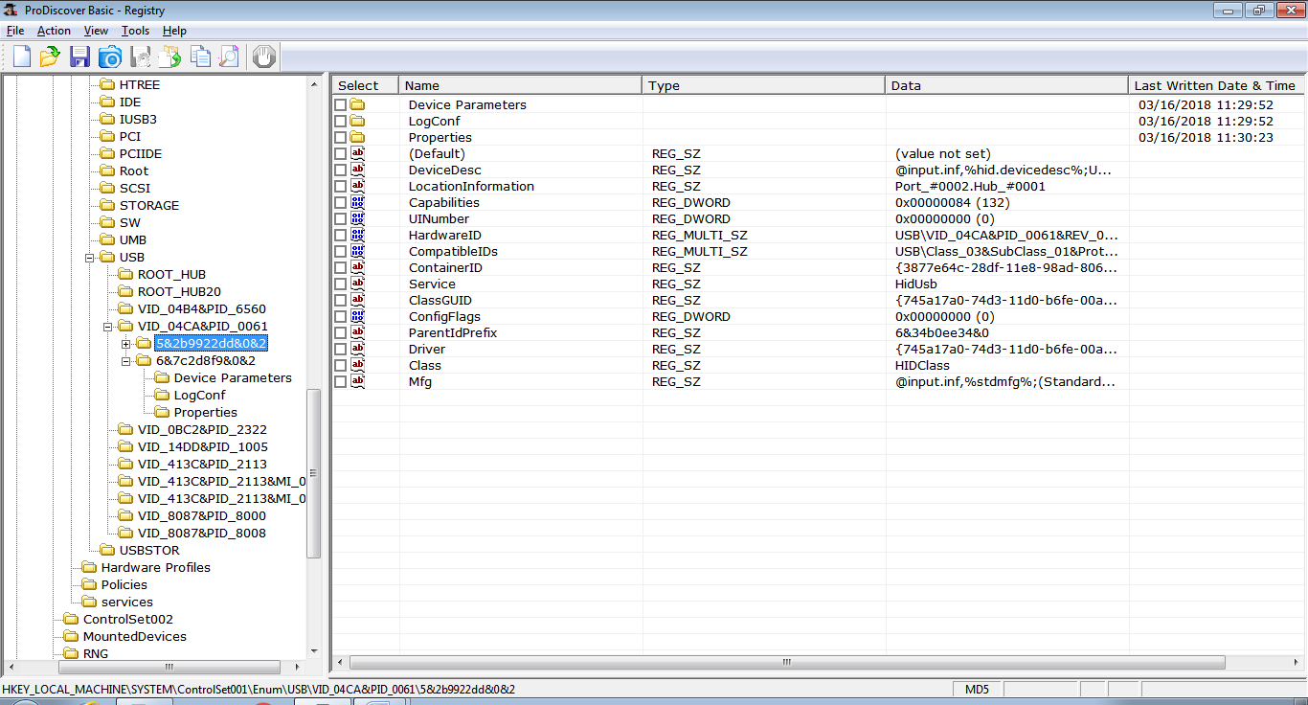

3) Under the device instance key, note the device class, subclass, and protocol codes:

**HKEY_LOCAL_MACHINE\SYSTEM\CurrentControlSet\Enum\USB**

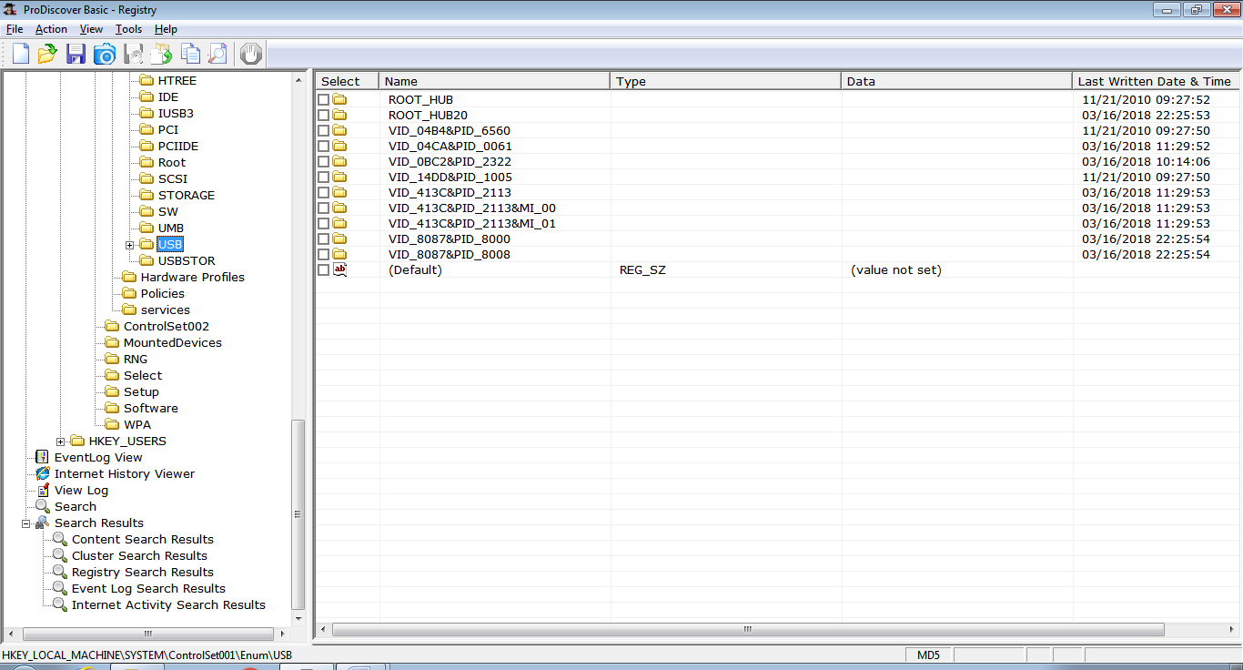

4)Wireless Network

**HKLM\SYSTEM\ControlSet001\ Services\Tcpip\Parameters\Interfaces\**

n addition to logging the name of the SSID, Windows also logs the network settings of that particular connection - such as the IP address, DHCP domain, subnet mask, etc.

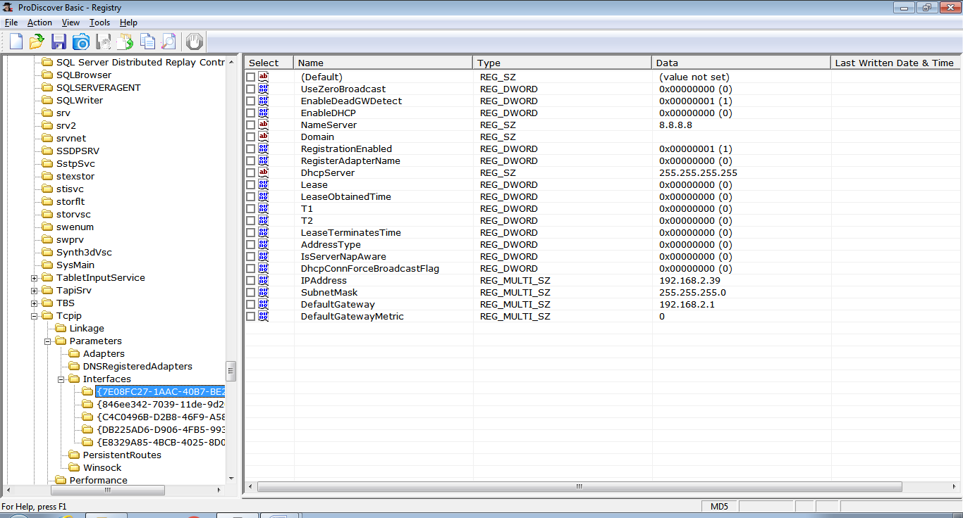

**Practical No.:9.a**

**Aim:** Computer system analysis using FTK

**Code:**

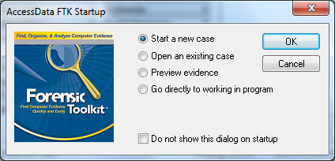

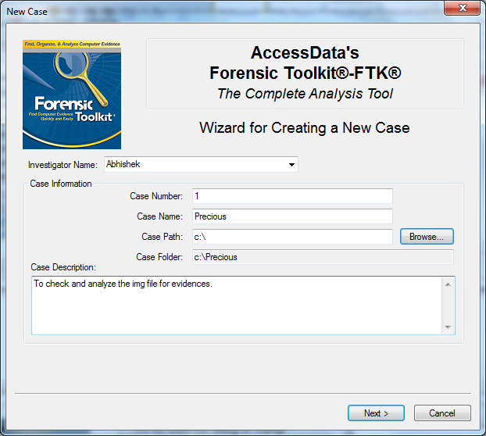

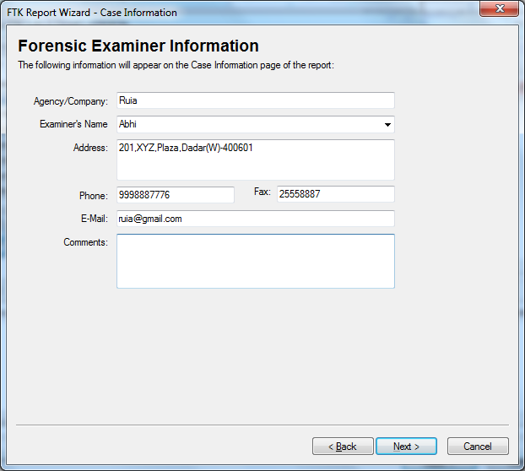

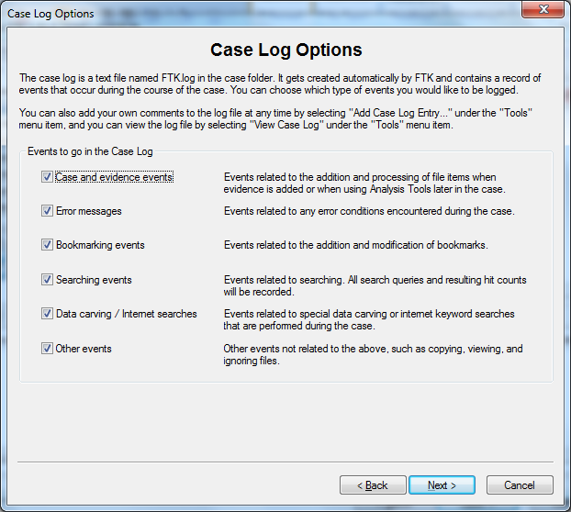

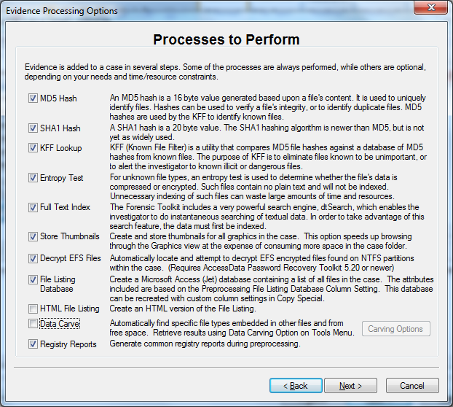

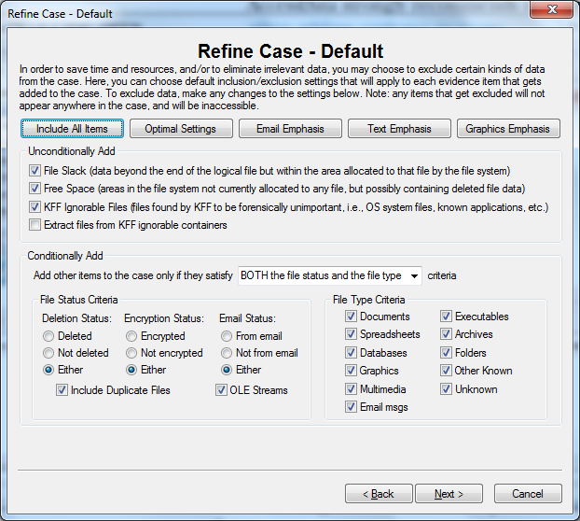

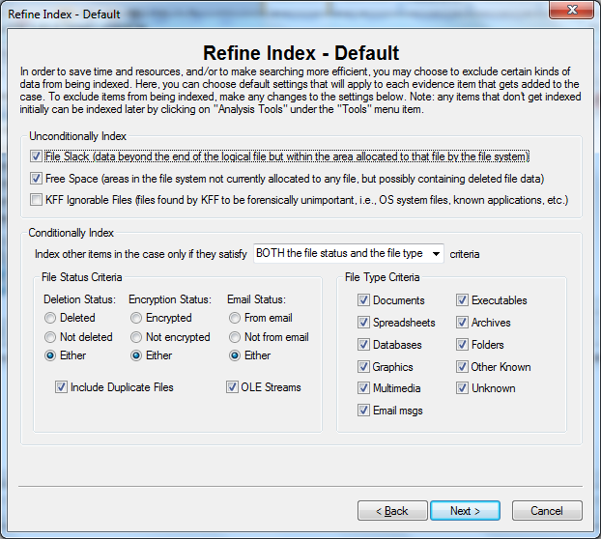

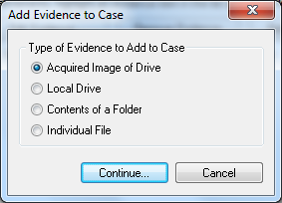

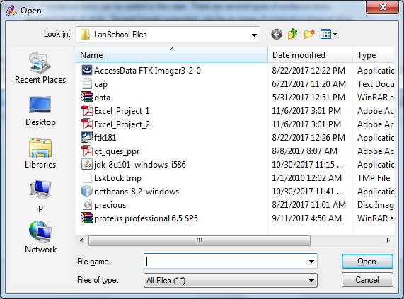

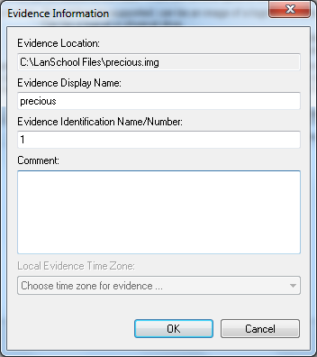

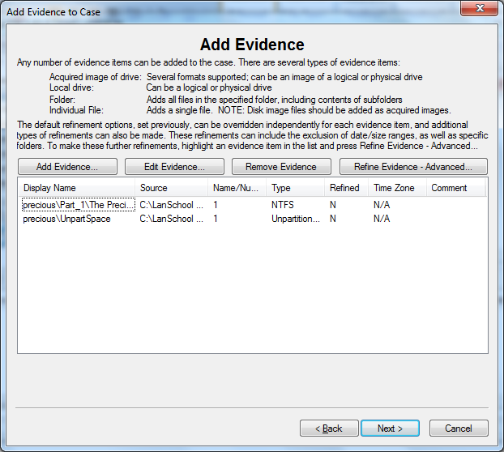

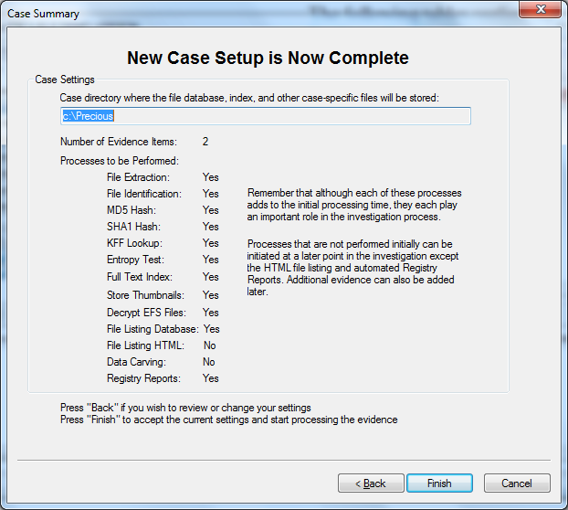

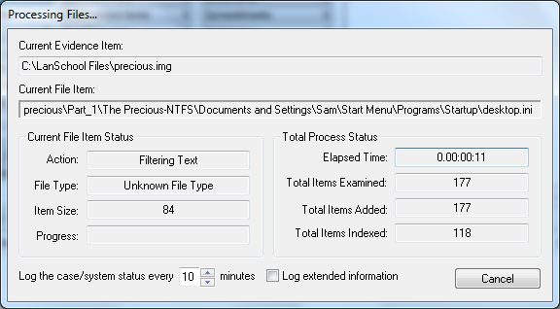

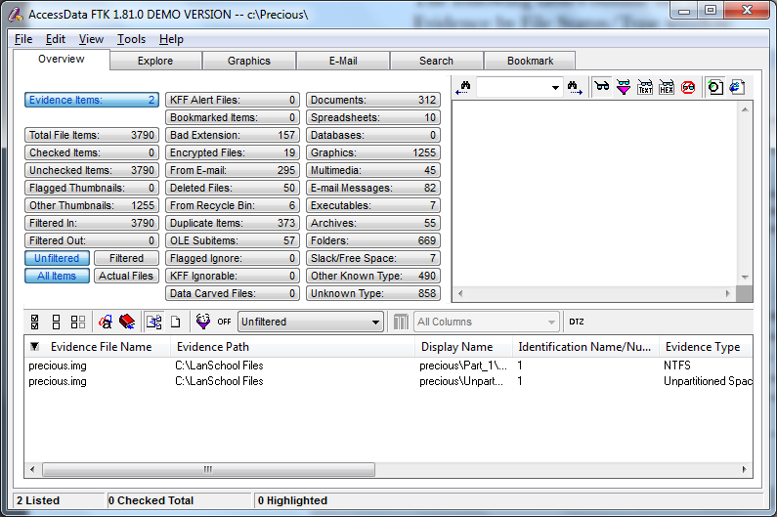

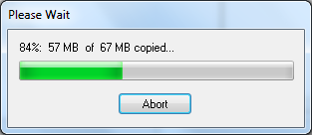

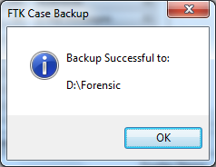

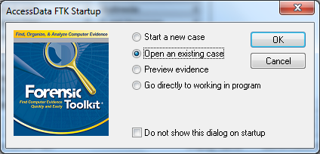

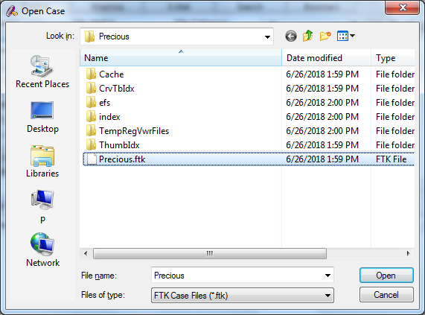

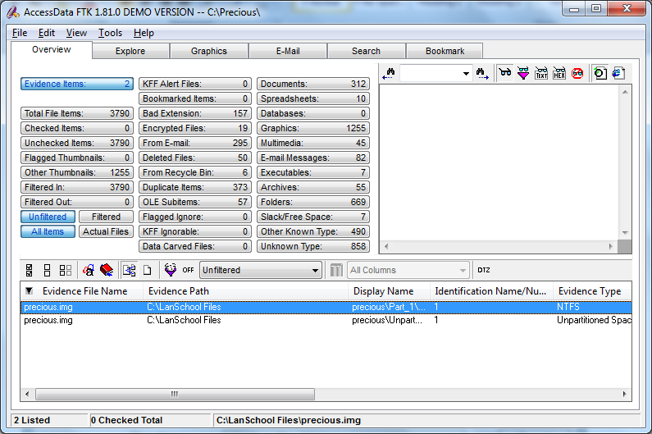

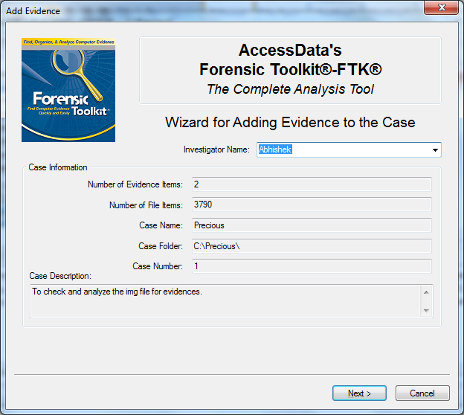

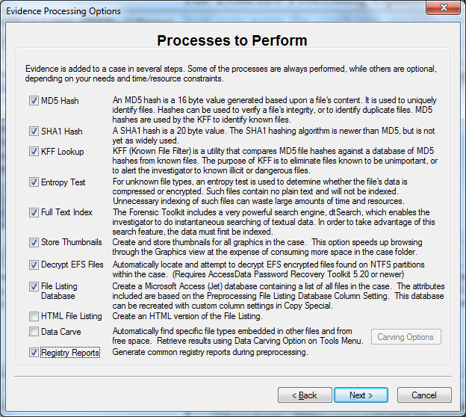

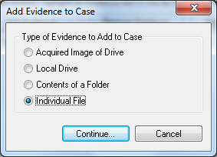

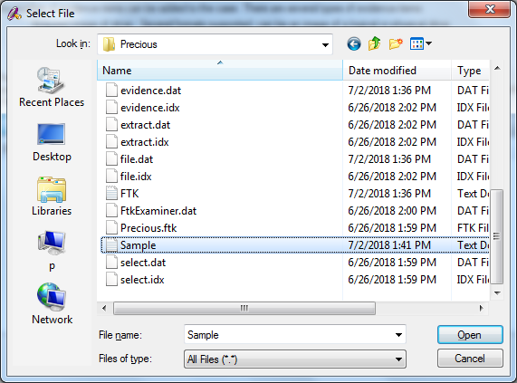

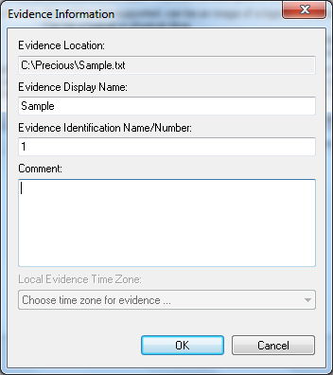

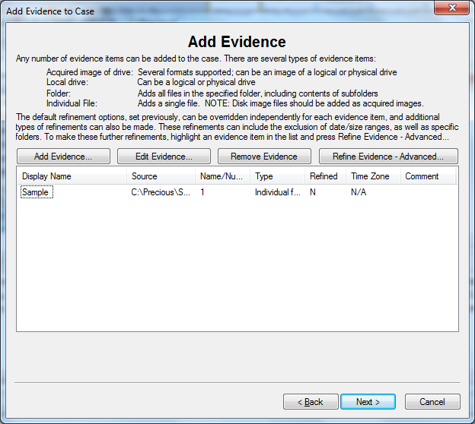

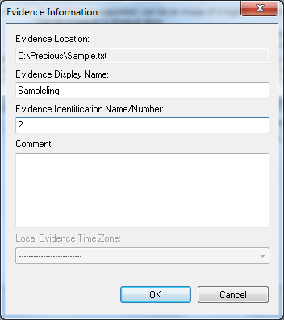

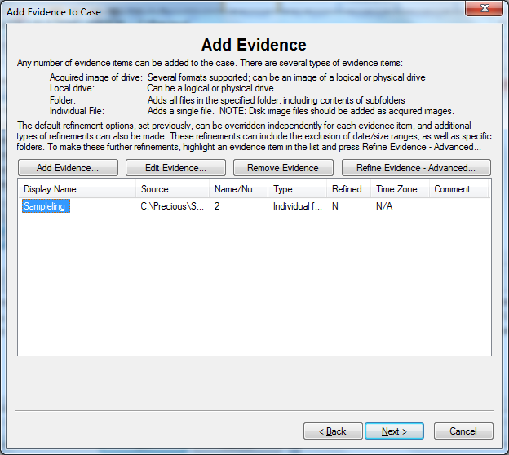

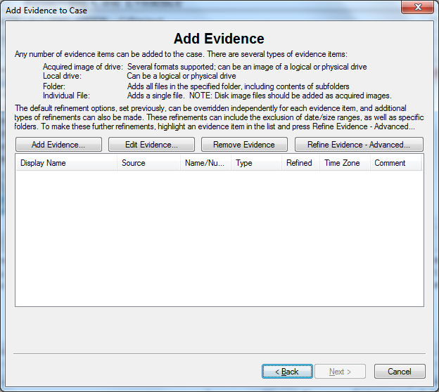

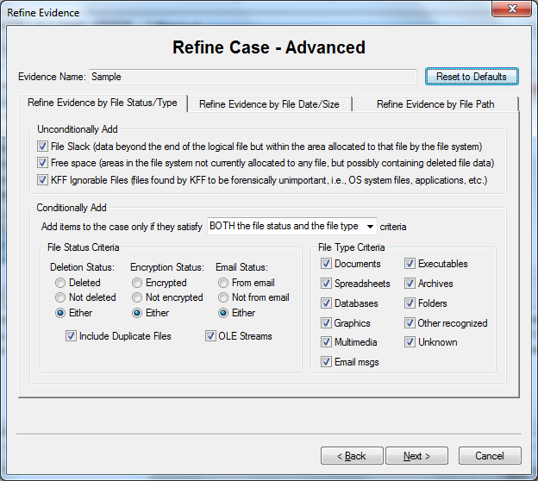

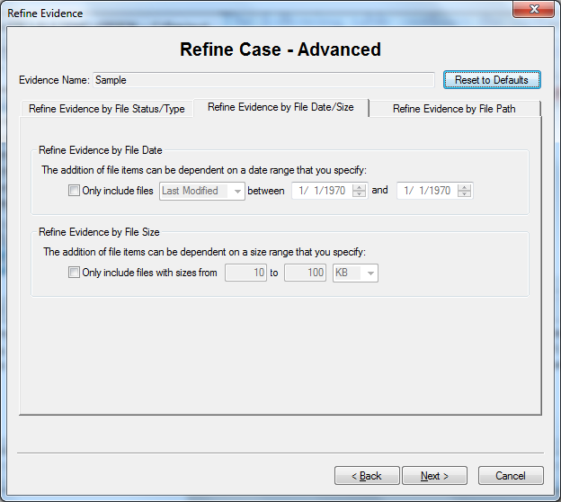

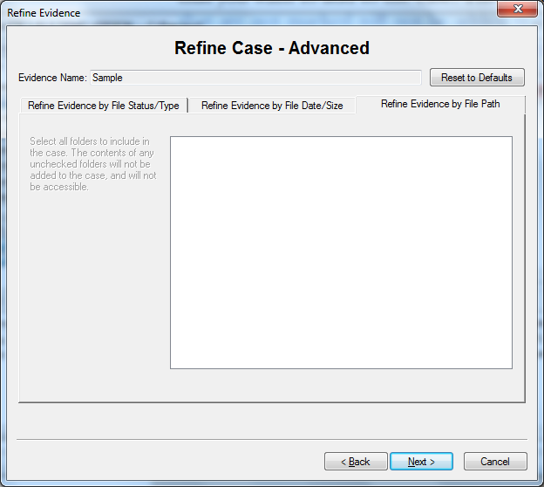

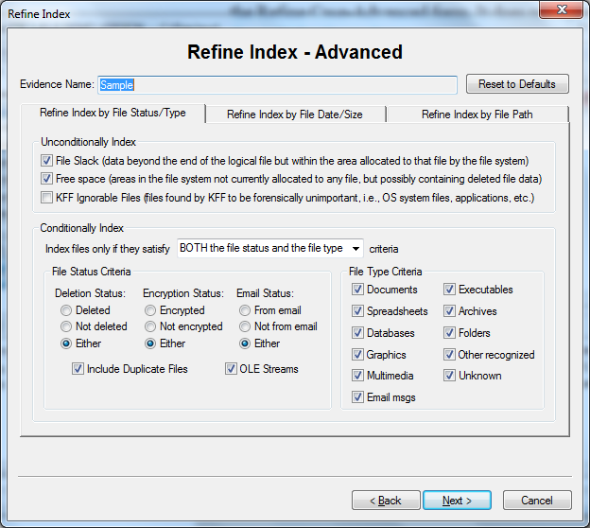

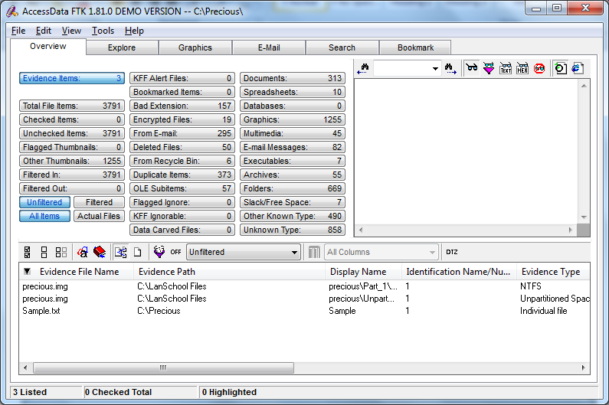

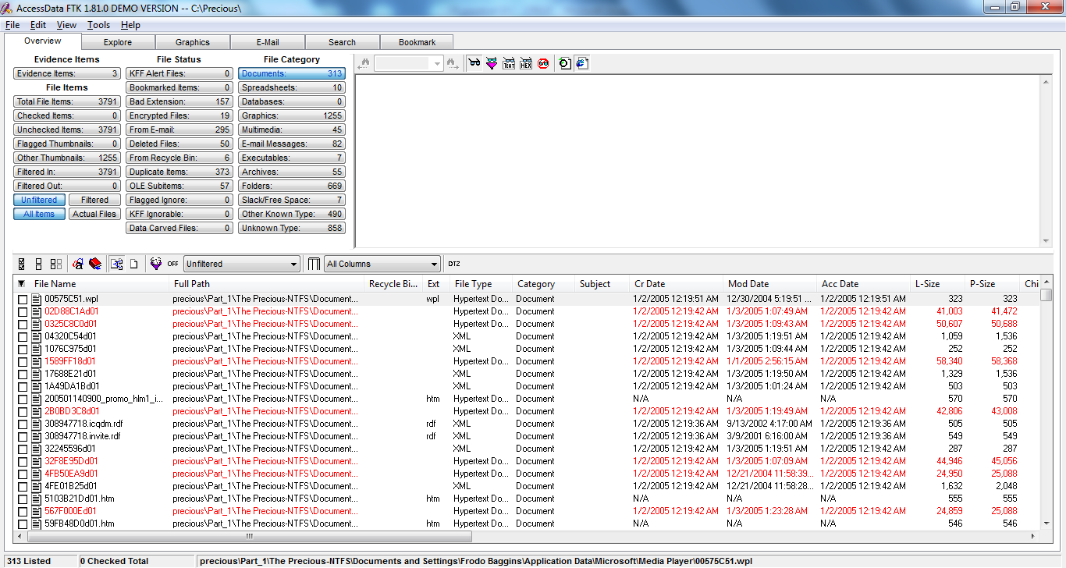

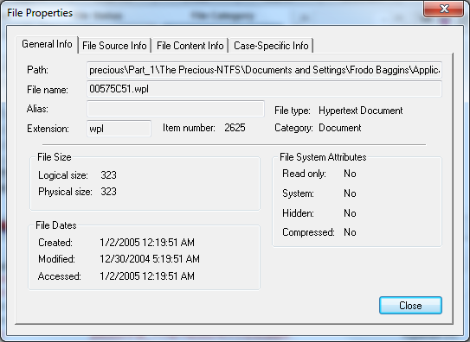

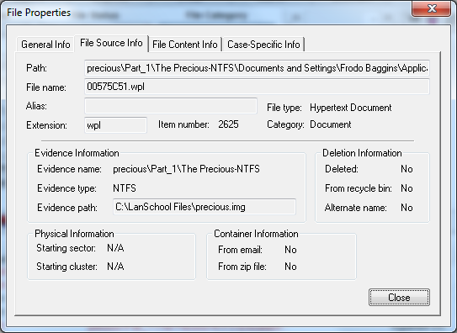

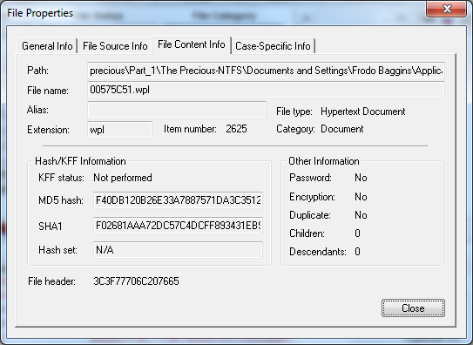

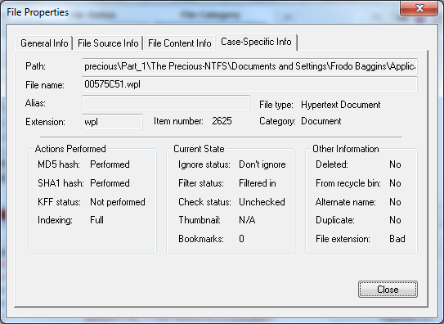

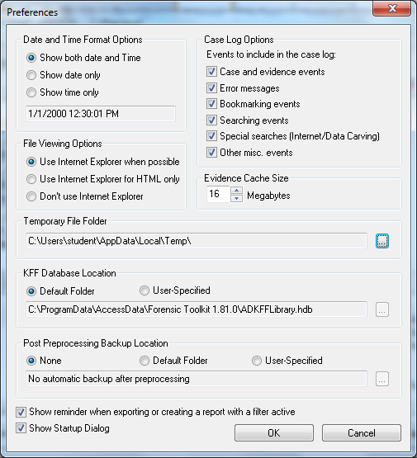

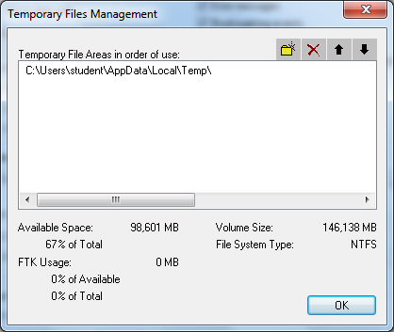

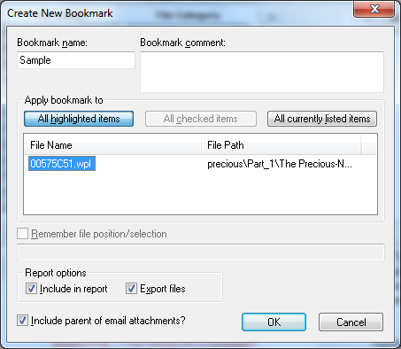

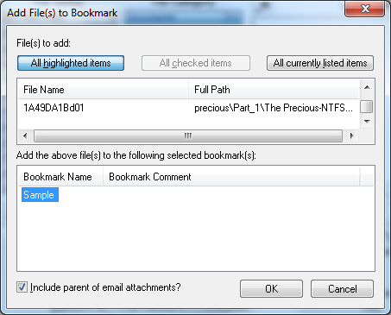

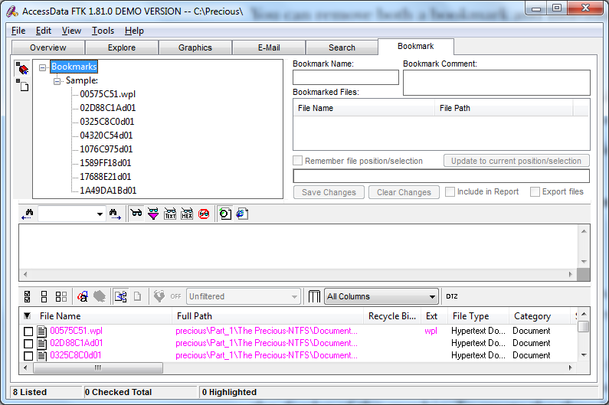

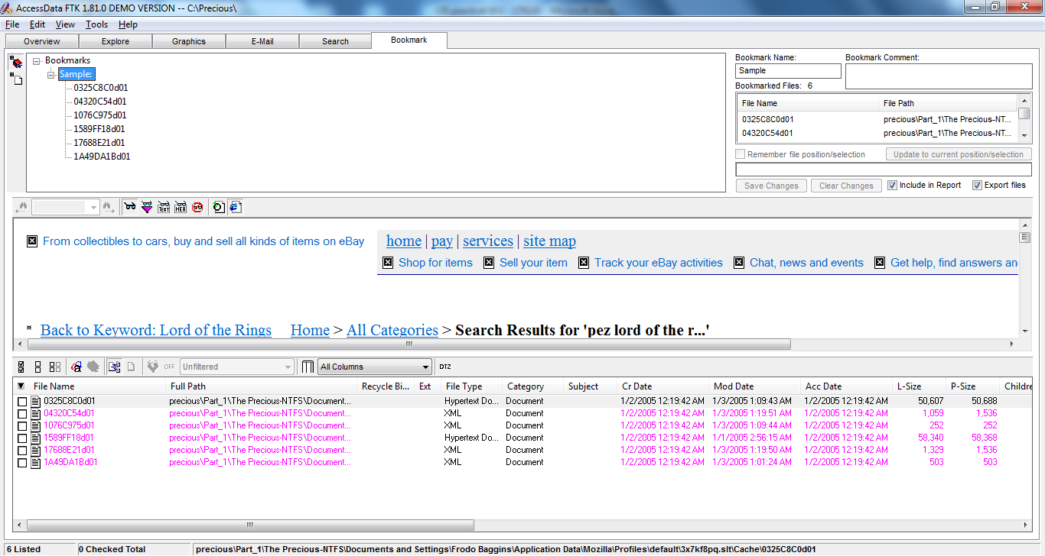

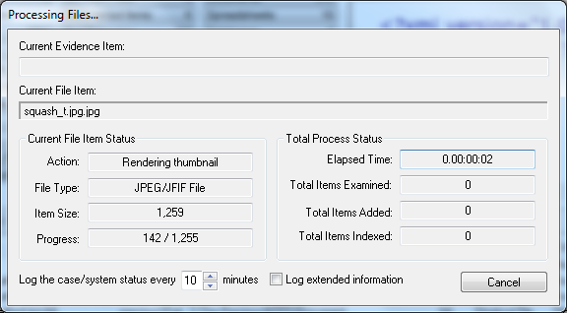

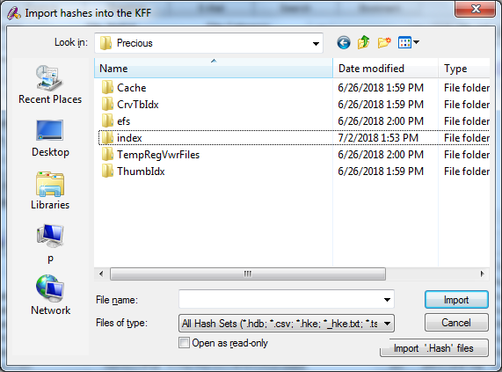

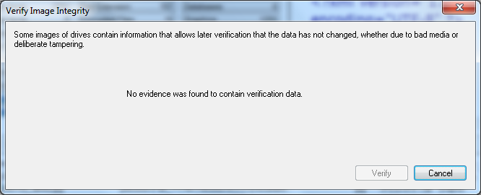

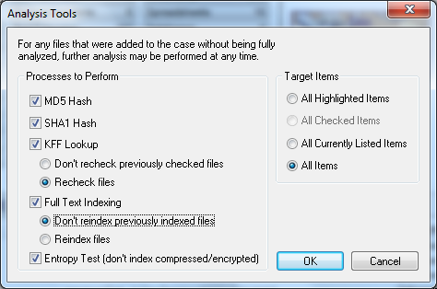

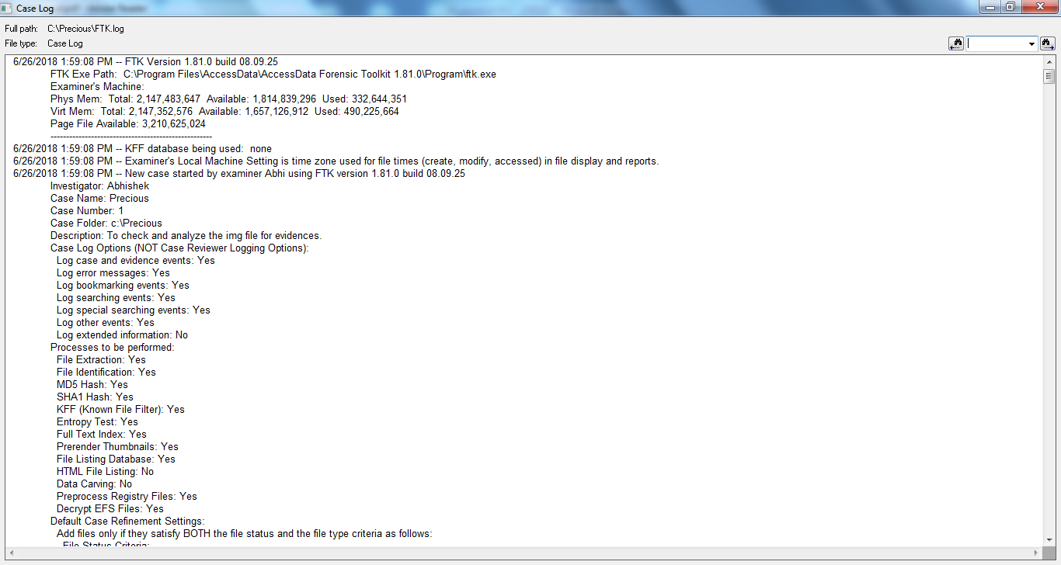

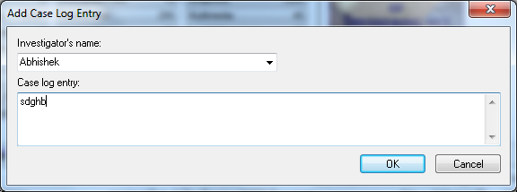

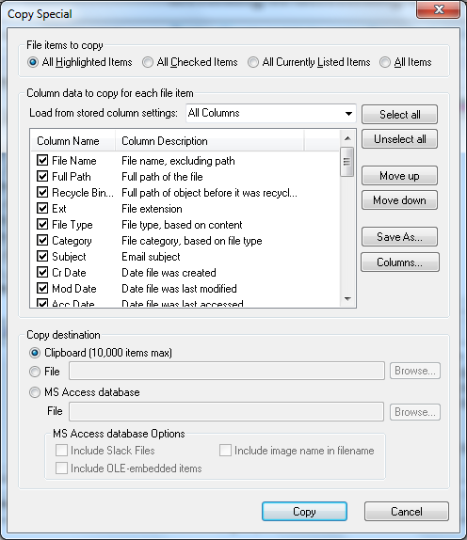

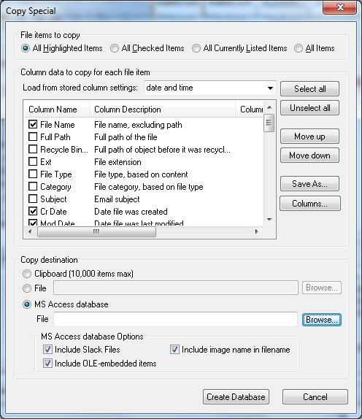

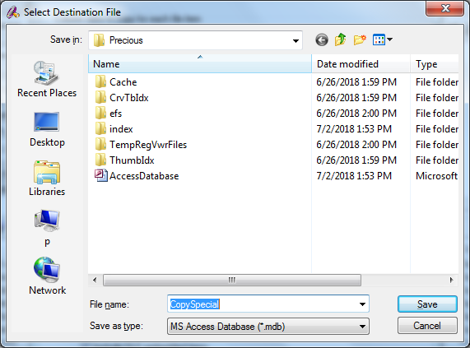

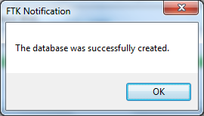

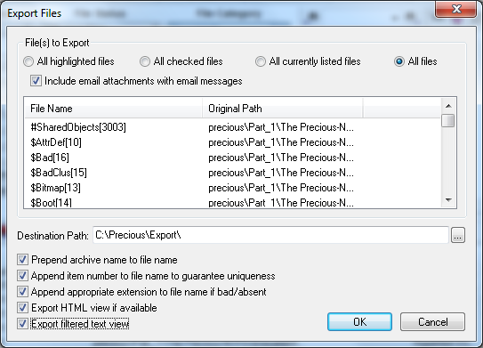

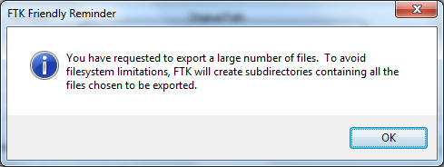

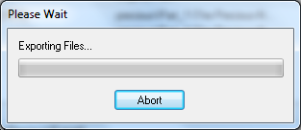

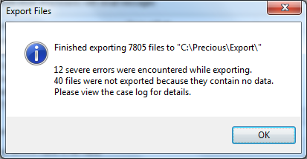

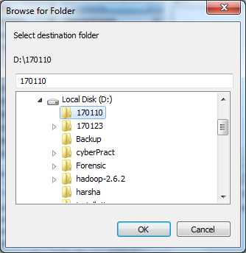

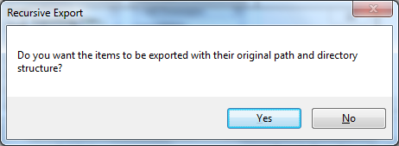

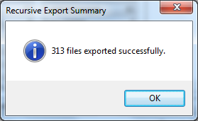

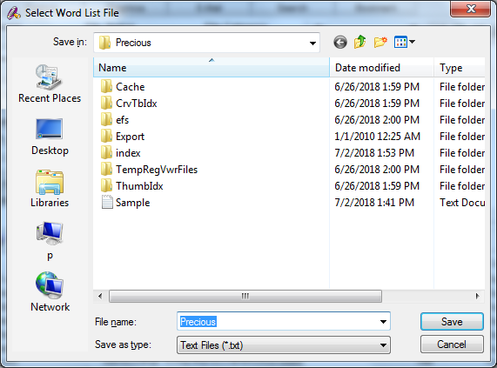

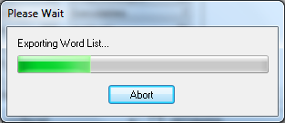

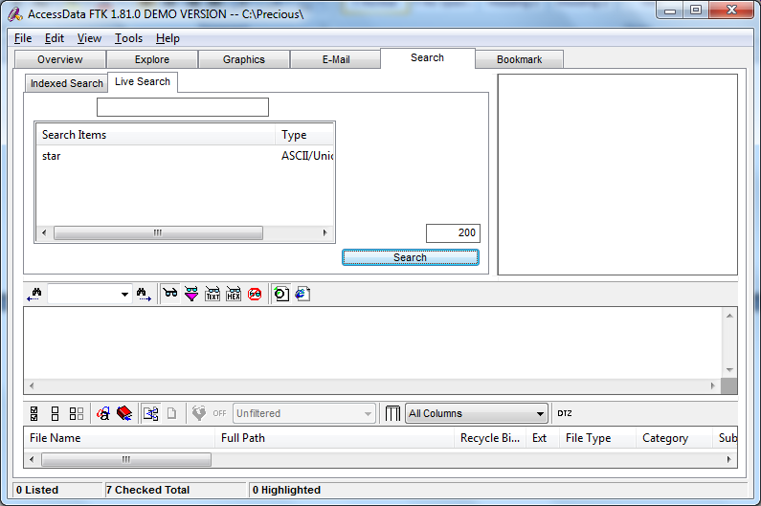

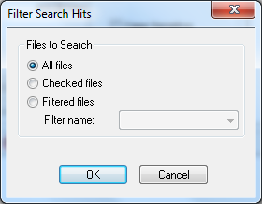

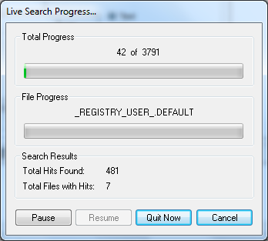

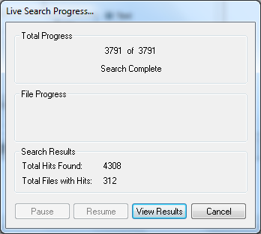

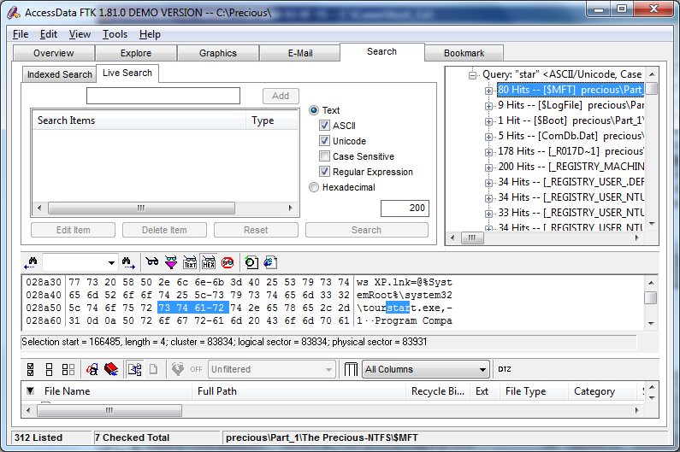

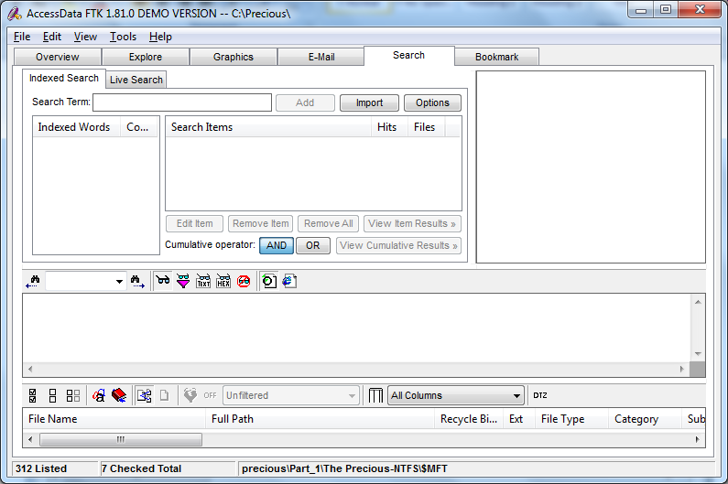

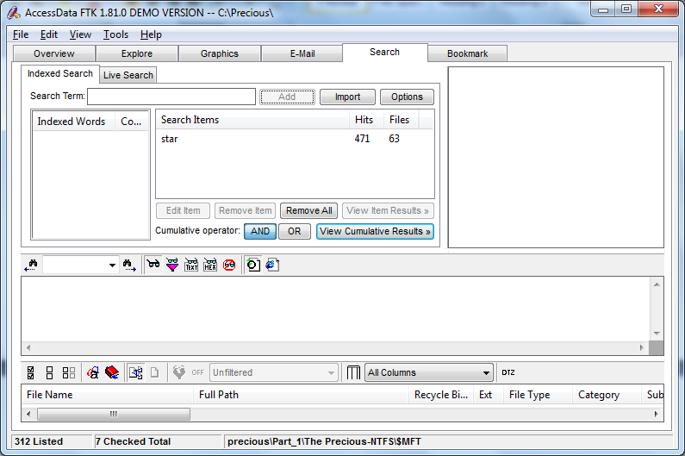

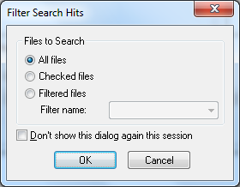

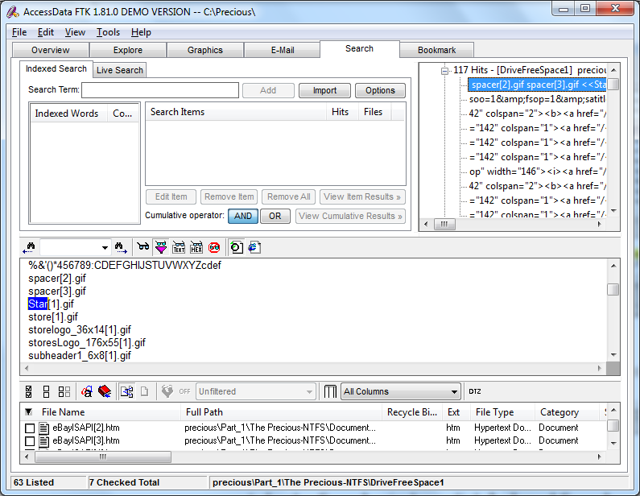

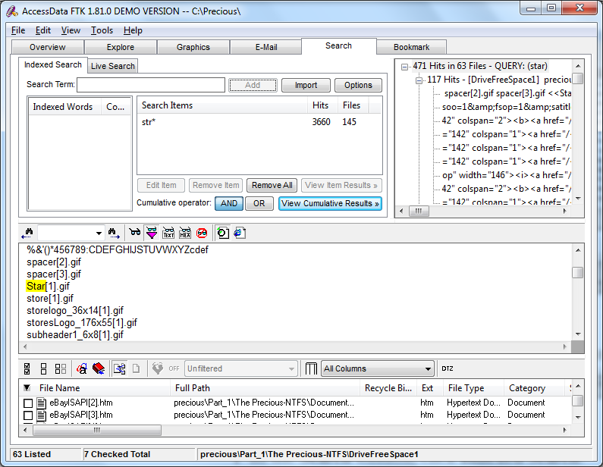

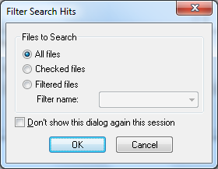

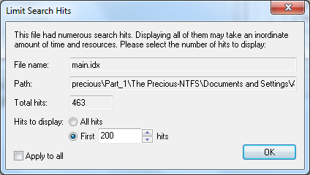

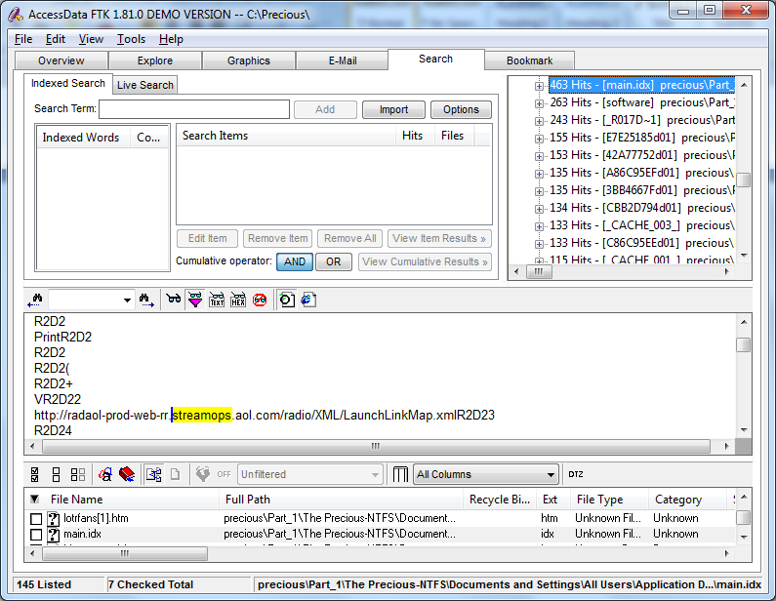

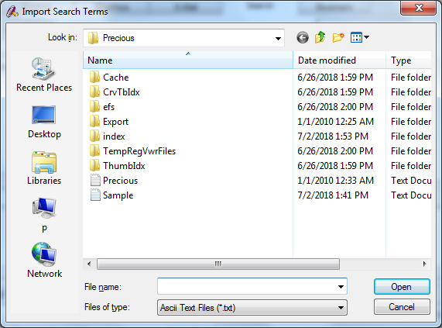

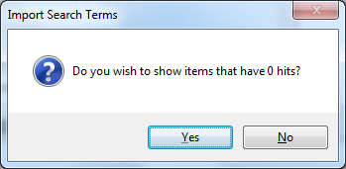

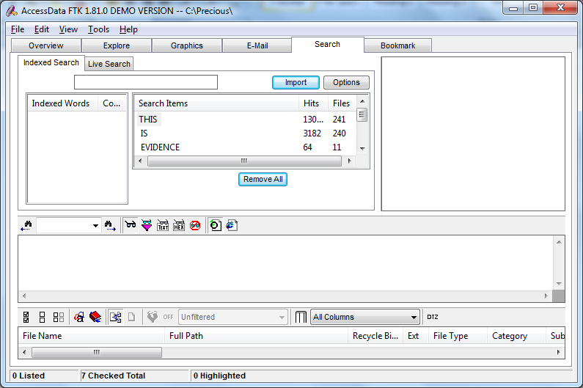

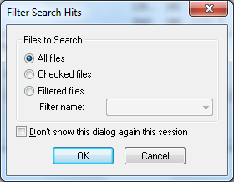

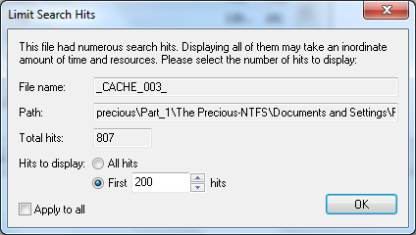

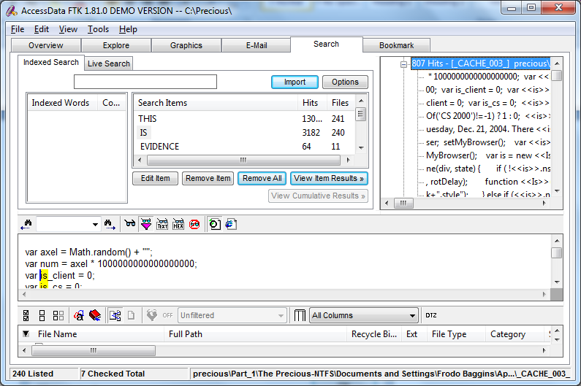

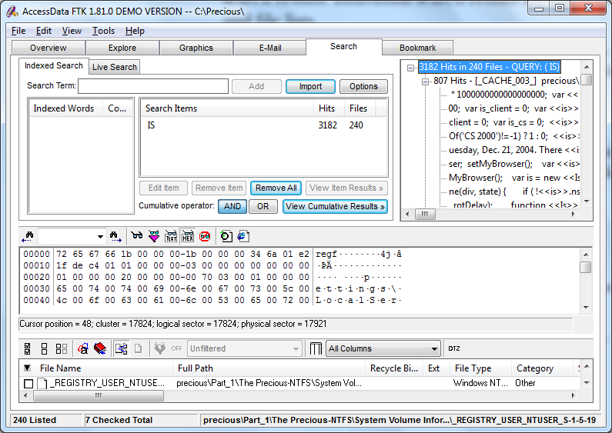

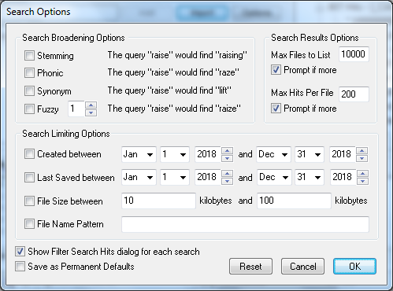

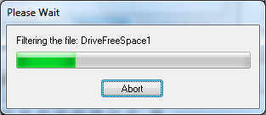

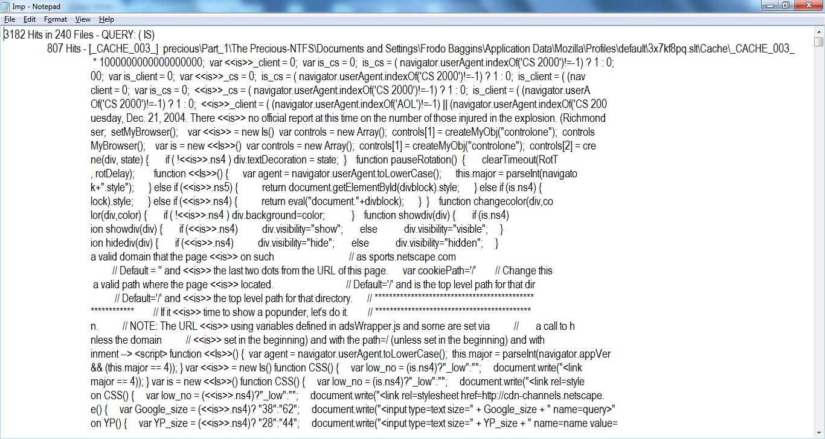

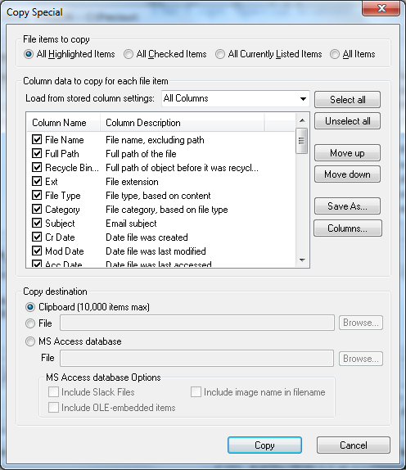

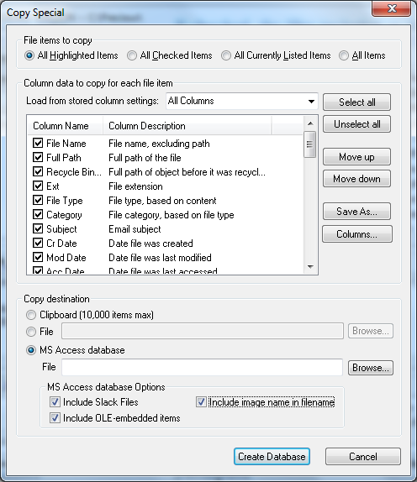

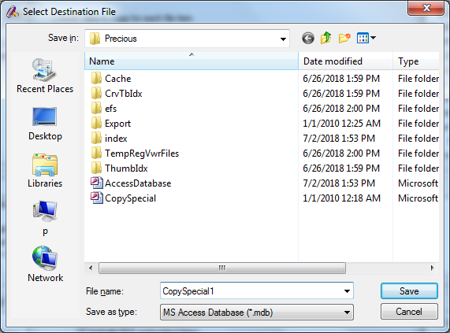

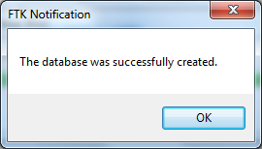

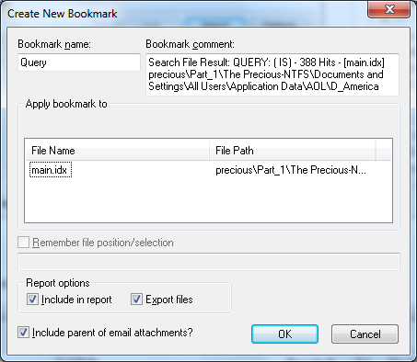

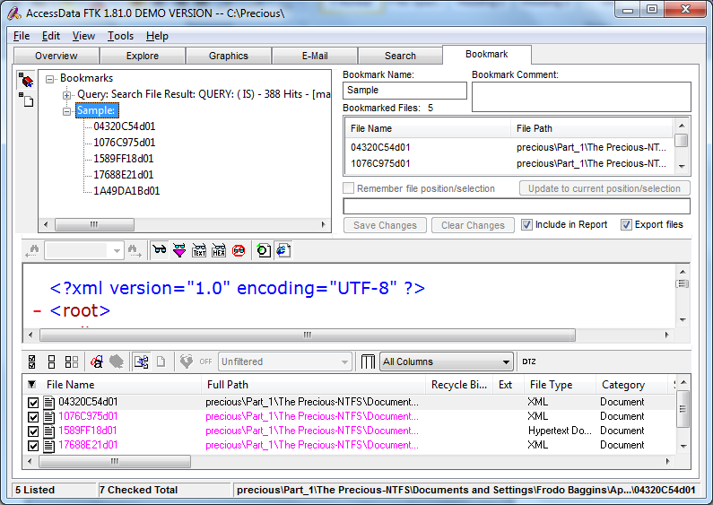

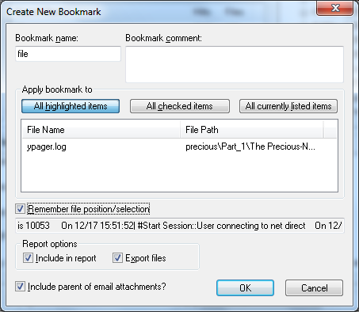

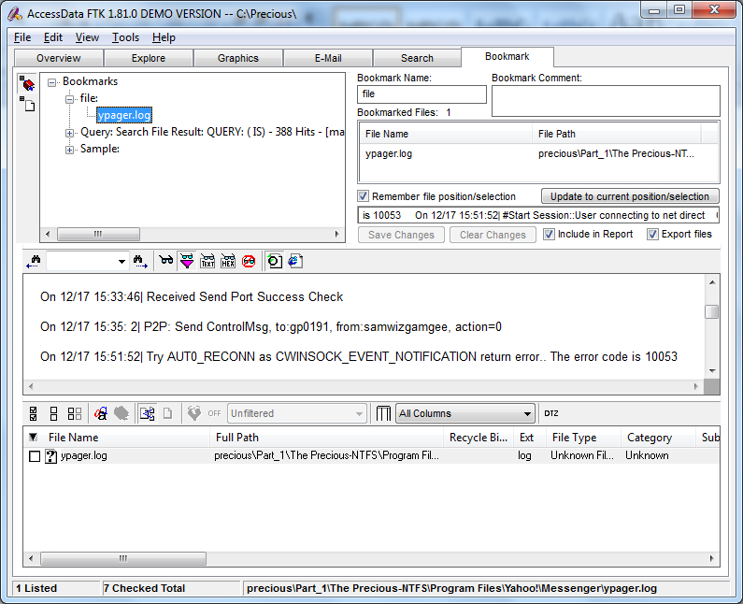

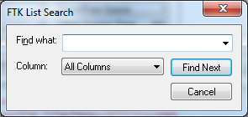

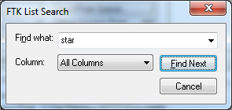

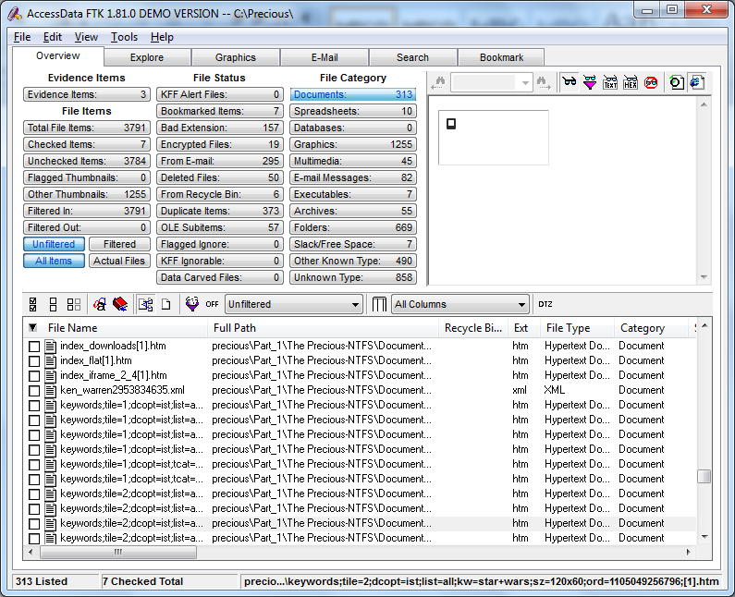

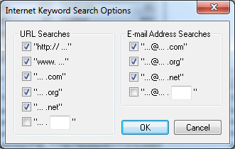

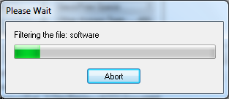

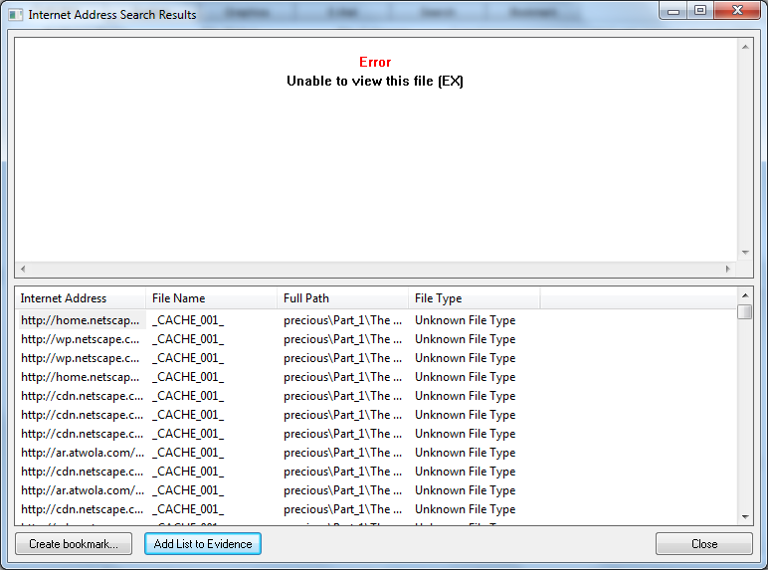

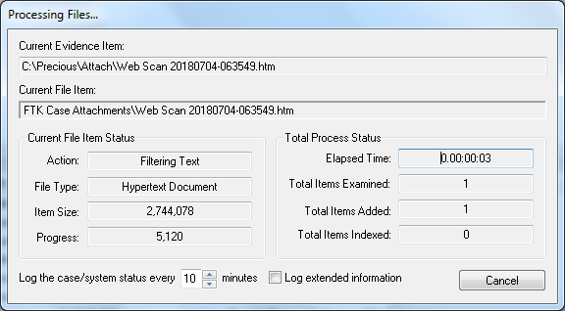

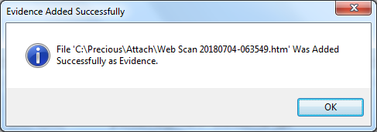

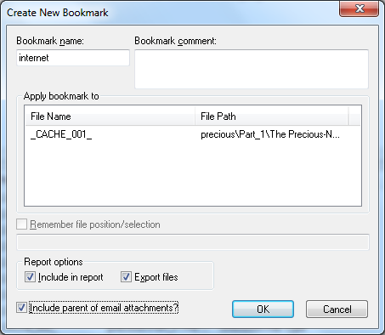

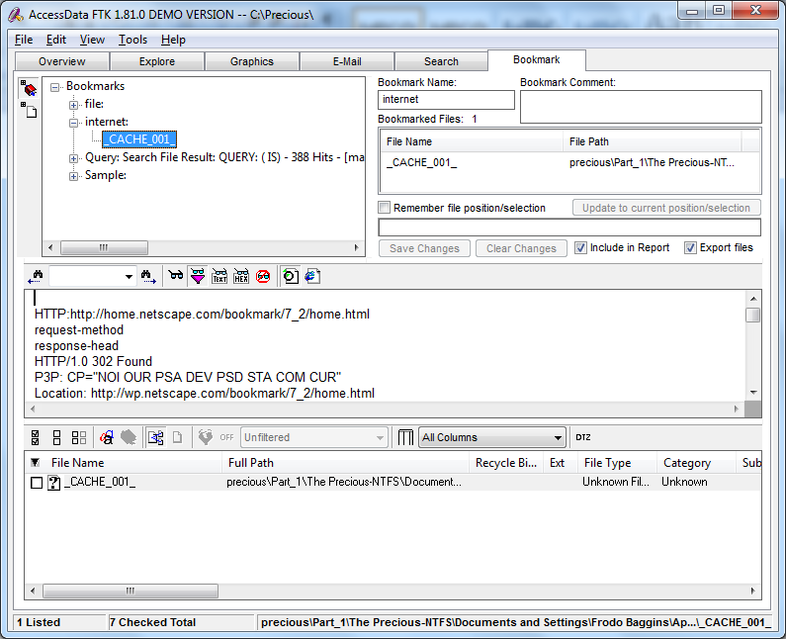

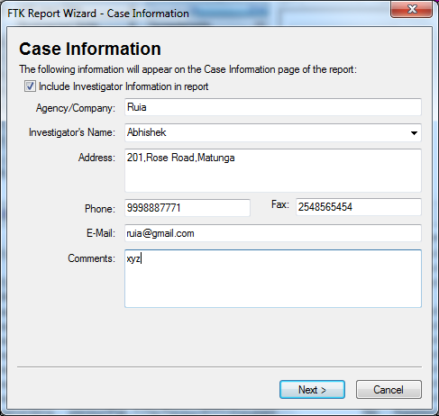

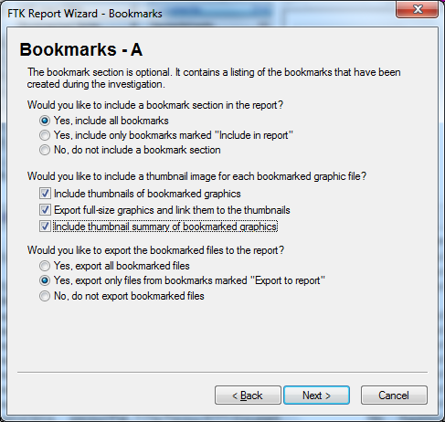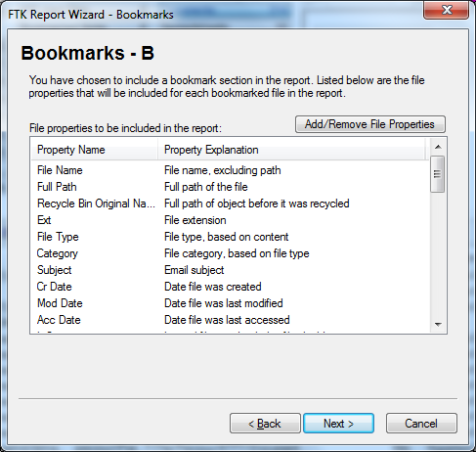

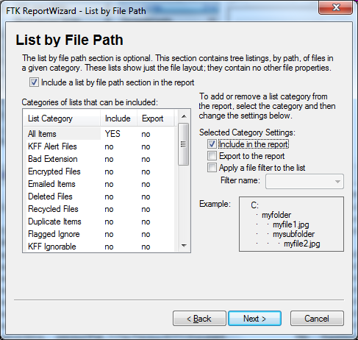

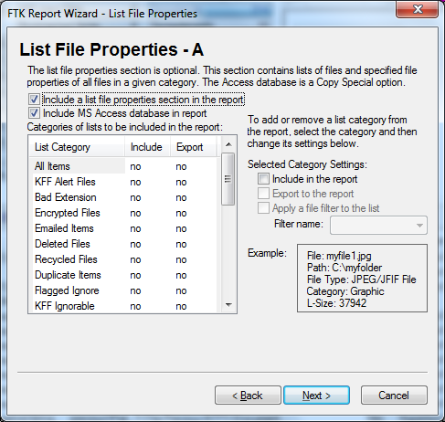

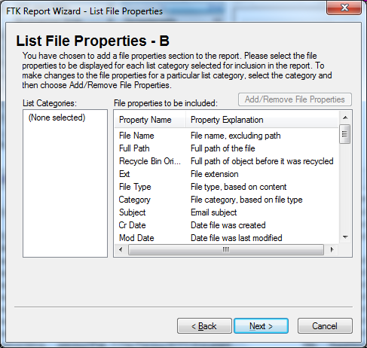

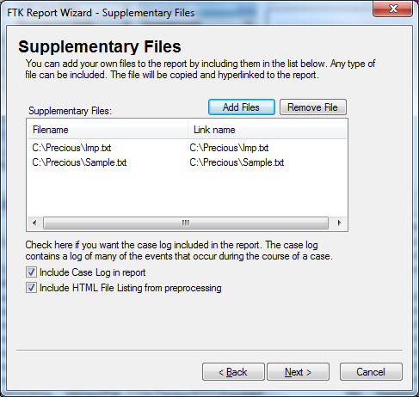

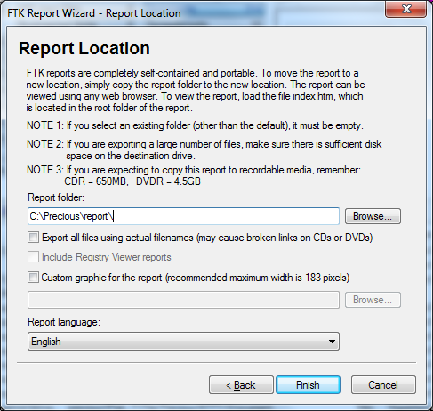

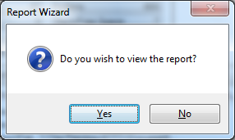

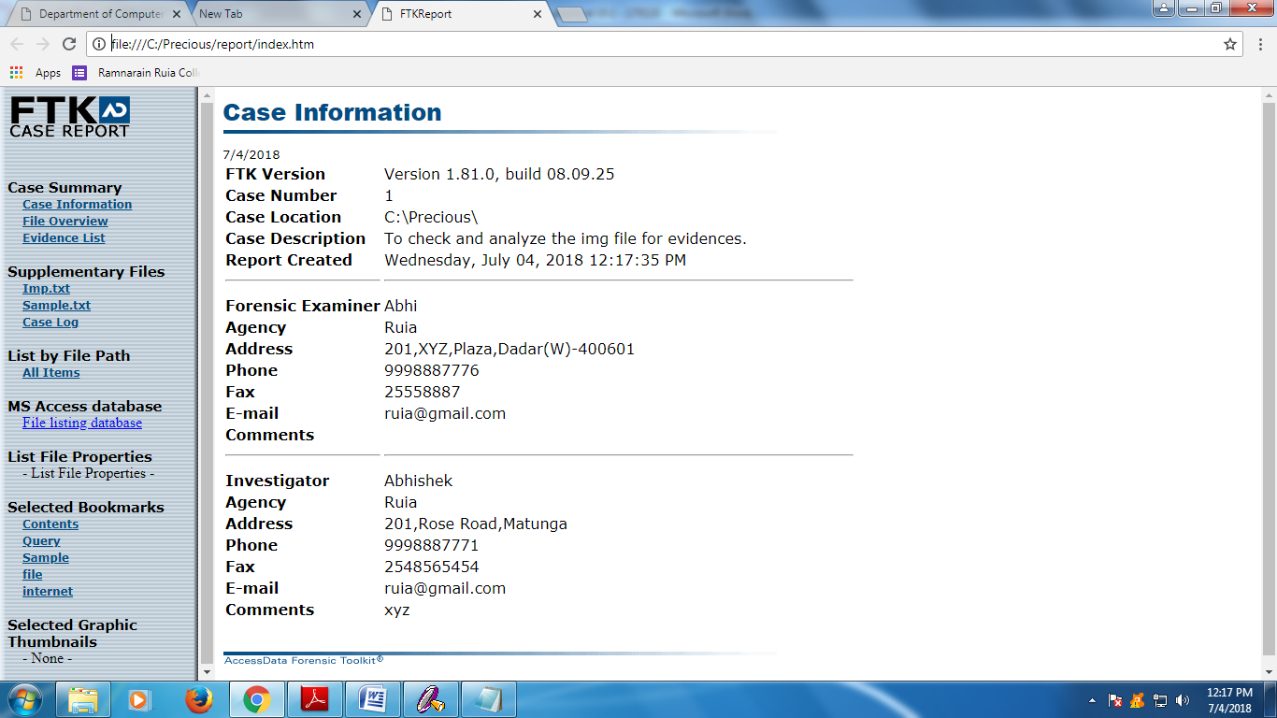

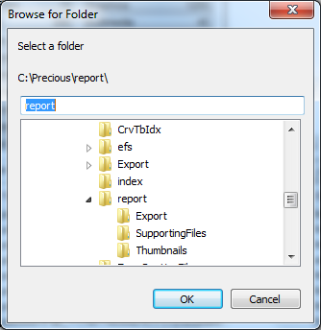

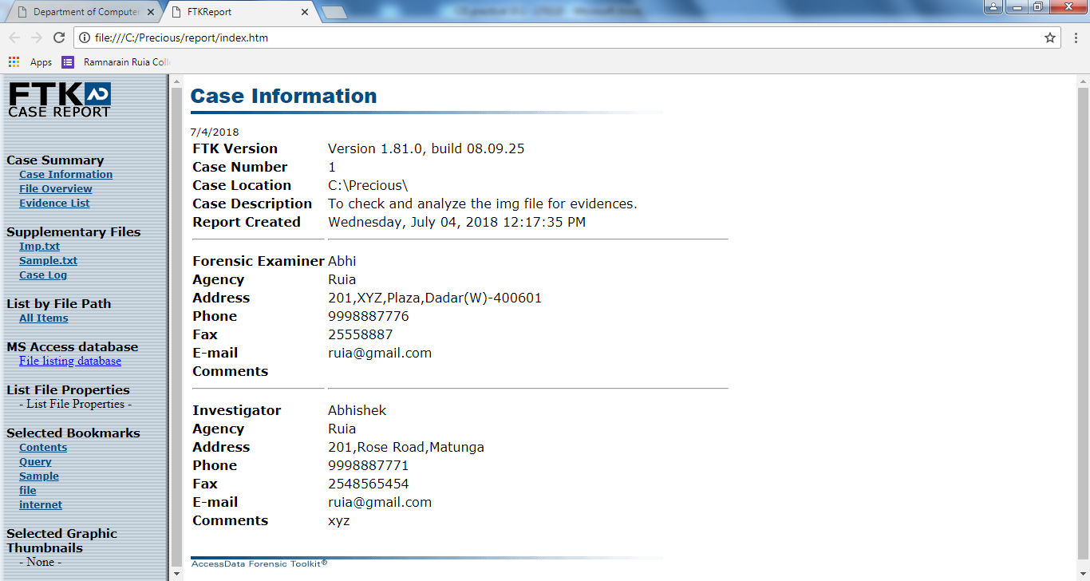

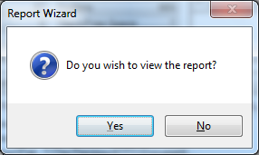

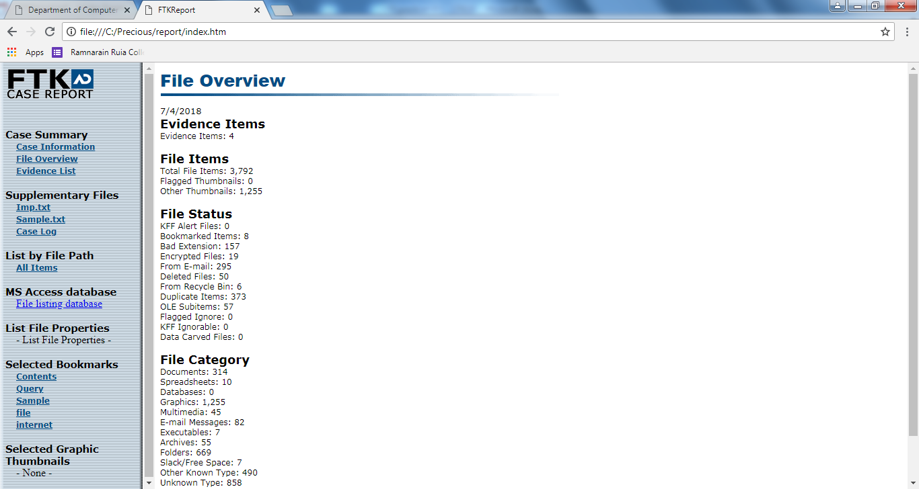

**Practical No.:9.b**

**Aim:** Practical to perform network forensic by wired network

**Code:**

**1)Inspect traffic for a specifc IP address.**

This will display all traffic for the IP entered, source or destination.

IP-: 192.168.2.197

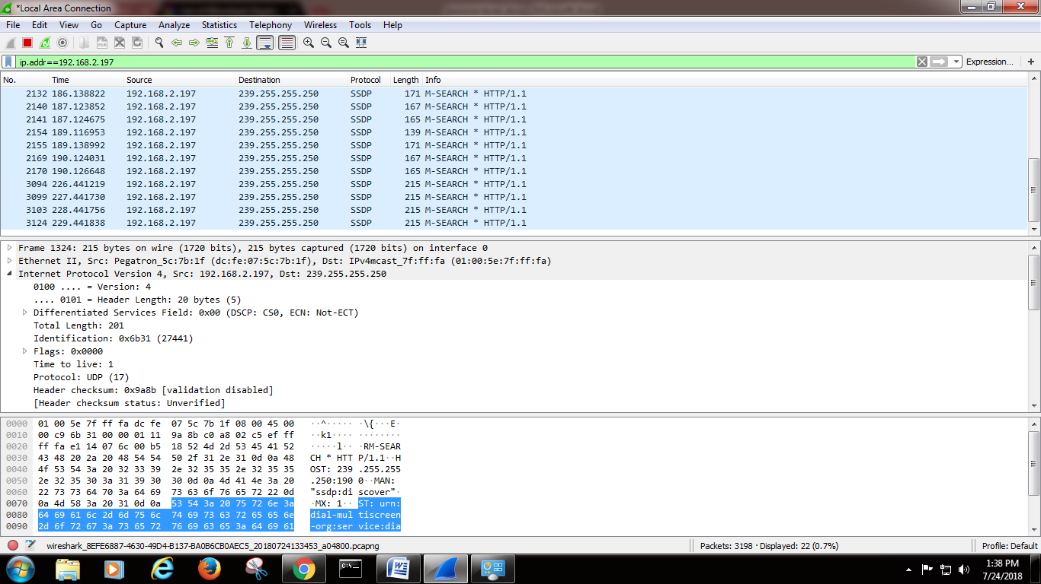

**2) Sniff the credentials details from the vulnerable website.**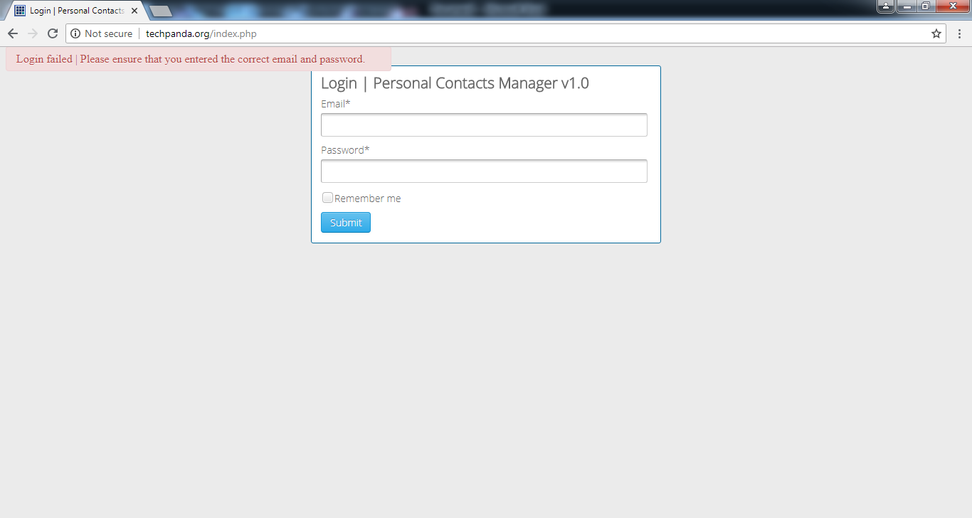

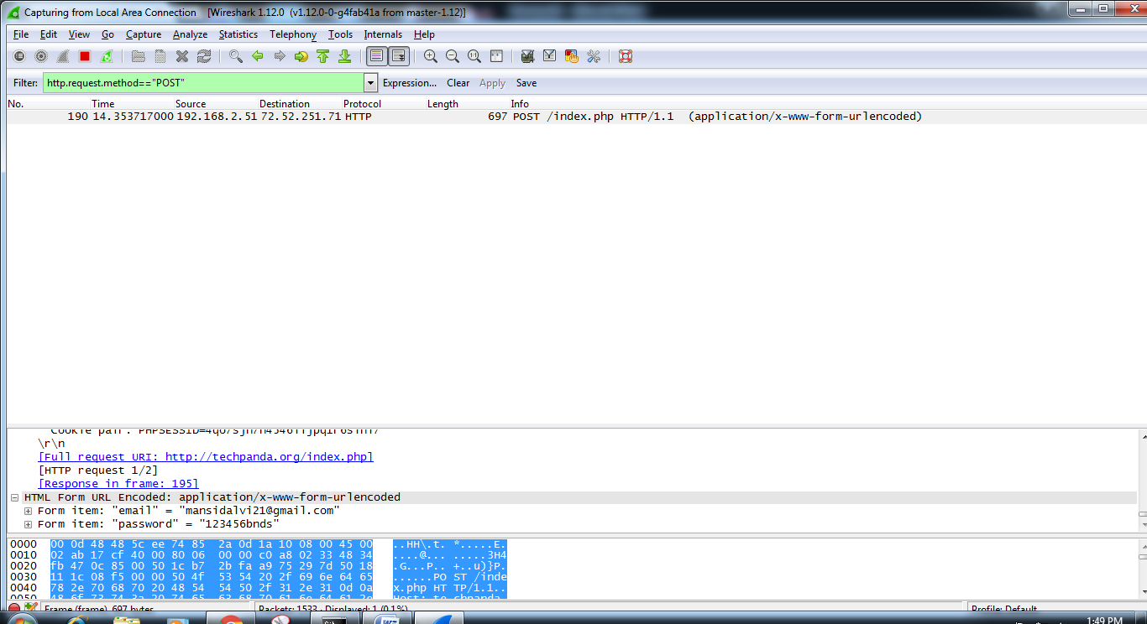

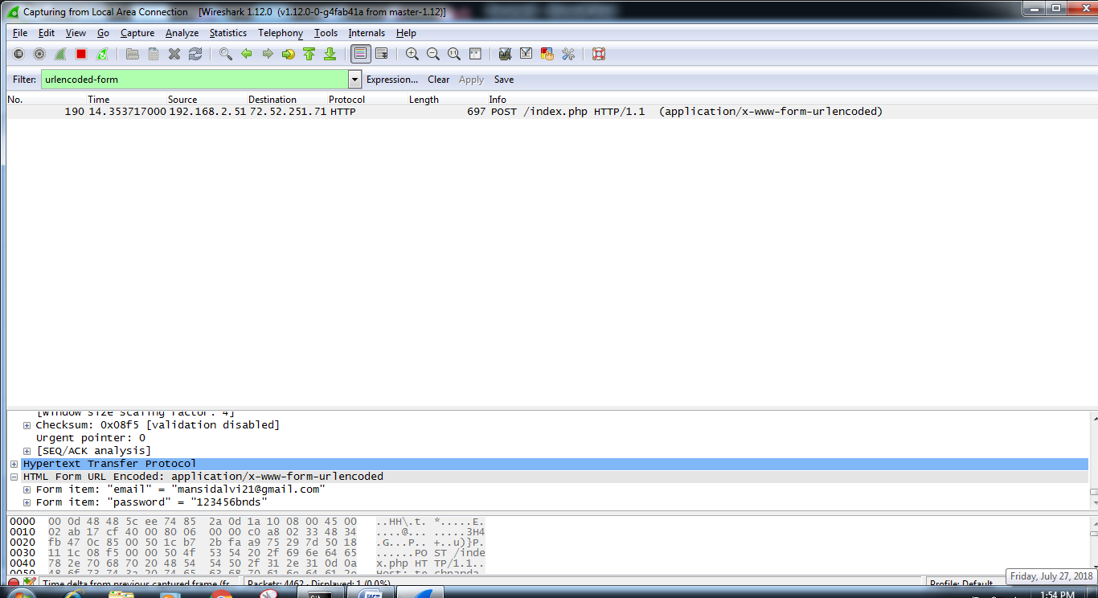

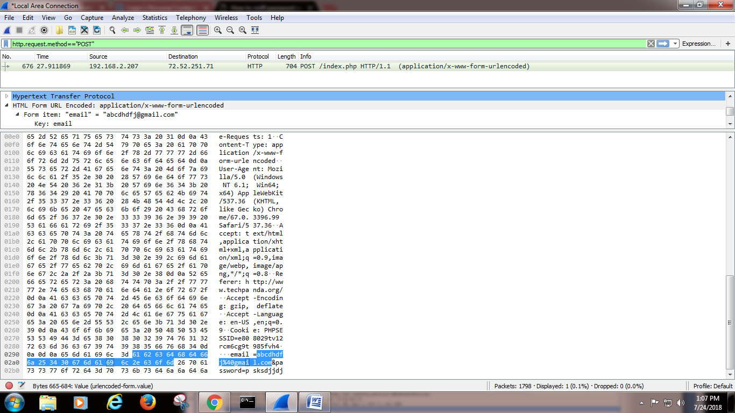

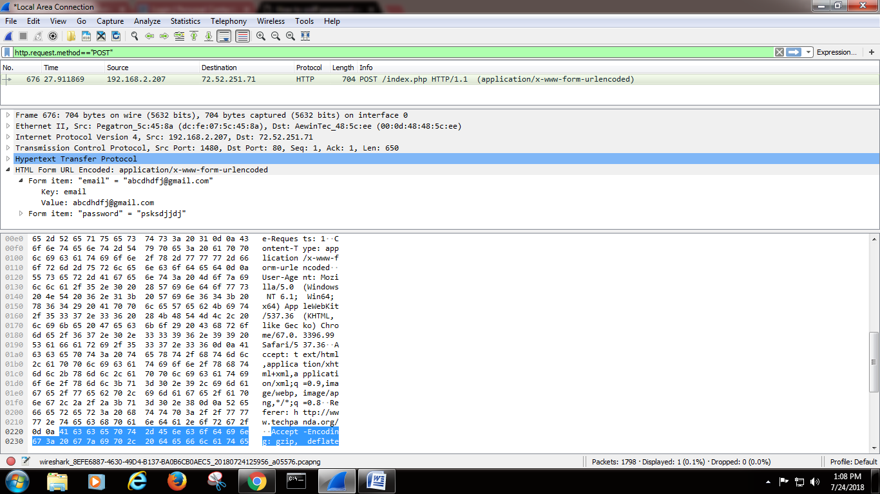

**3)For a Specific IP address search for a specific word in URL.**

Here we searched for mu.ac.in . So we searched "mu" in the filter.

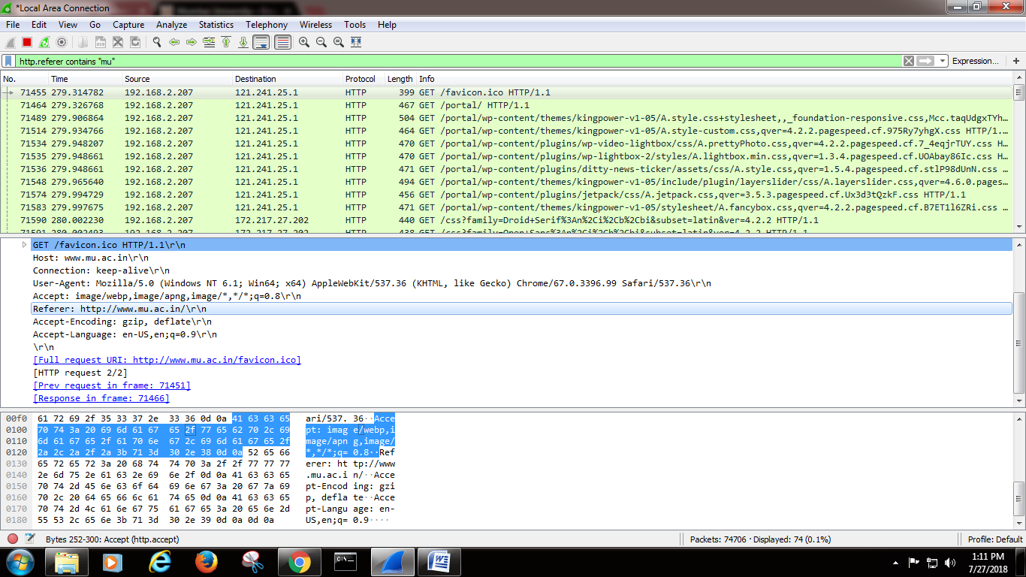

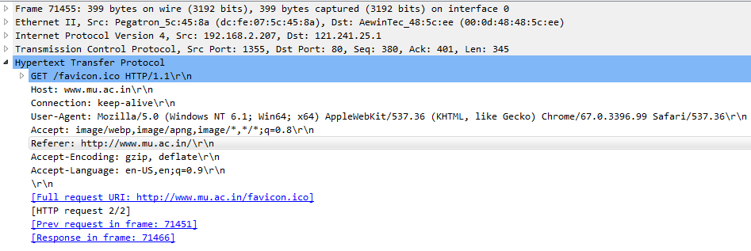

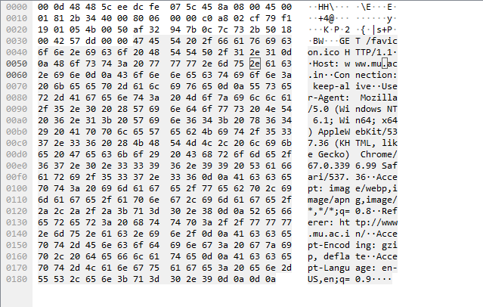

**4) Check what user has typed in browser in url**

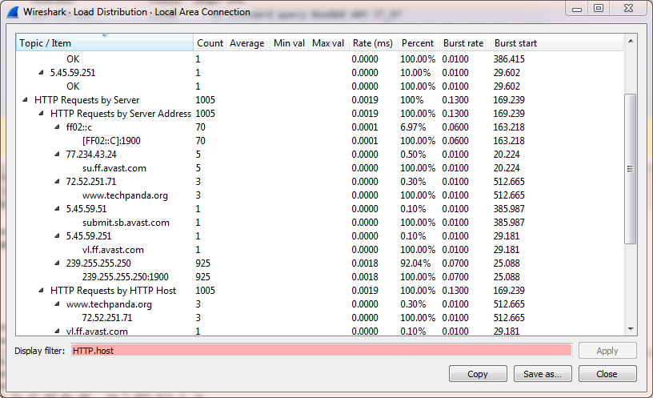

**5)Check what string user has passed in google search engine.**

Here the victim searched for "computer" keyword.... And so we got computer keyword in info tab.

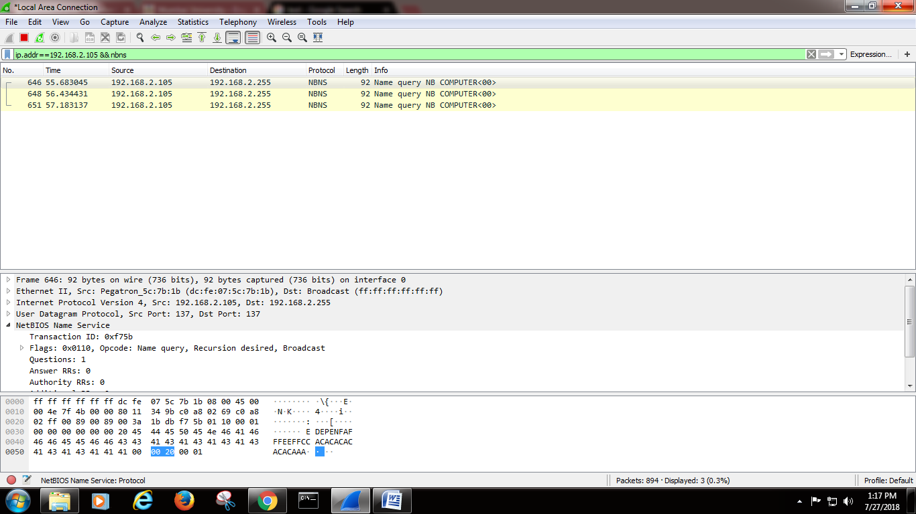

**6) Detect DOS attack.**

DOS attacks usually send a lot of traffic to the victim machine to consume its resources so that the legit users are not able to access the services. A very common traditional example is Ping flood as DOS attack.

**Ping flood**: Send a huge amount of Ping packets with packet size as big as possible. In windows you can specify the data/buffer size too. The command is [ping -l](https://technet.microsoft.com/en-in/library/cc737478%28v=ws.10%29.aspx). The attacker will use the maximum value.

Detection: The normal ping packet has default packet size of 32 bytes in case of Windows. So if you see a lot of Ping packets with unusual size of buffer for eg: like 4000 then you could say it could be a Ping flood. You can use PING command to simulate this attack. In wireshark create a filter for ICMP Echo packets and check the buffer size.

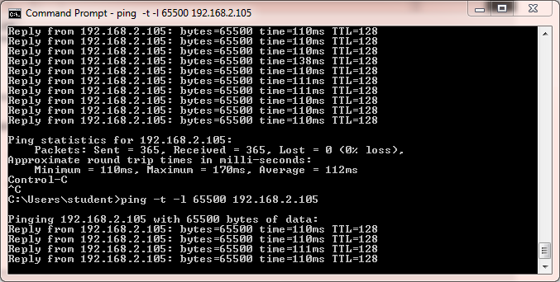

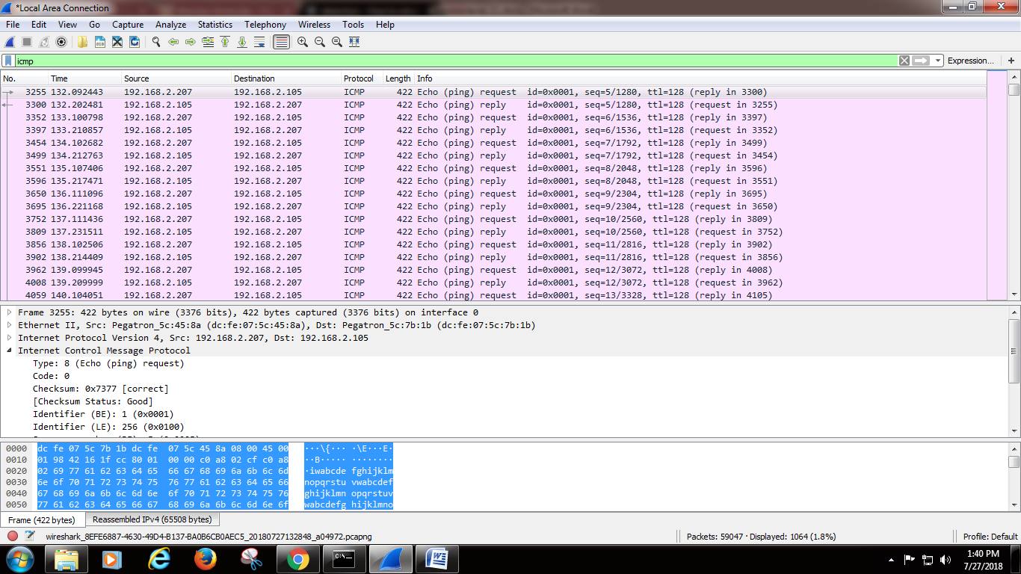

**Source**

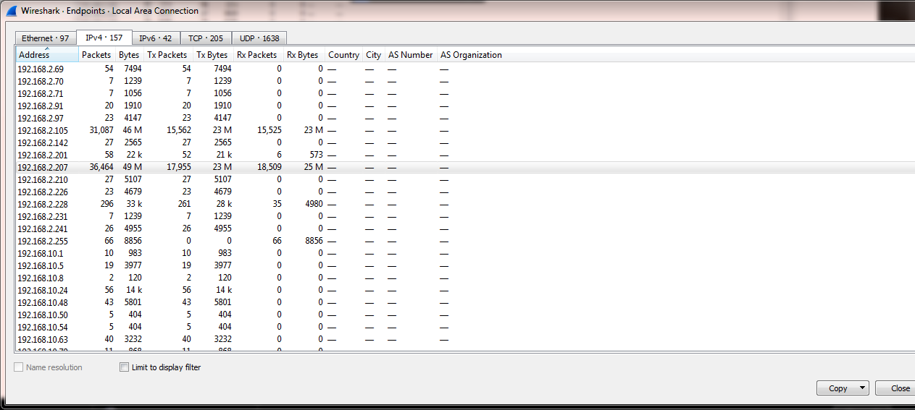

**Destination**

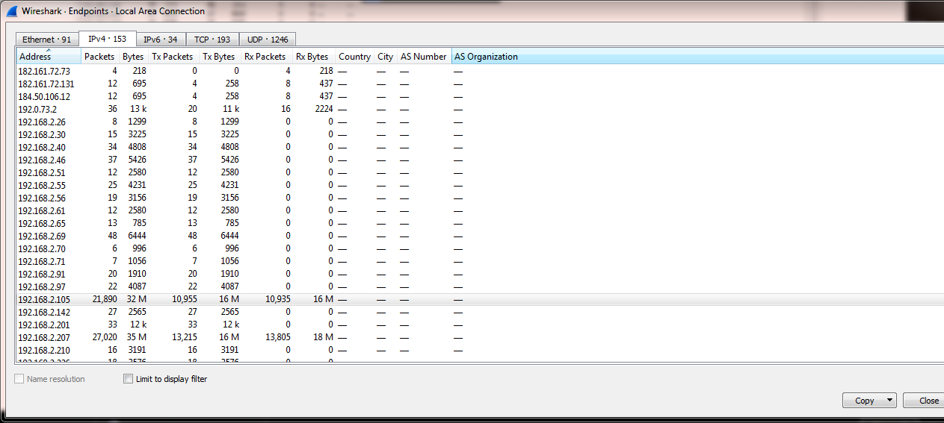

**7) Find out packets which are getting the response as PAGE NOT FOUND.**

Here we got page not found type website-: trafficindia.com/india.htm and detected in wireshark.

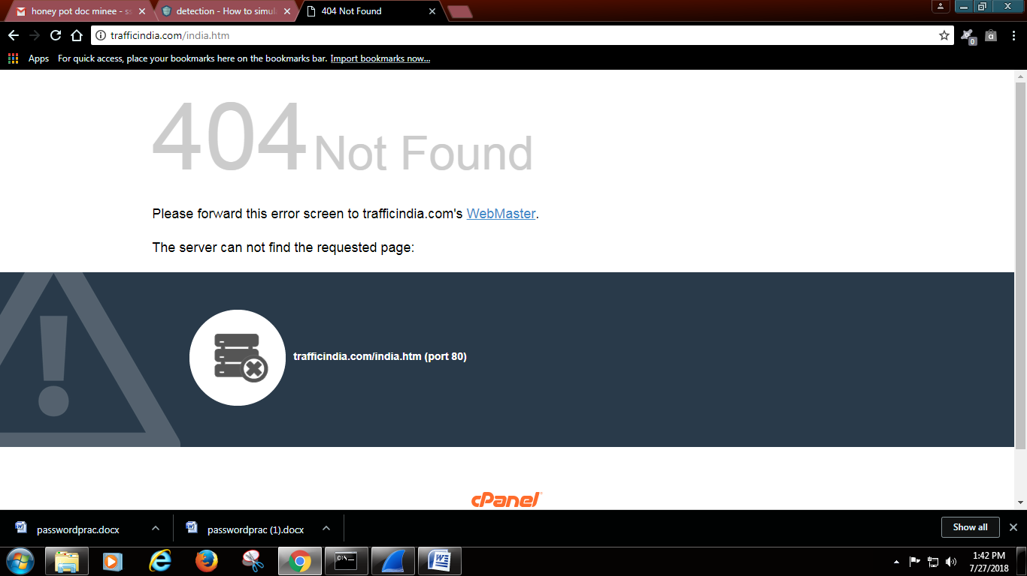

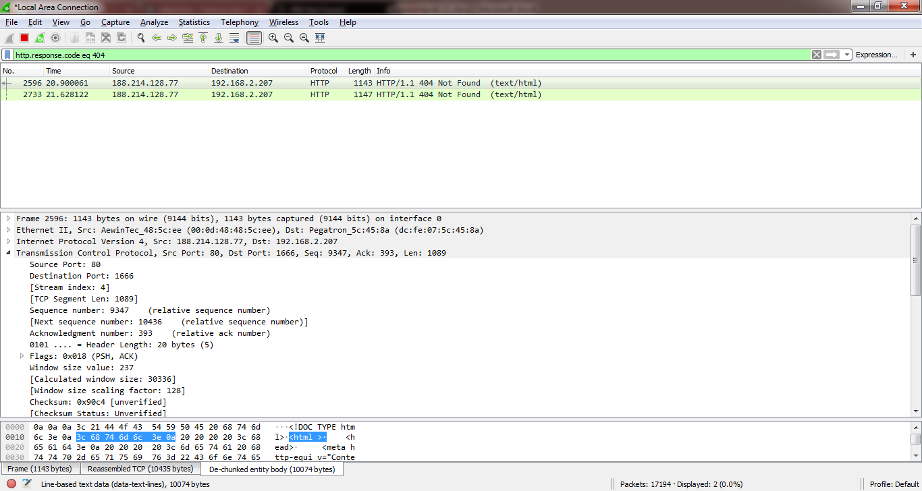

**8) Find out those packets which are getting response.**

Here we searched for mu.ac.in. We got response. And detected it in Wireshark.

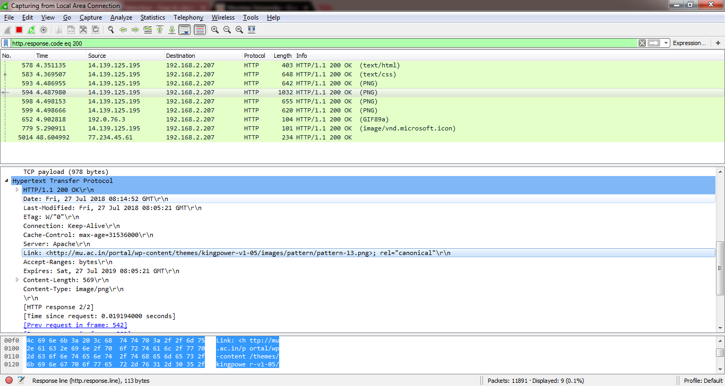

**9)Find packets according to their length.**

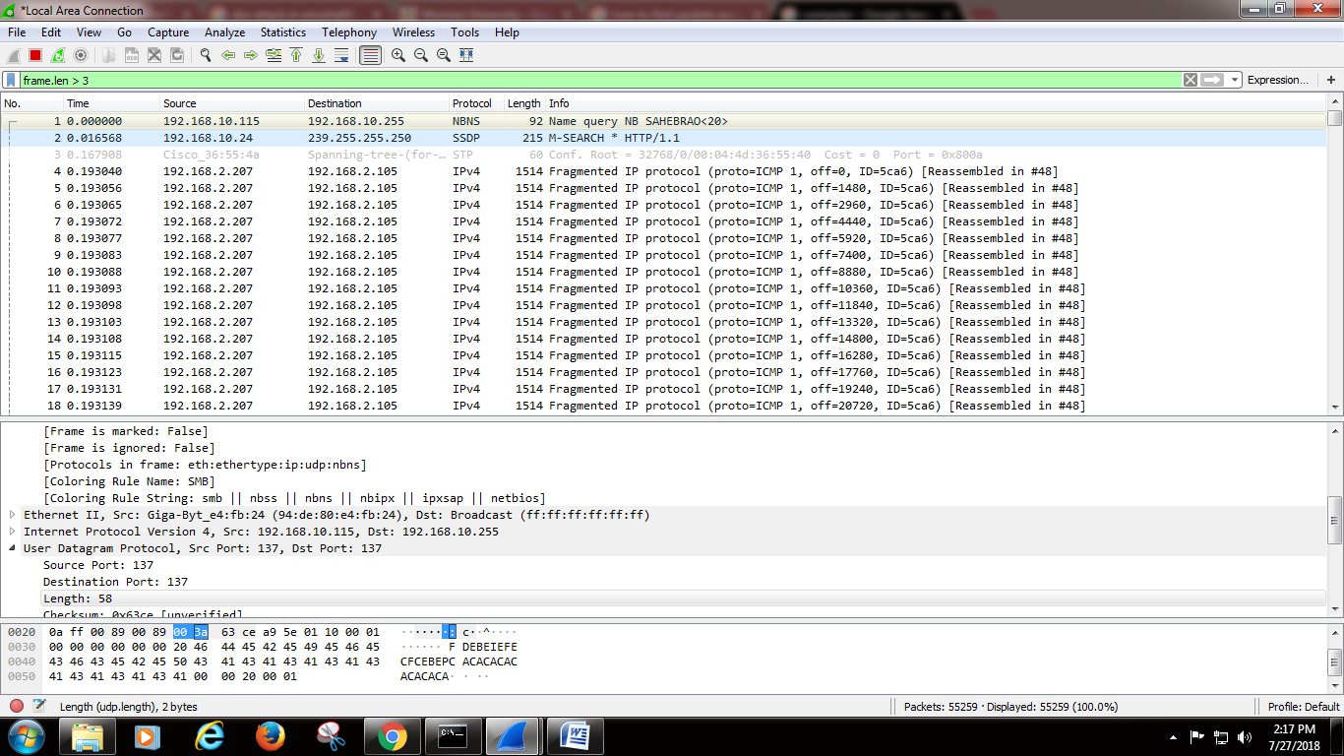

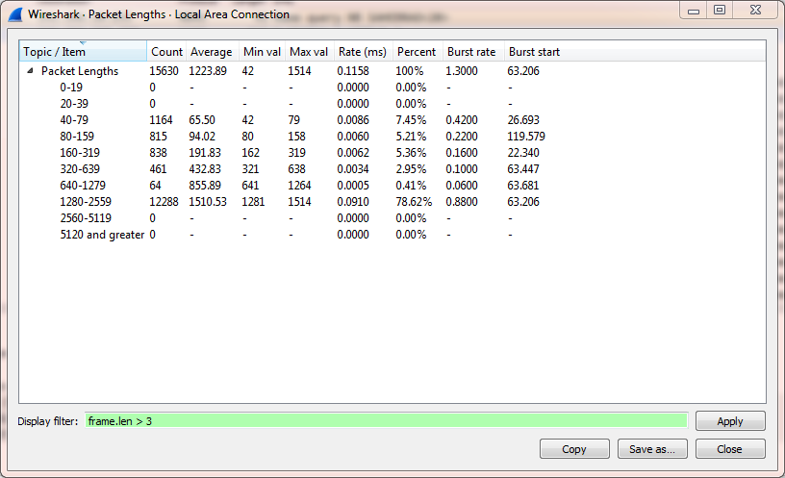

**10) Find Packets-: Browser Specific.**

Its a good idea to understand what user agents are being used on your network, malicious traffic can often use unusual agent strings. To search for a user agent use this filter

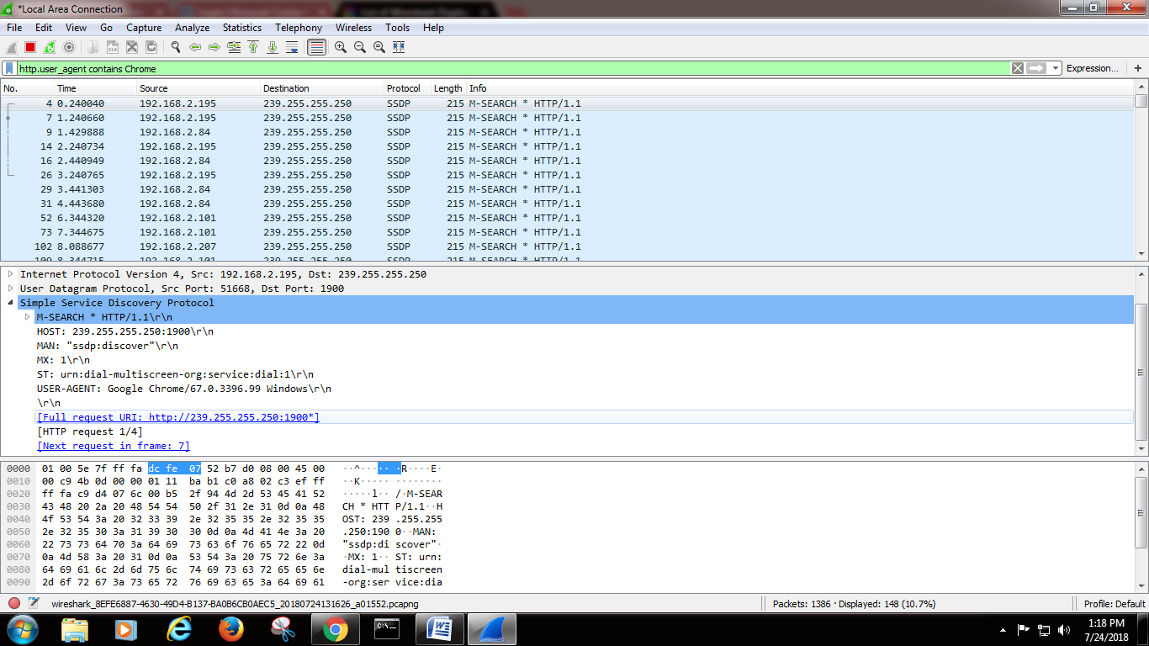

**11)Inspect traffic between specific source and destination**

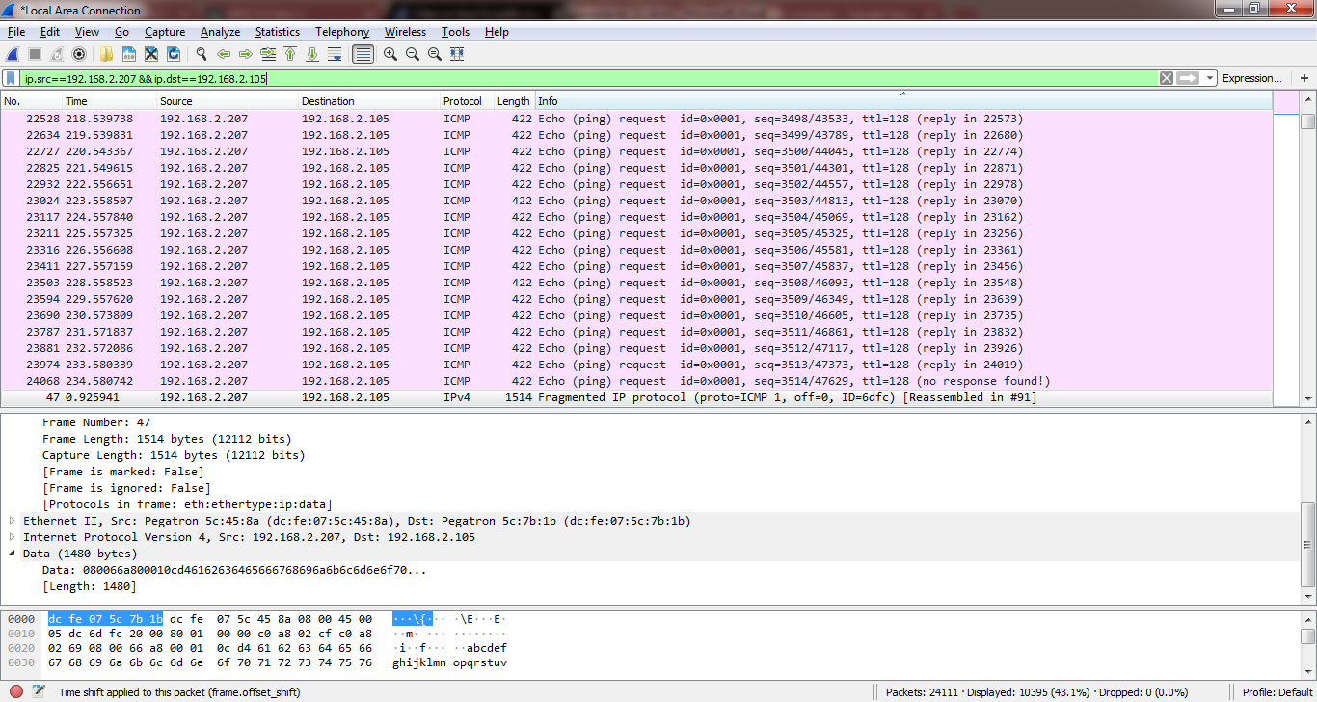

Source 192.168.2.207 and destination 192.168.2.105

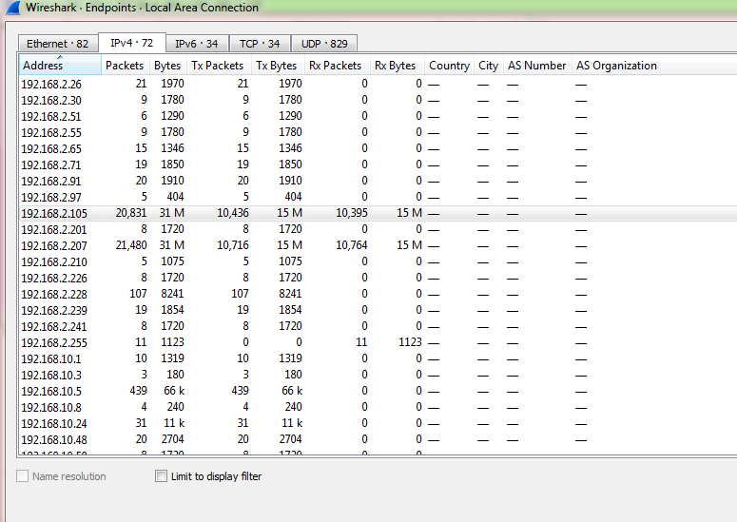

**12) Find out packet having good checksum value.  
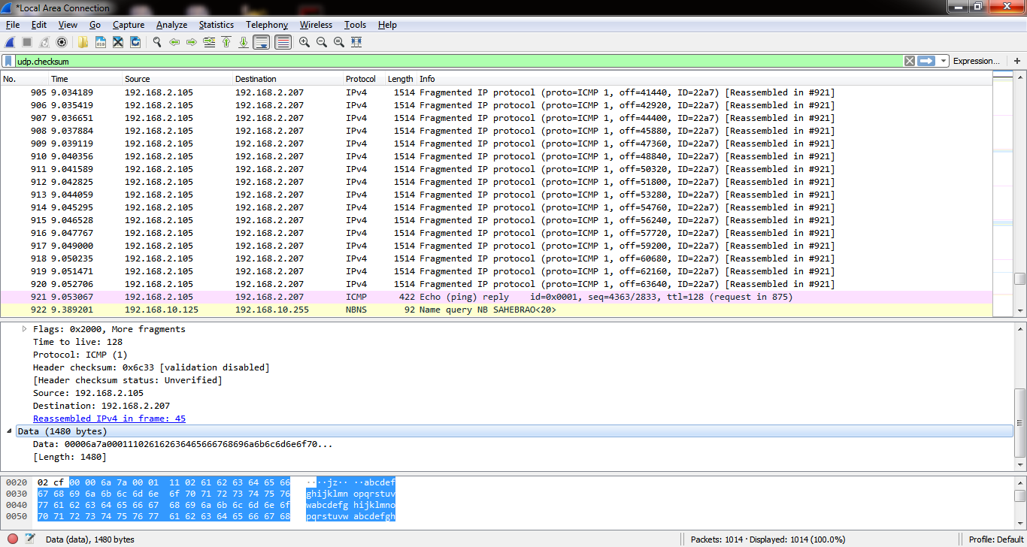**

**13) To sniff communication between client and server**

**Java code for TcpClient.java**

import java.net.*;

import java.io.*;

public class TcpClient

{

public staatic void main(Strin args[]) throws Exception

{

System.out.println("CLIENT");

byte b[]=new byte[1000];

Socket s1=new Siocket("IT_101",9000);

System.out.println("Server Found");

InputStream is=s1.getInputStream();

BufferedReader br=new BufferedReader(new InputStreamReader(is));

System.out.println(br.readLine());

OutputStream os=s1.getOutputStream();

System.in.read(b,0,1000);

os.write(b);

}

}

**Java code for TcpServer.java**

import java.io.*;

import java.net.*;

public class TcpServer

{

public static void main(String args[]) throws Exception

{

OutputStream os;

System.out.println("SERVER");

ServerSocket ss = new ServerSocket(9000);

Socket s1=ss.accept();

os=s1.getOutputStream();

byte b[]=new byte[1000];

System.out.println("Client Connected");

System.out.println("Enter your message");

System.in.read(b,0,b.length);

os.write(b);

InputStream is=s1.getInputStream();

BufferedReader br=new BufferedReader(new InputStreamReader(is));

System.out.println(br.readLine());

}

}

**Compiling and running the java server code on server machine**

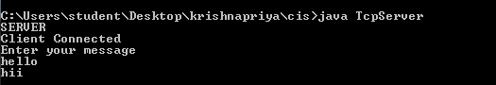

**Compiling and running the java server code on client machine**

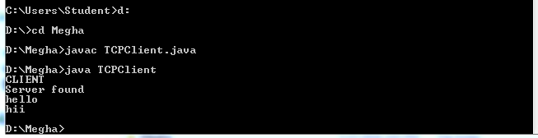

**Open Wireshark**

In Filter tcp.stream eq 1

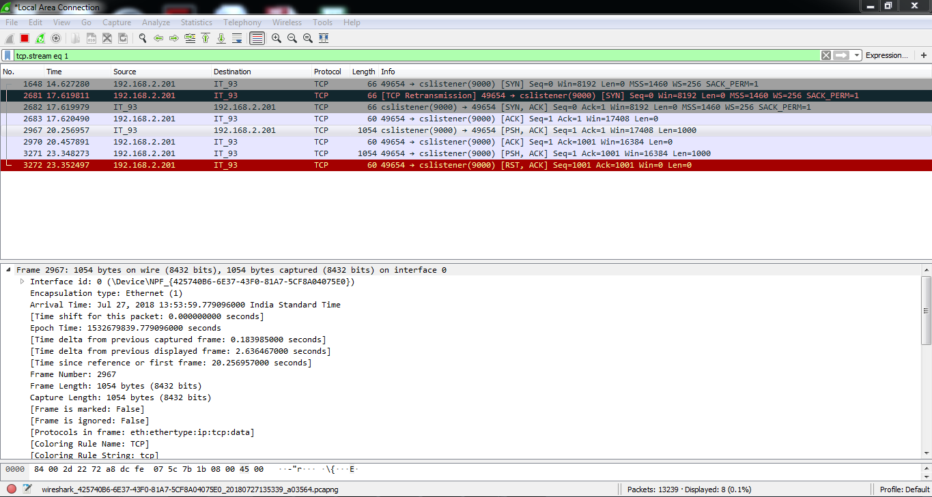

Select ip address 192.168.2.201 and right click,select follow-Tcp Stream

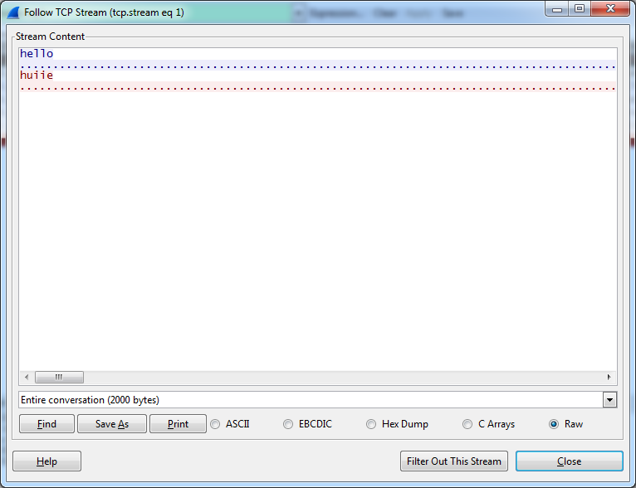

**Practical No.:9.c**

**Aim:** Practical to perform mobile device forensic(Innovative Practical)

**Software:** Magnet Axiom

**Code:**

1. Enter Case Details

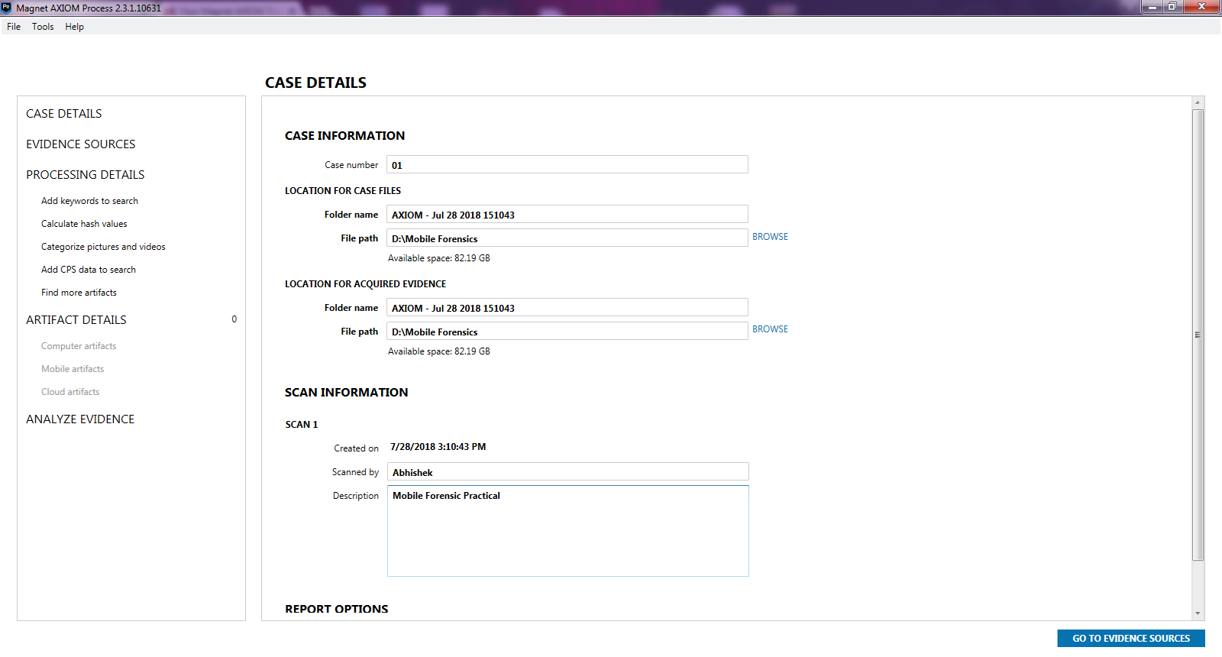

1. Acquire Evidence

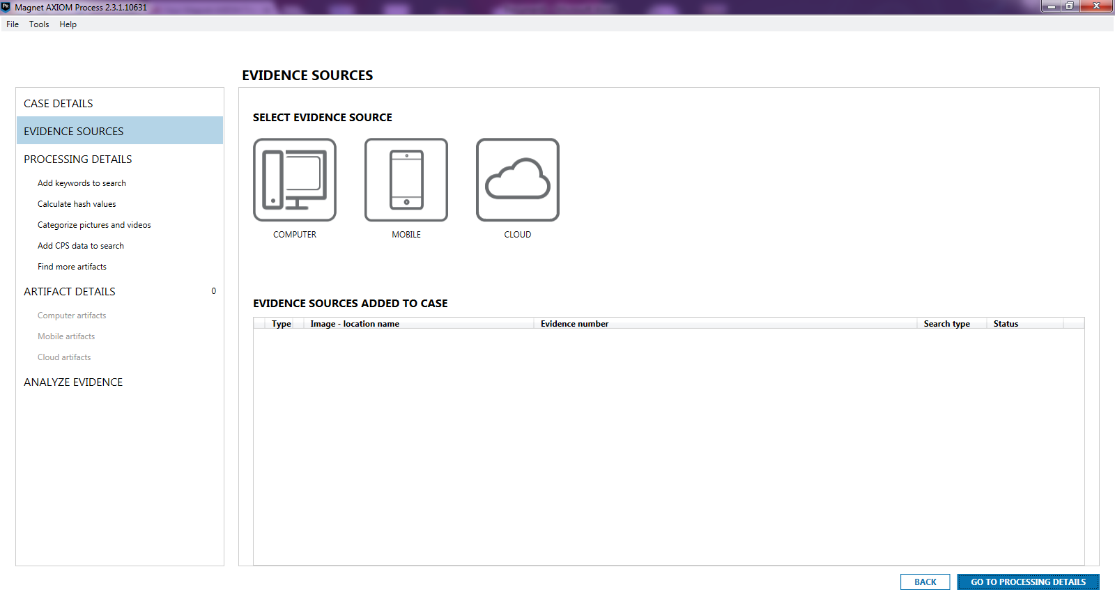

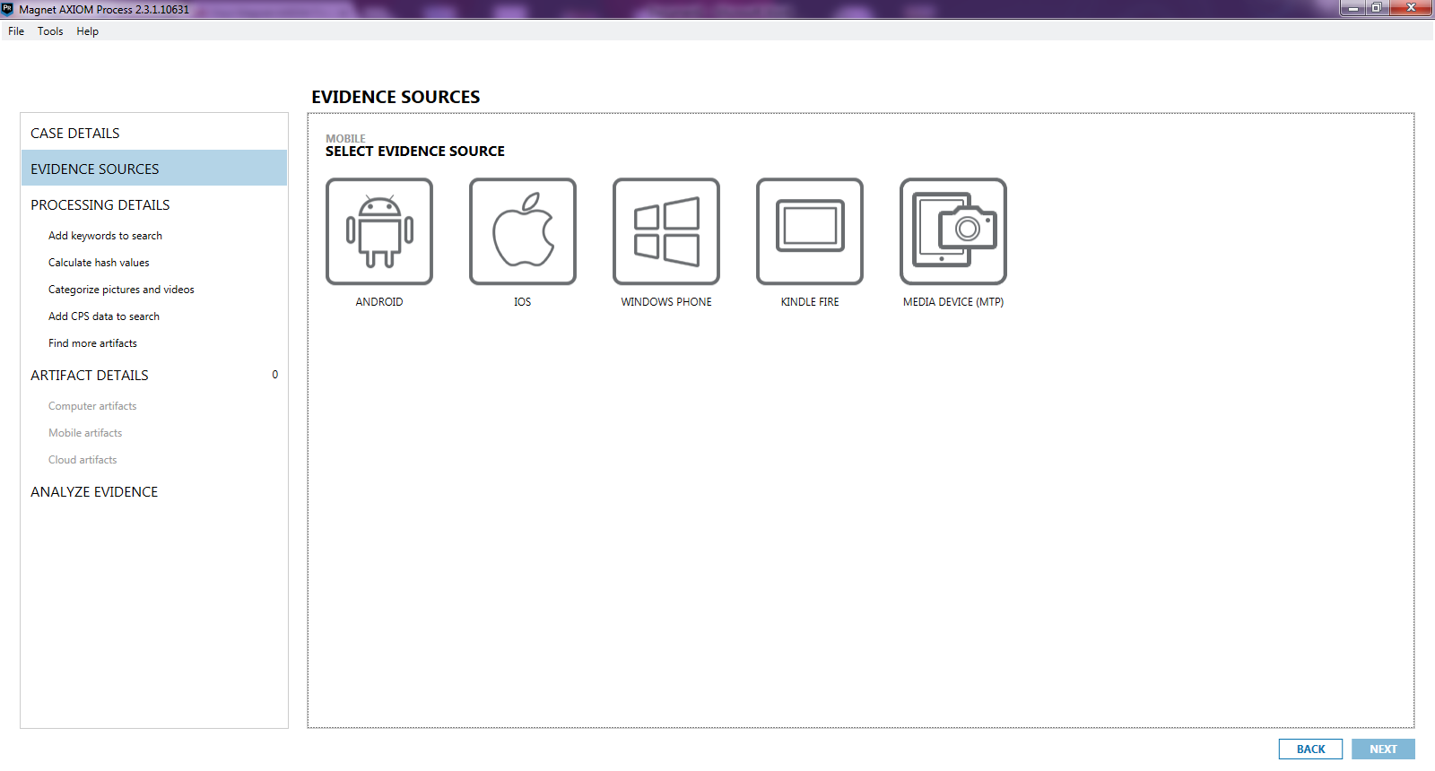

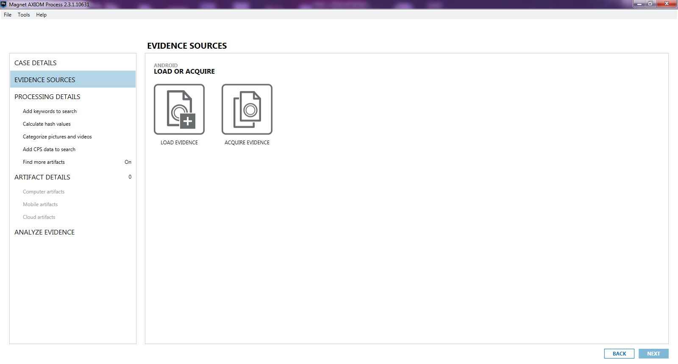

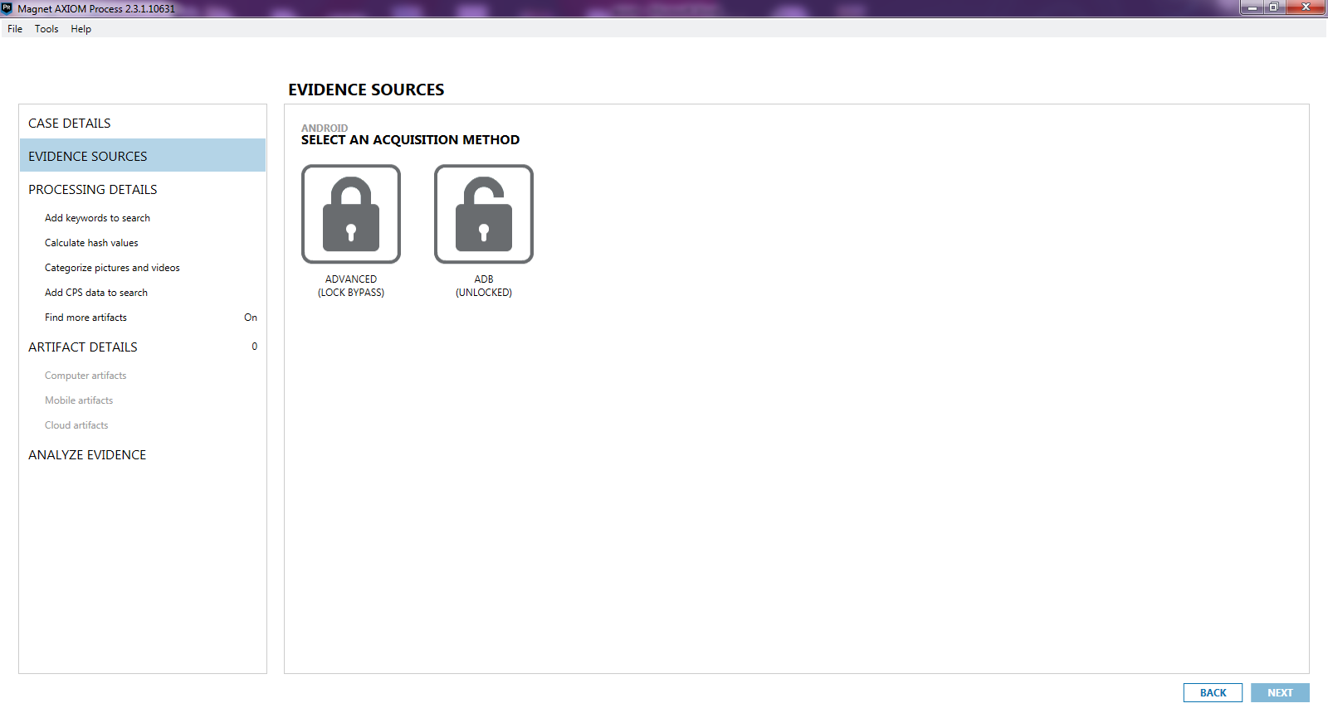

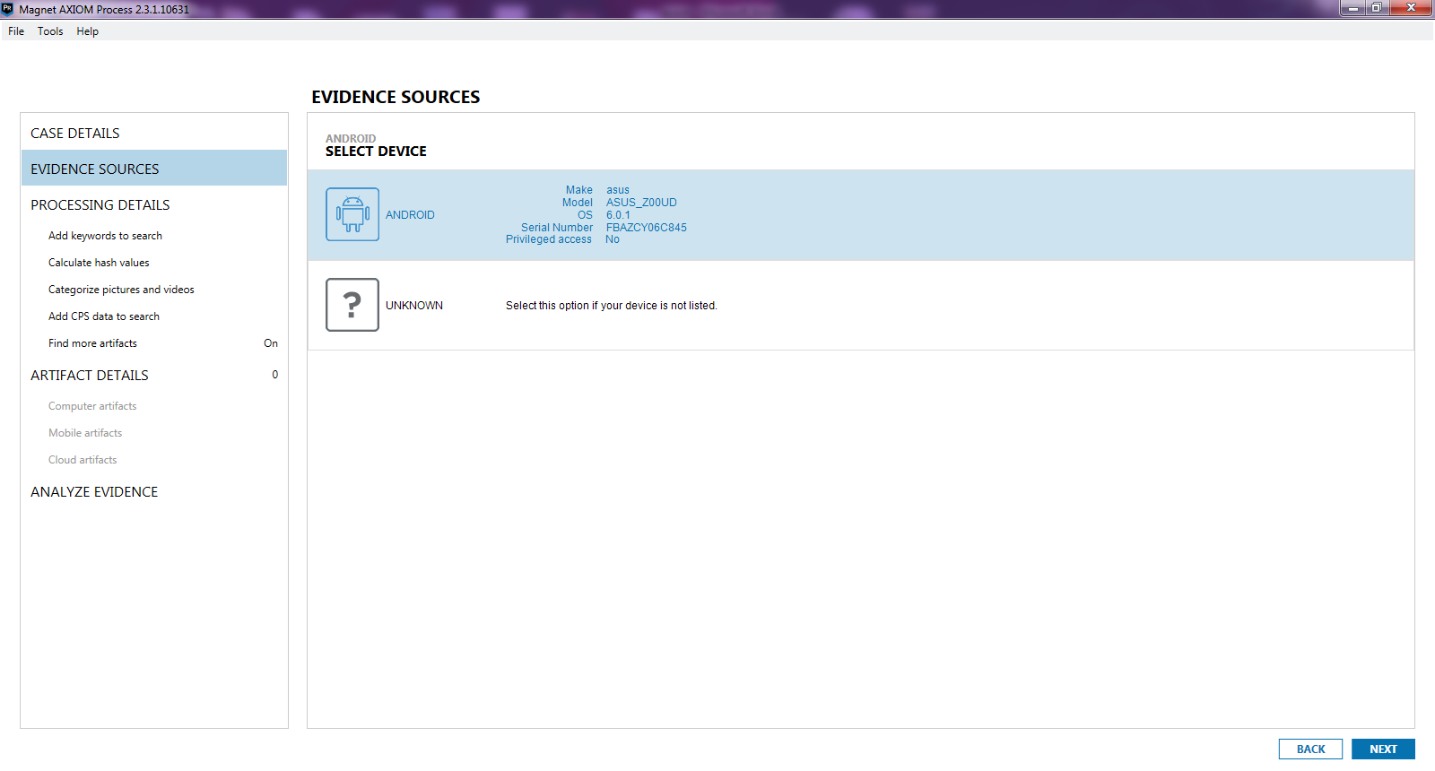

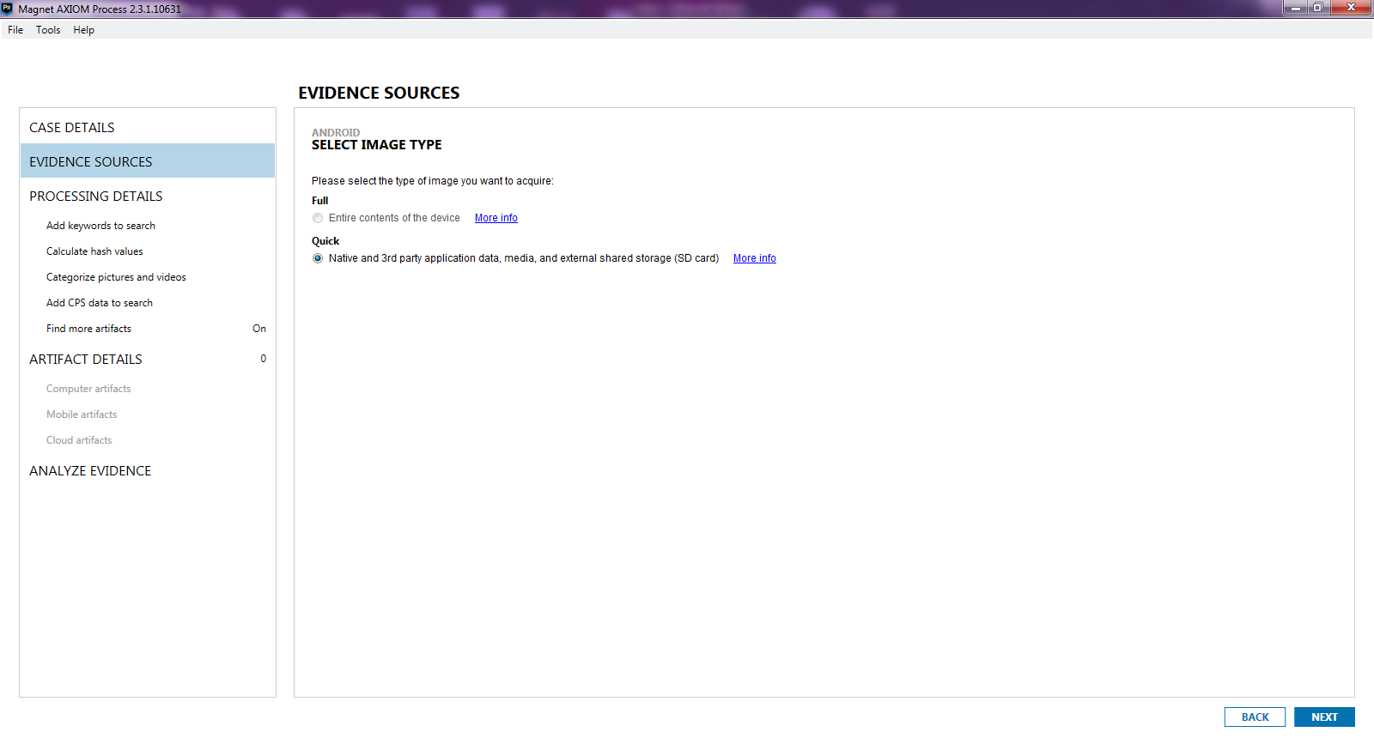

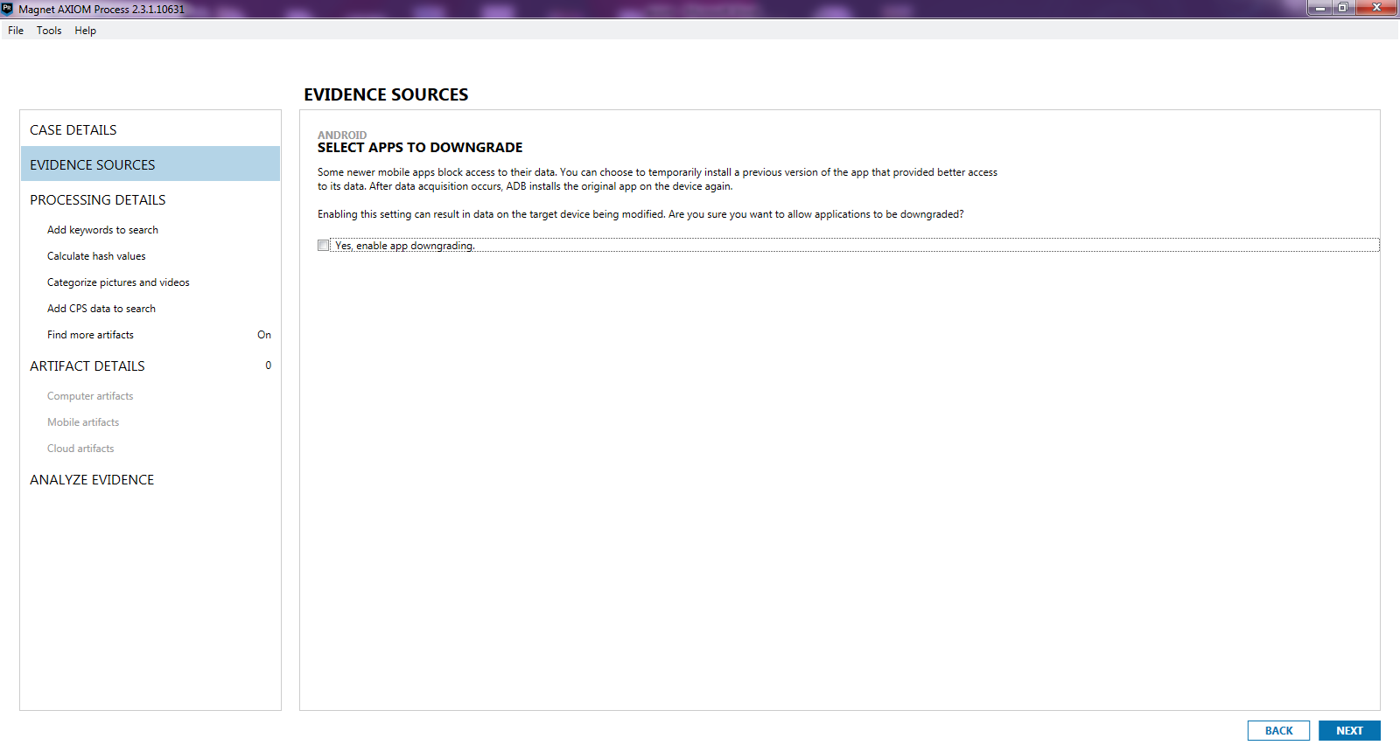

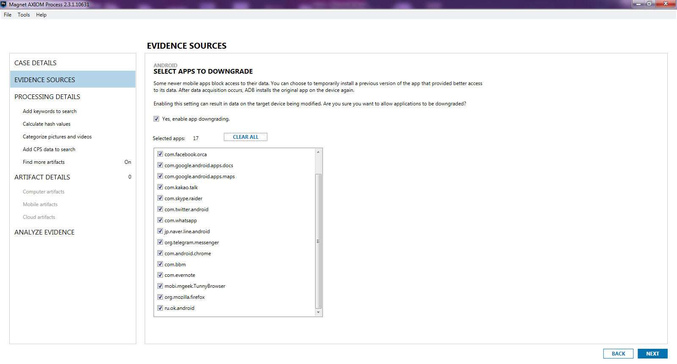

1. Load Evidence

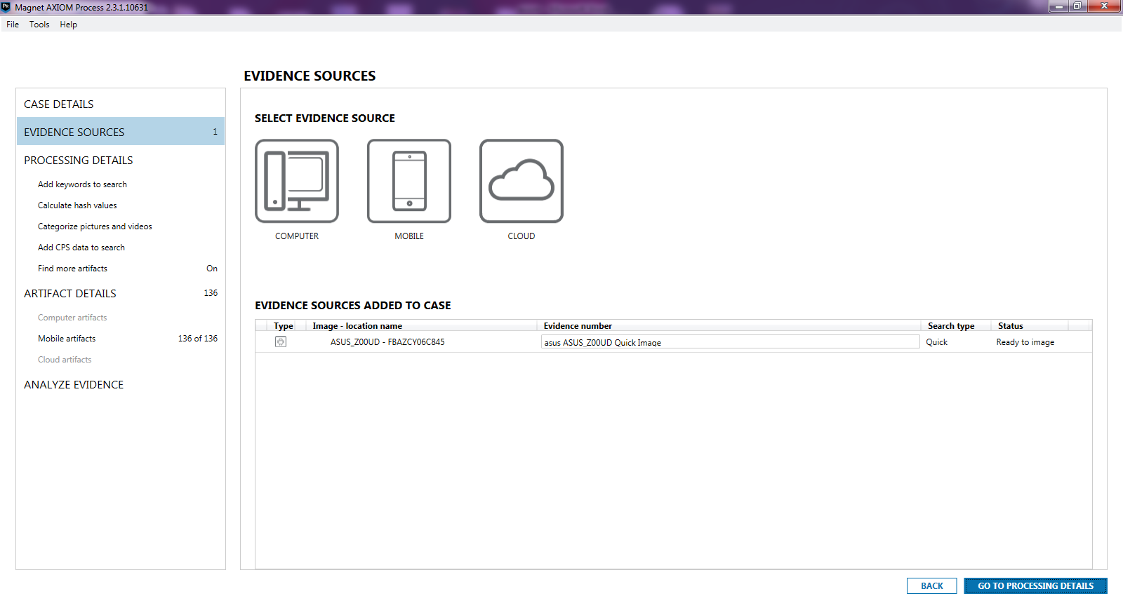

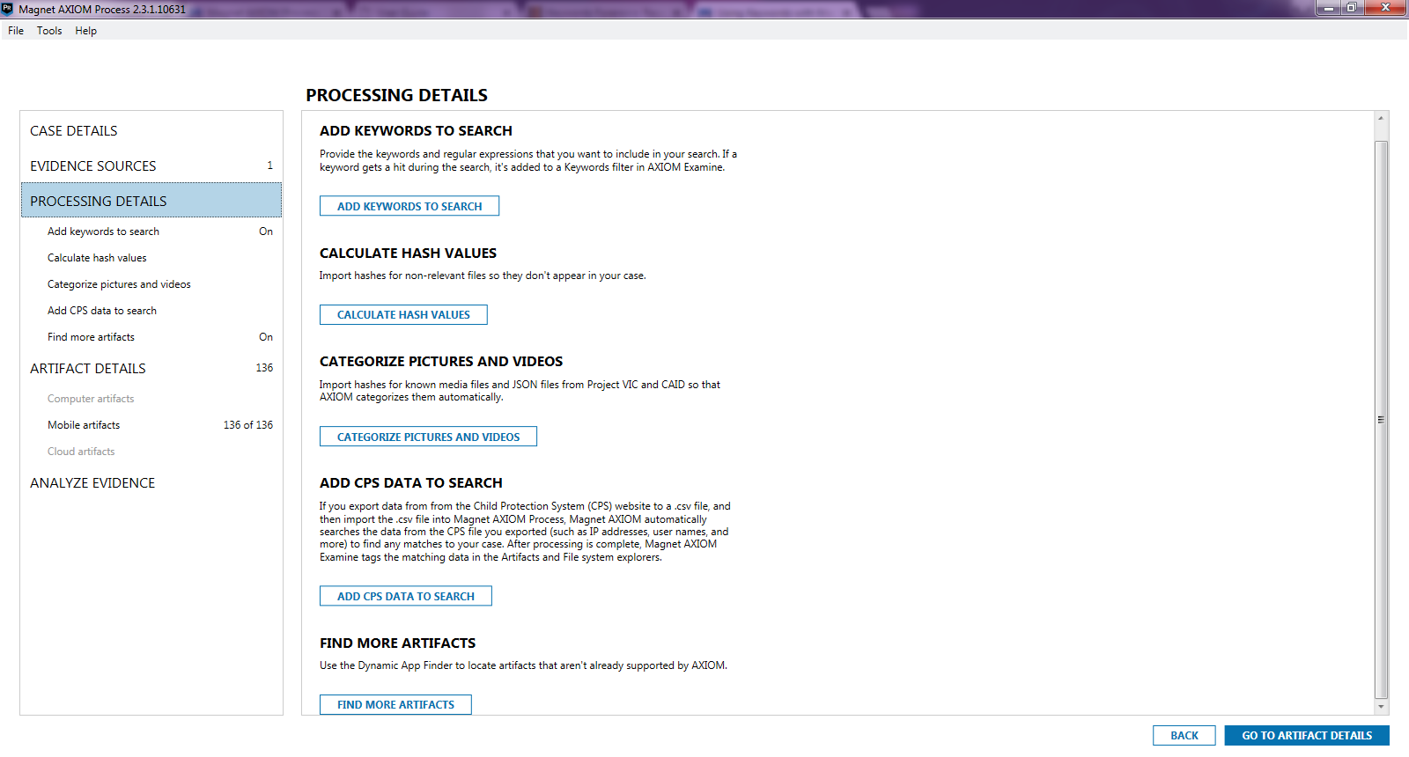

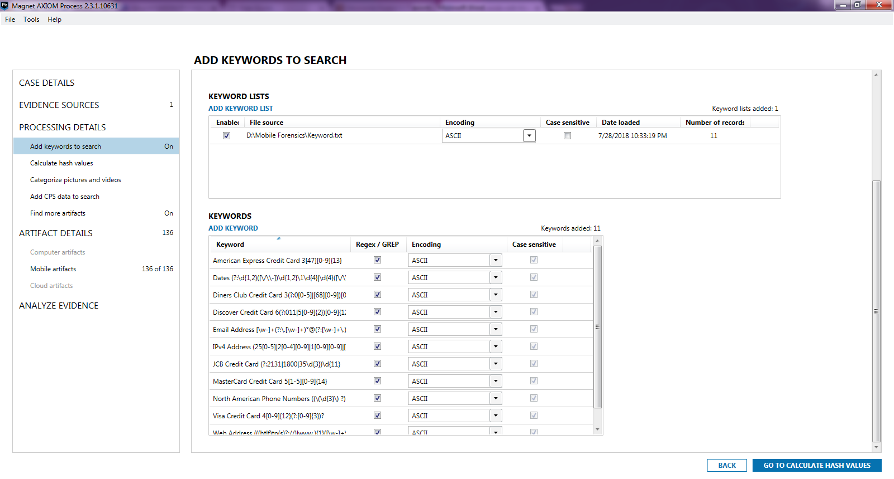

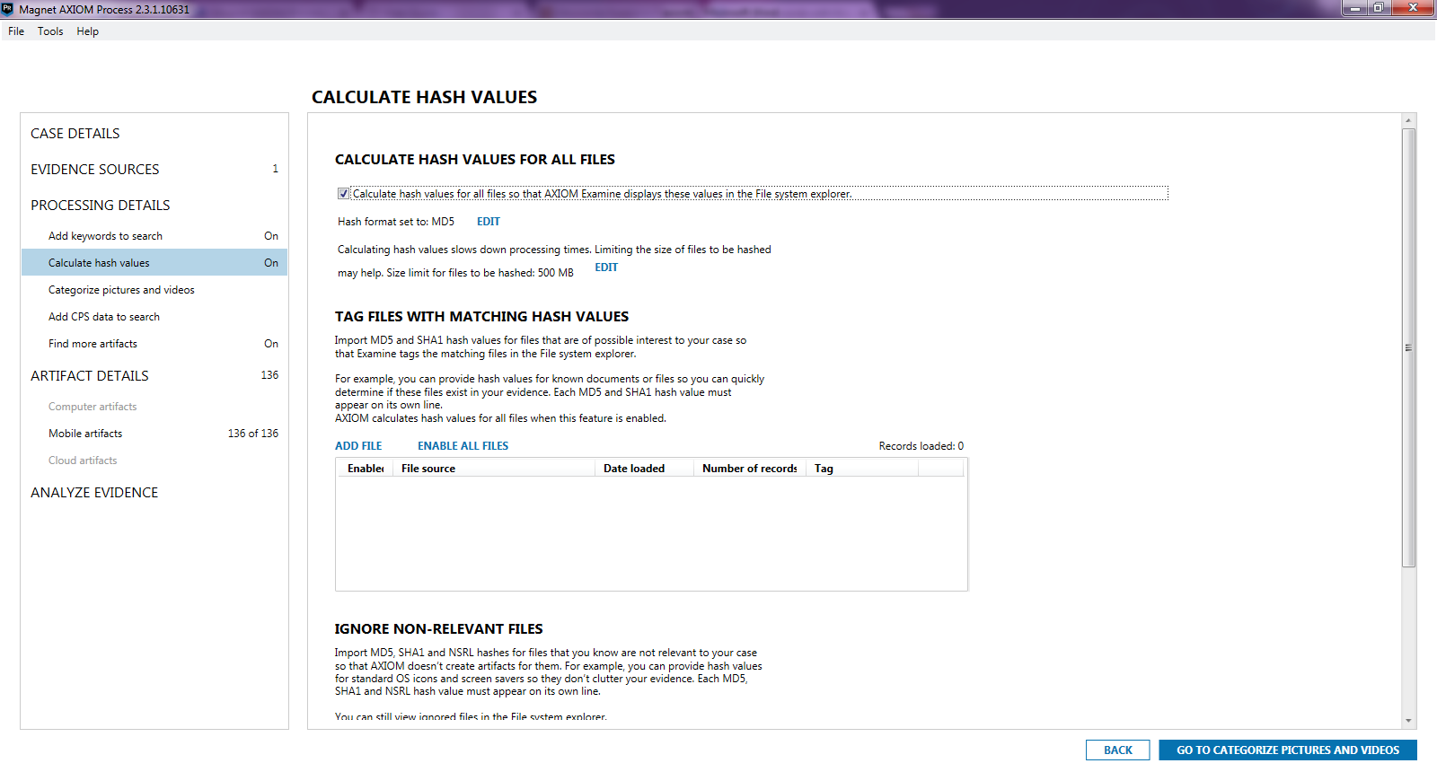

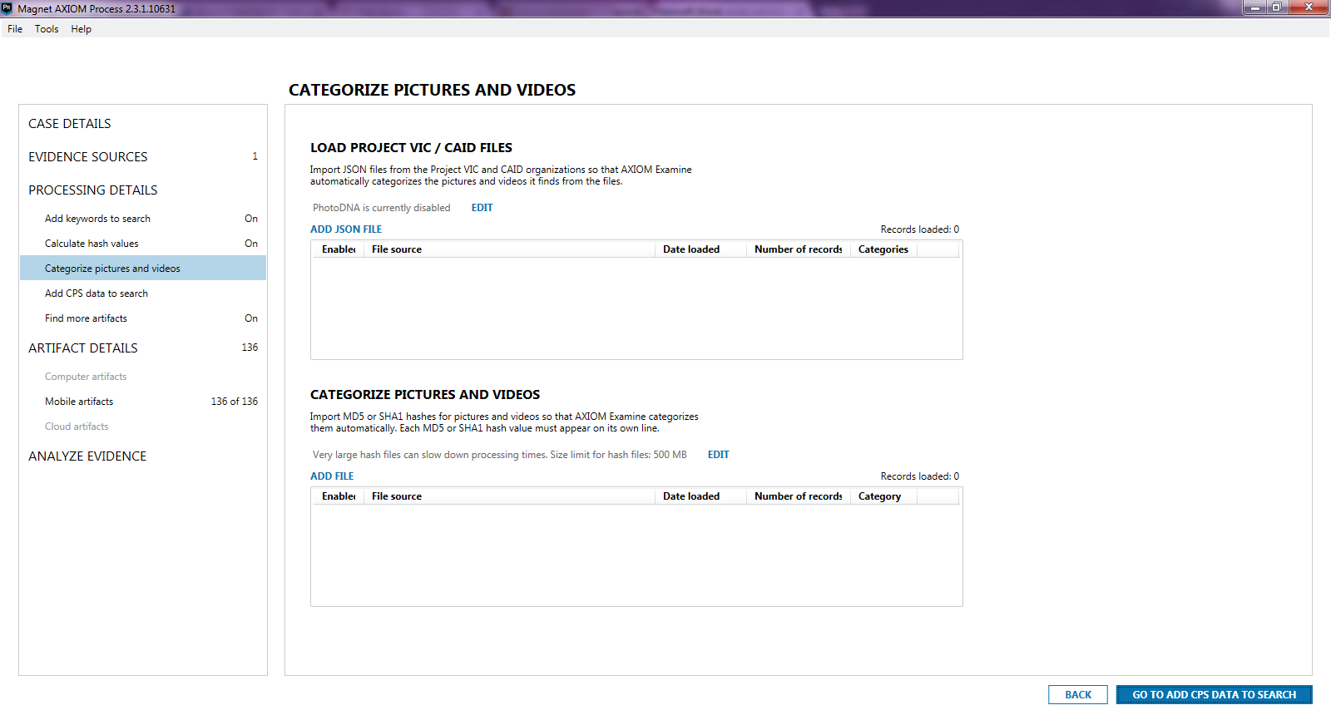

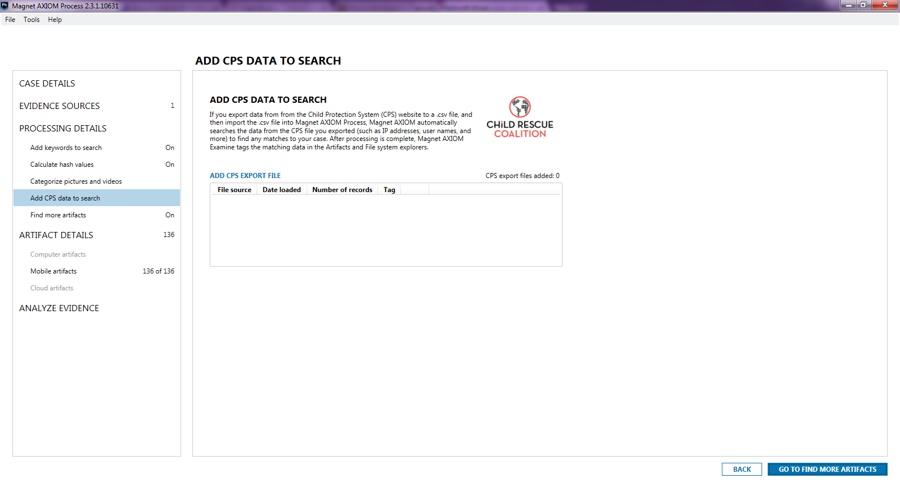

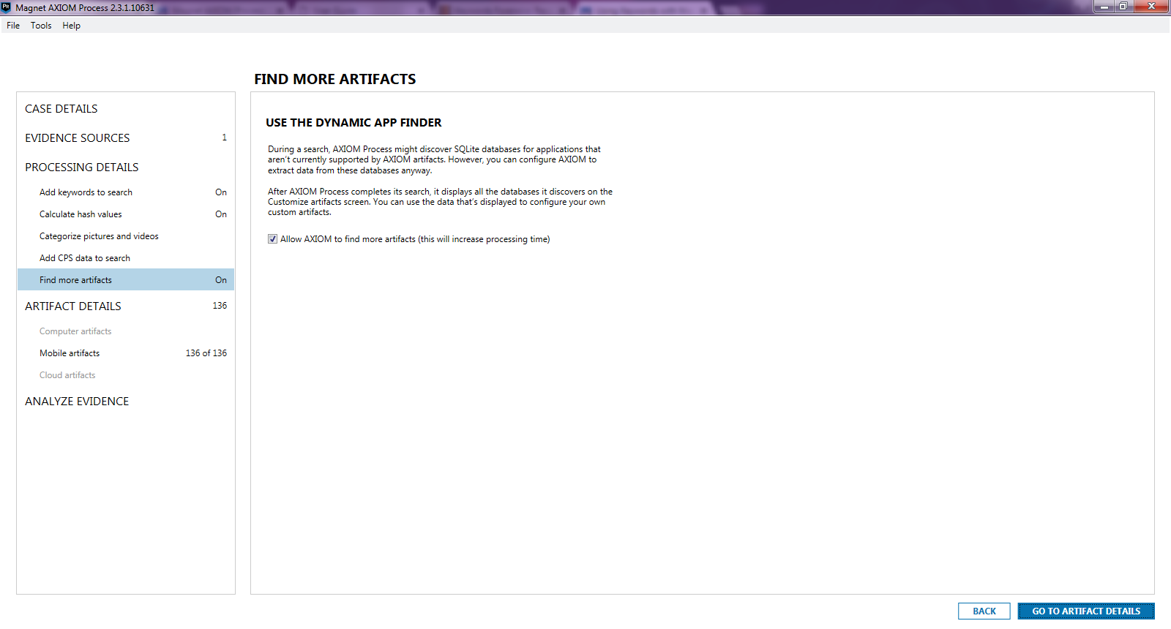

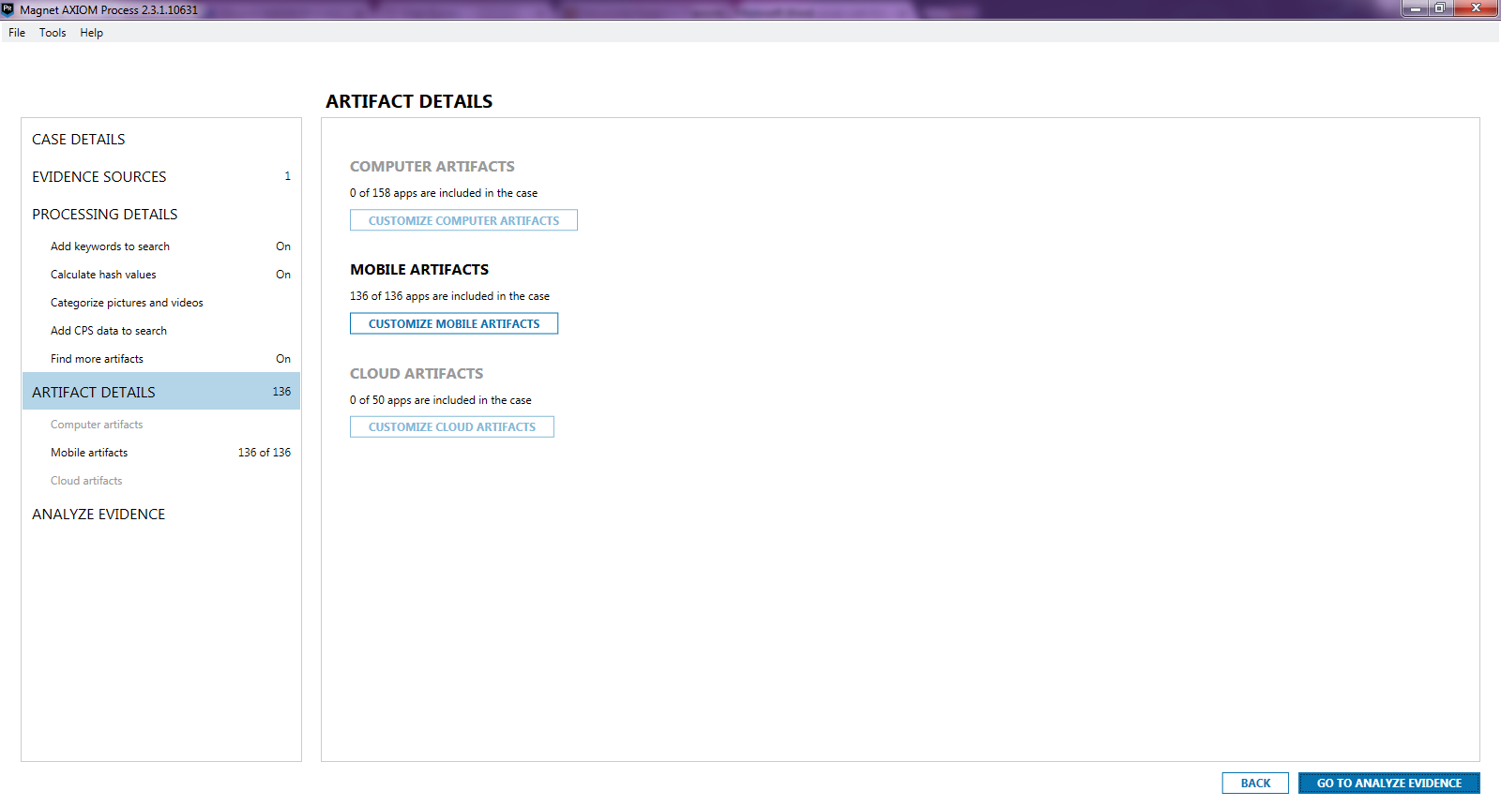

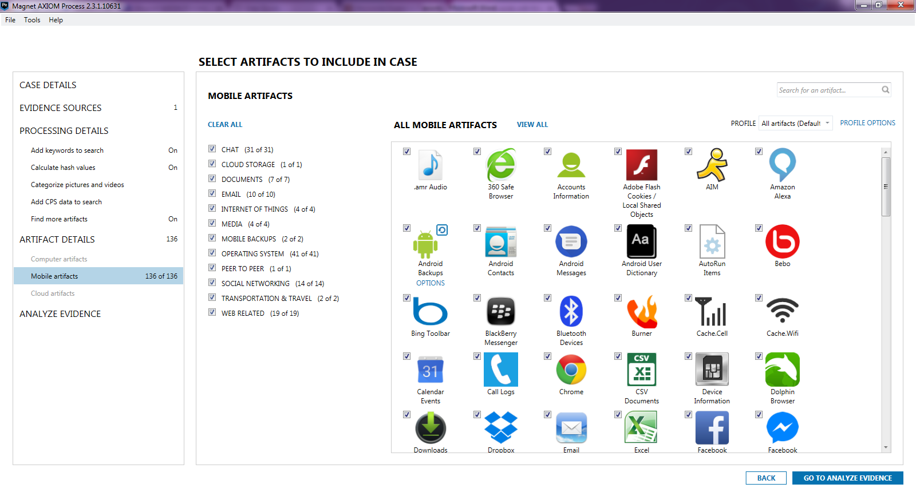

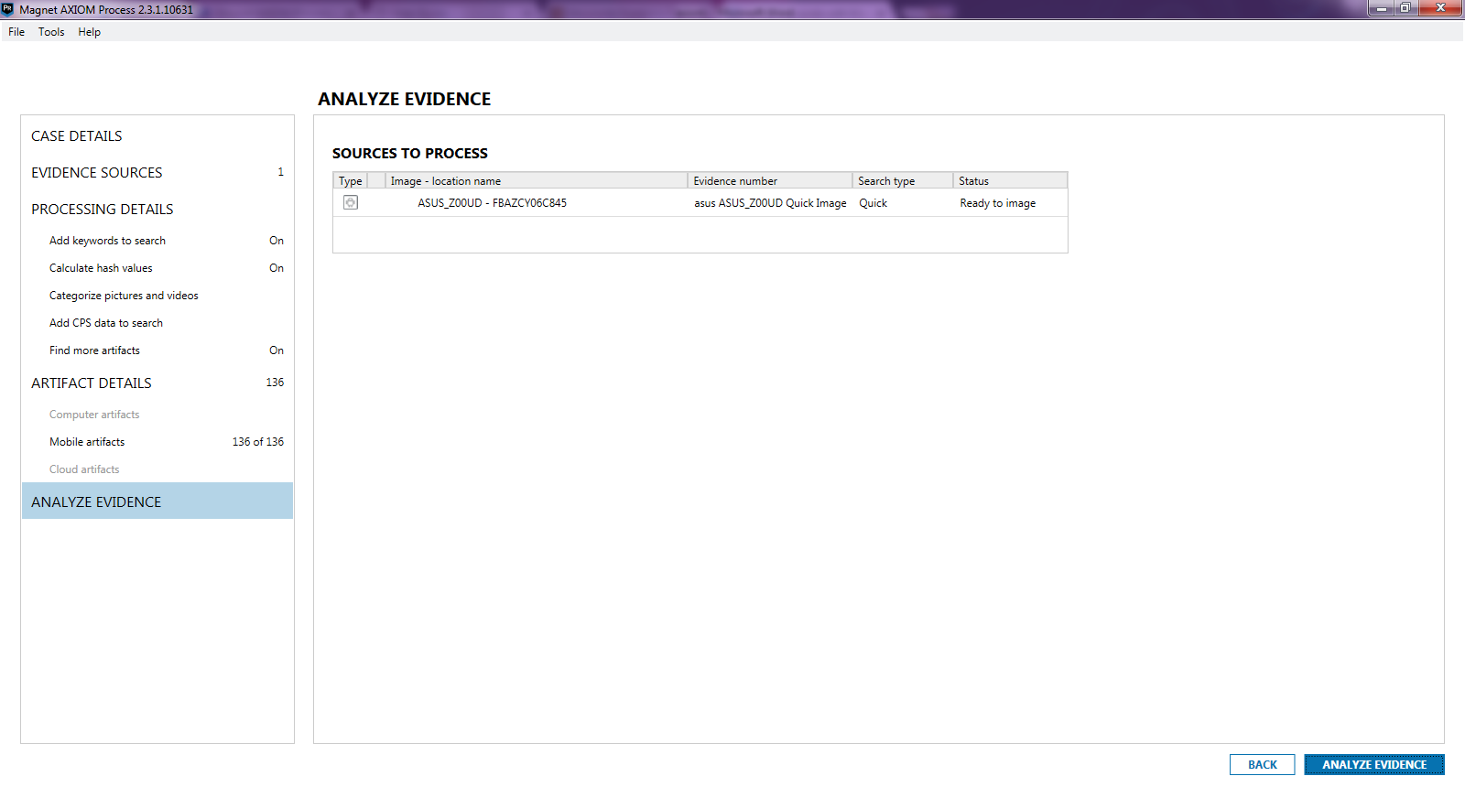

1. Analyze Evidence

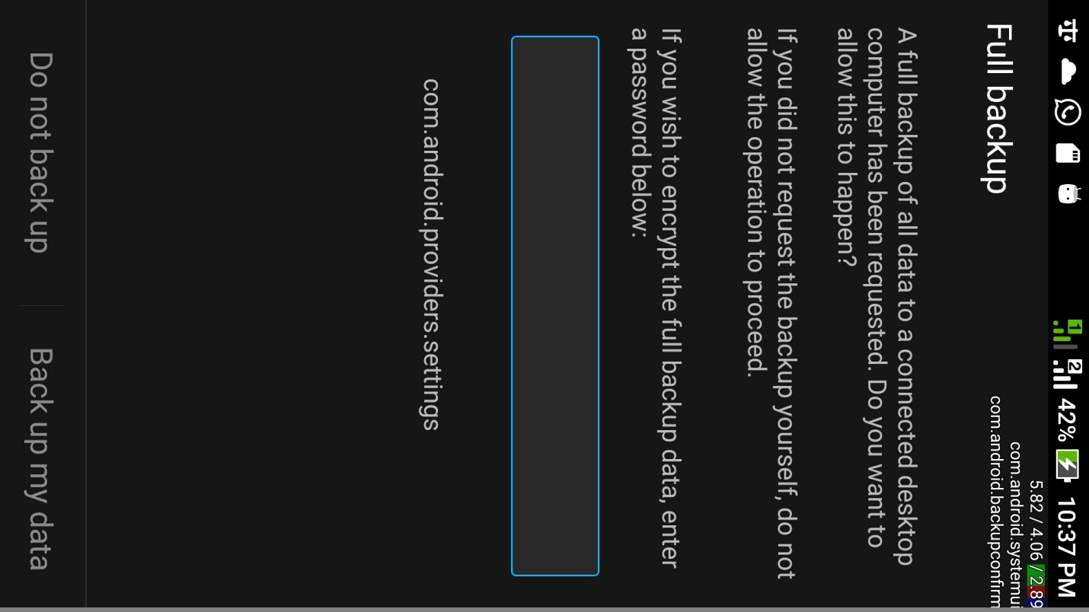

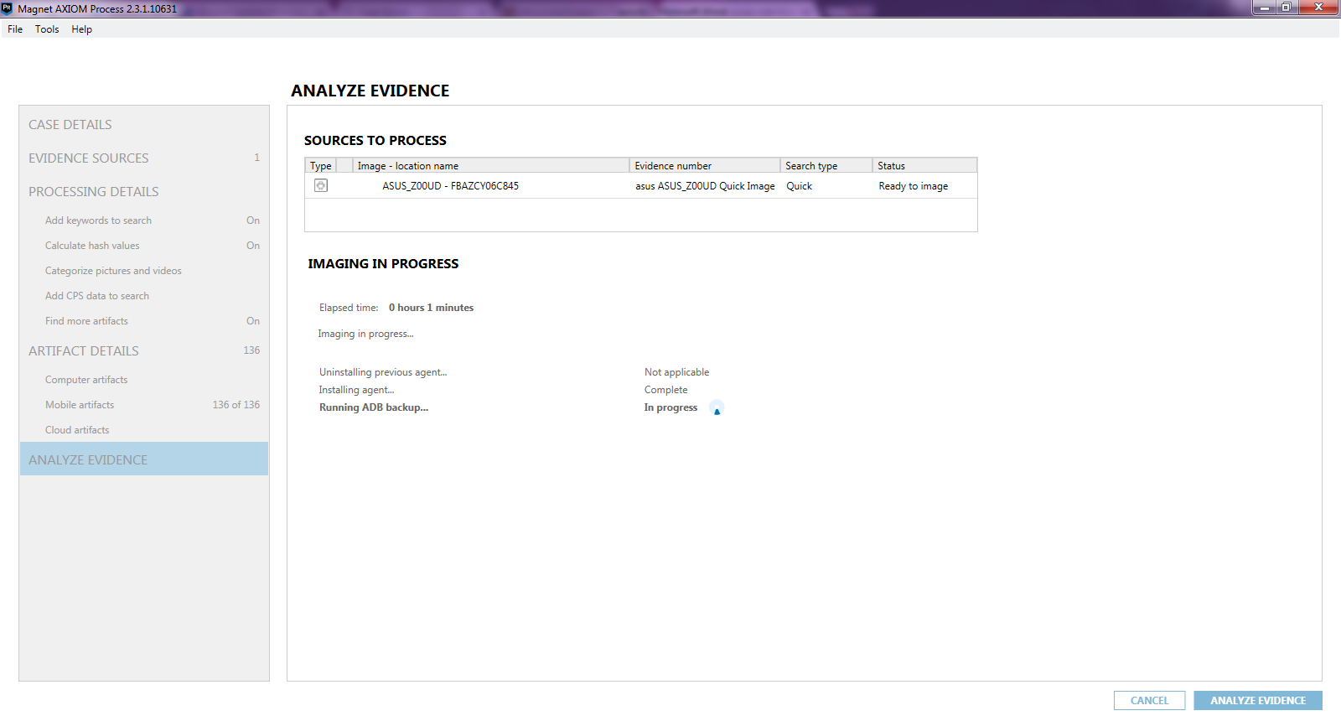

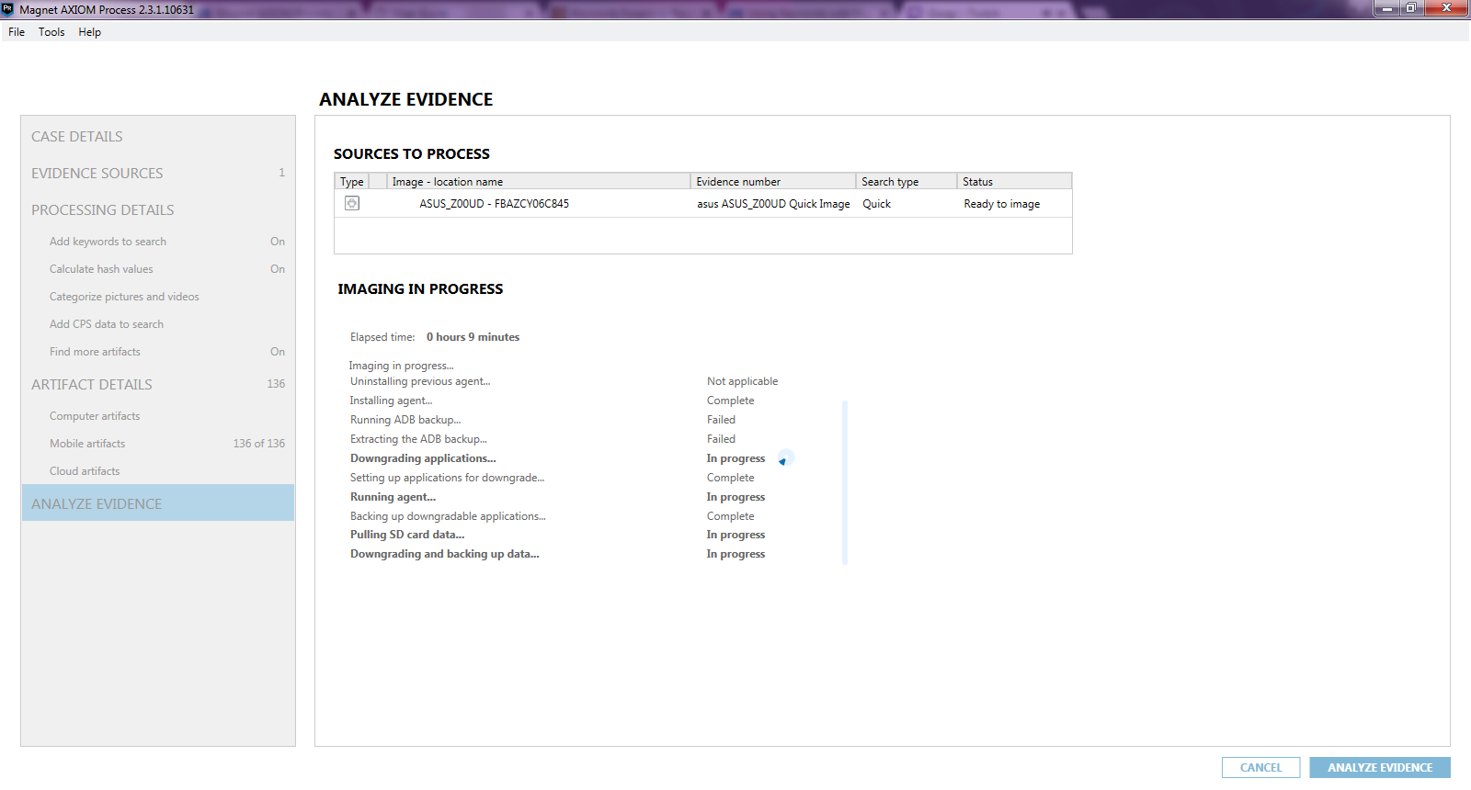

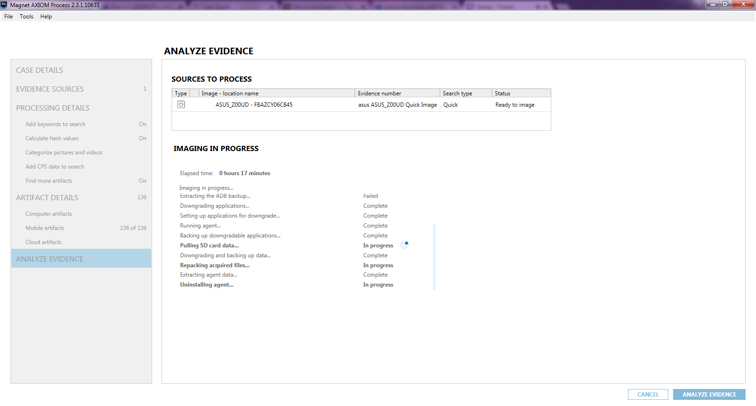

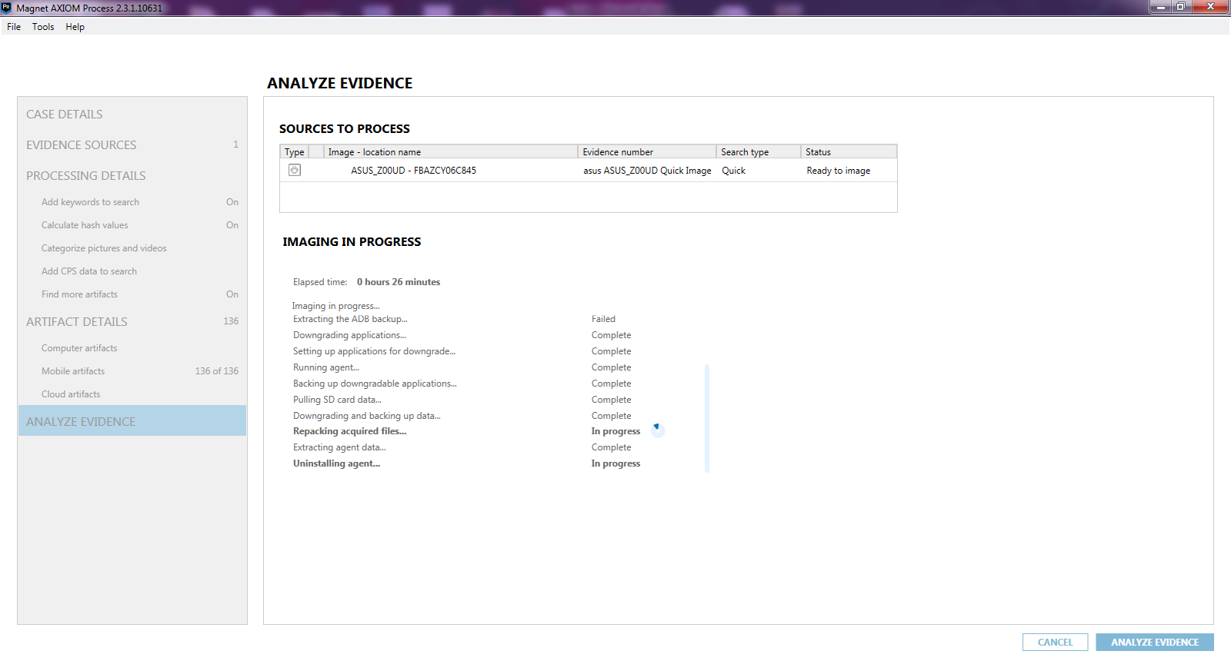

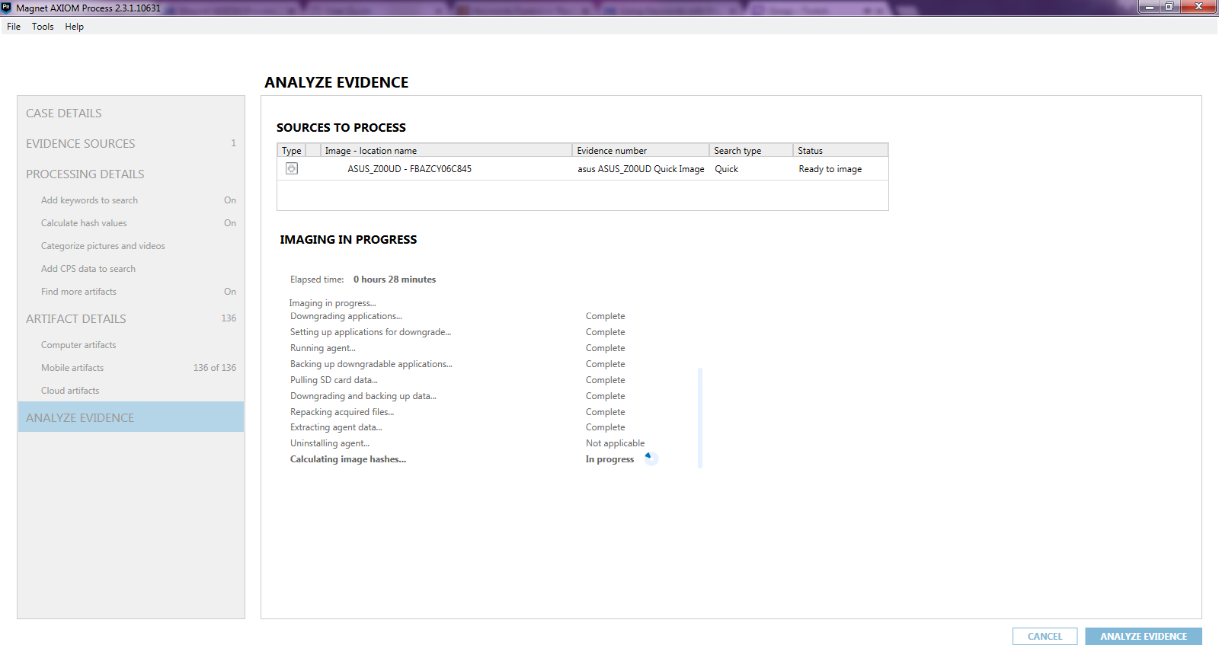

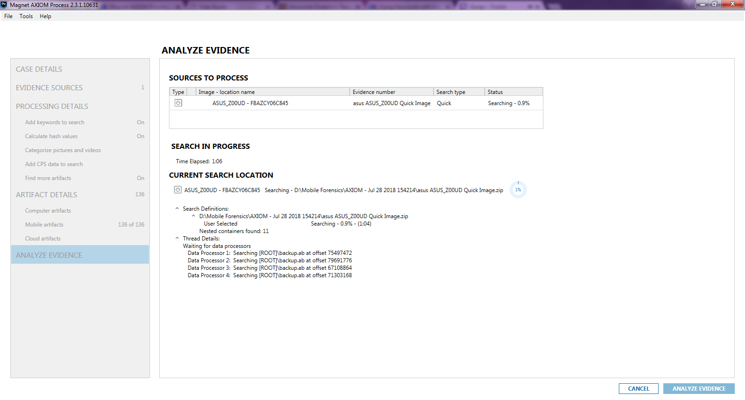

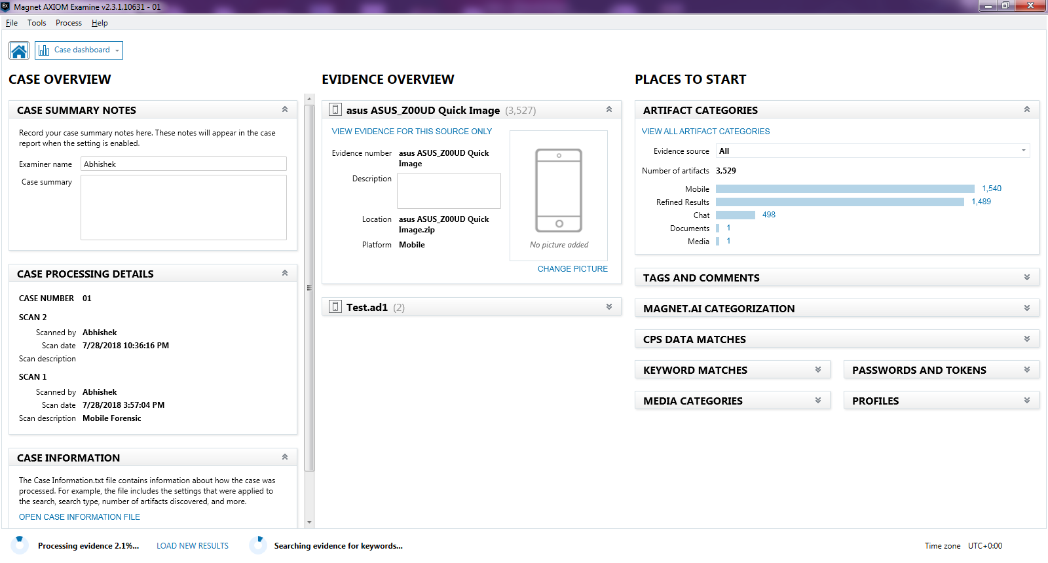

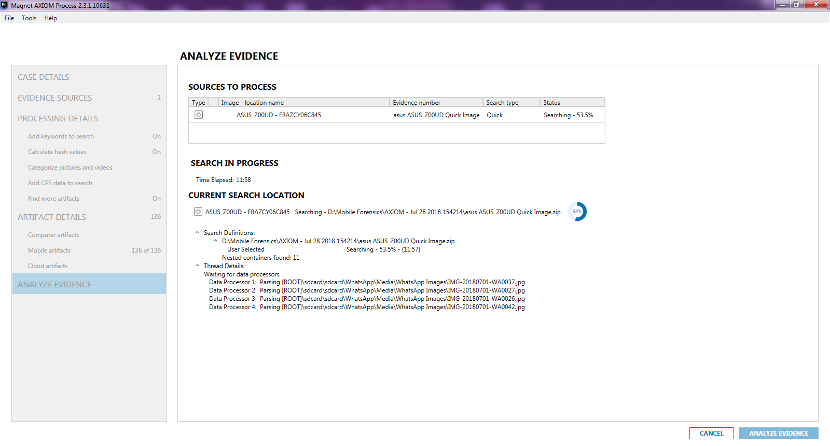

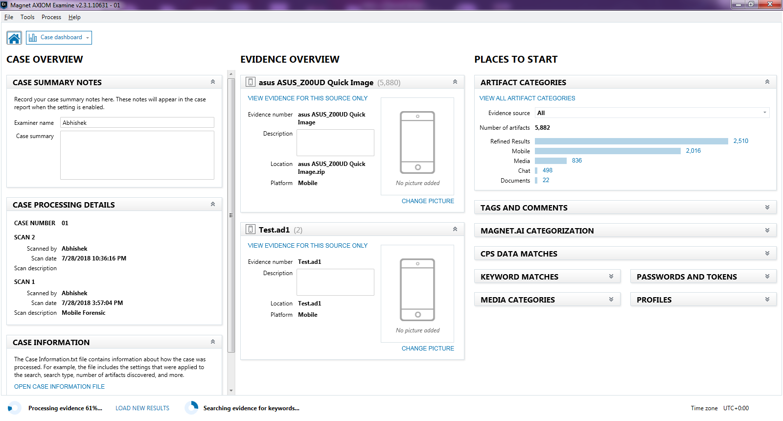

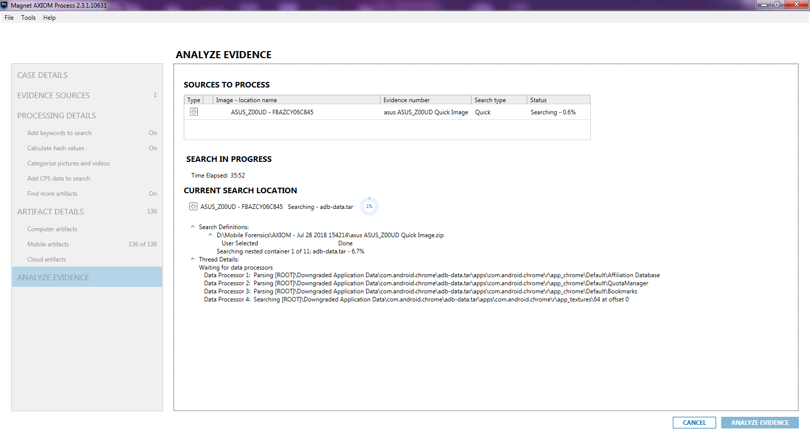

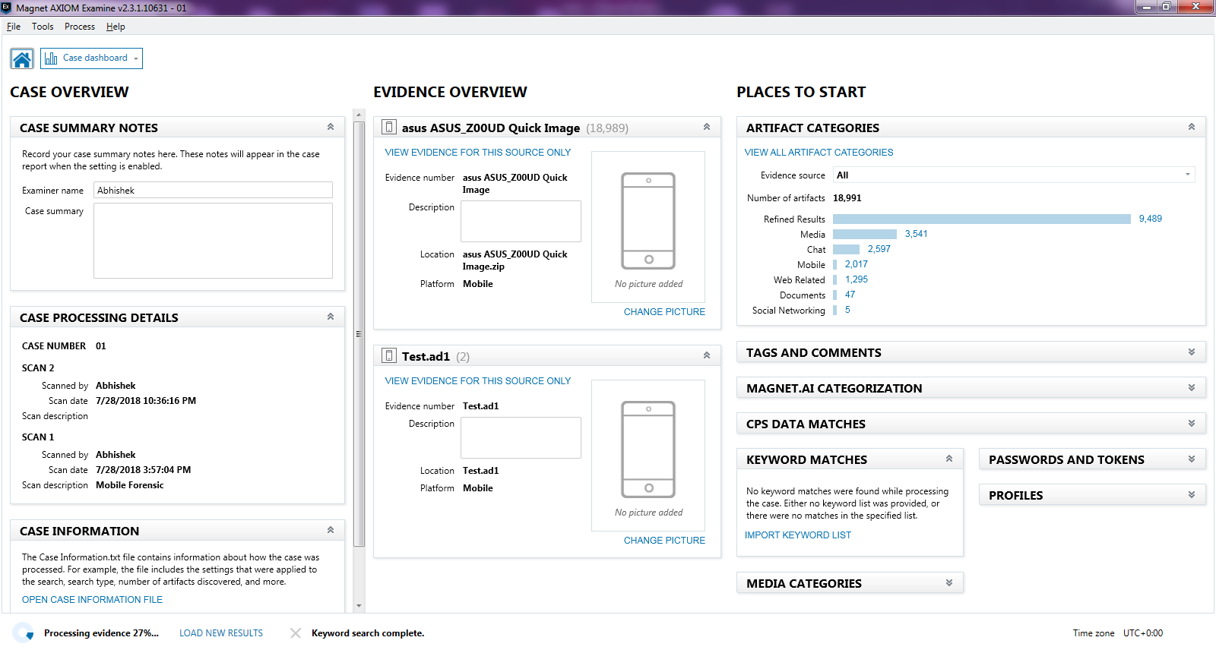

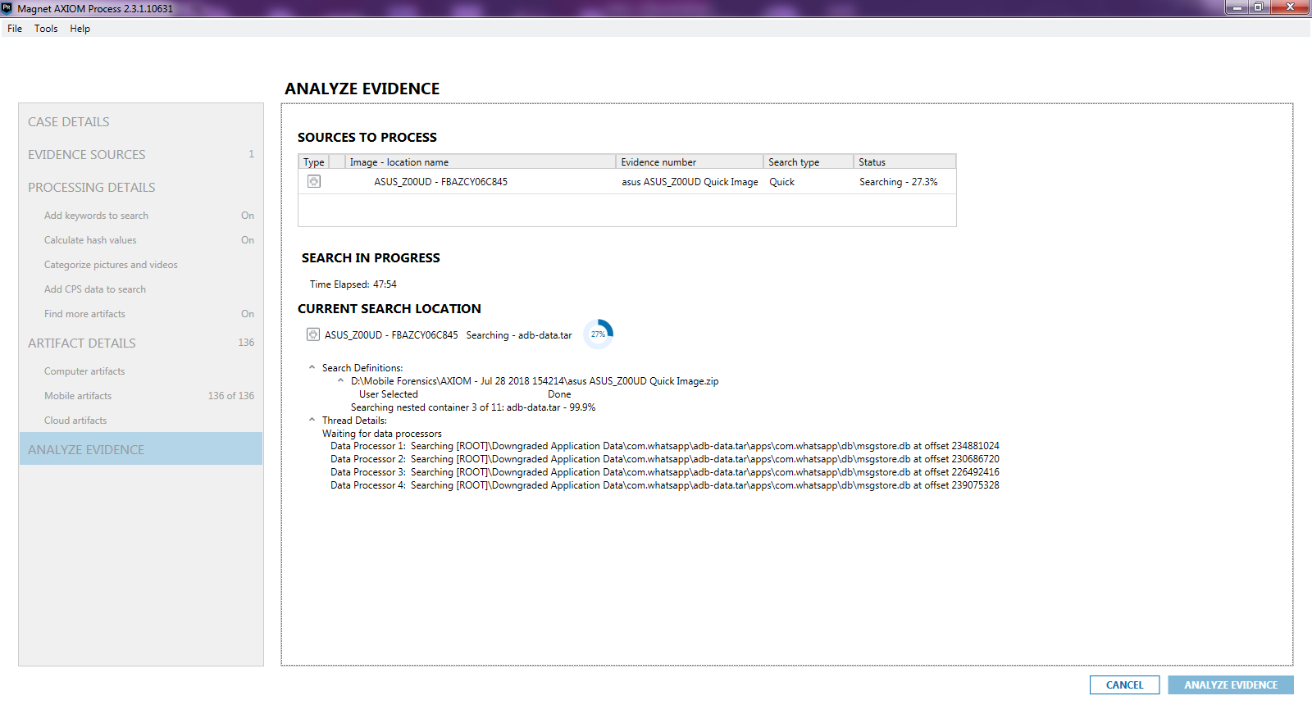

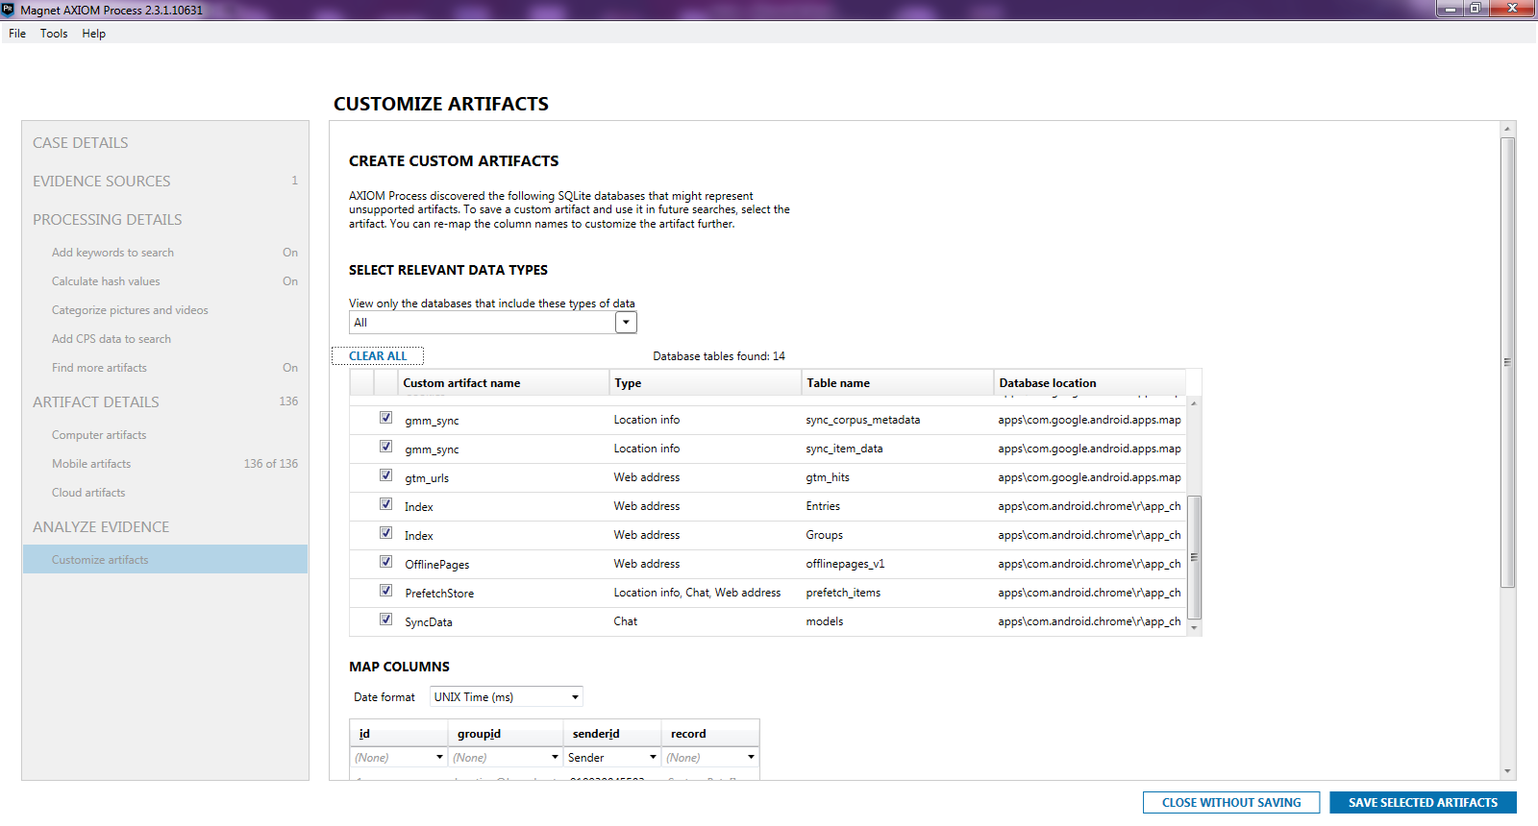

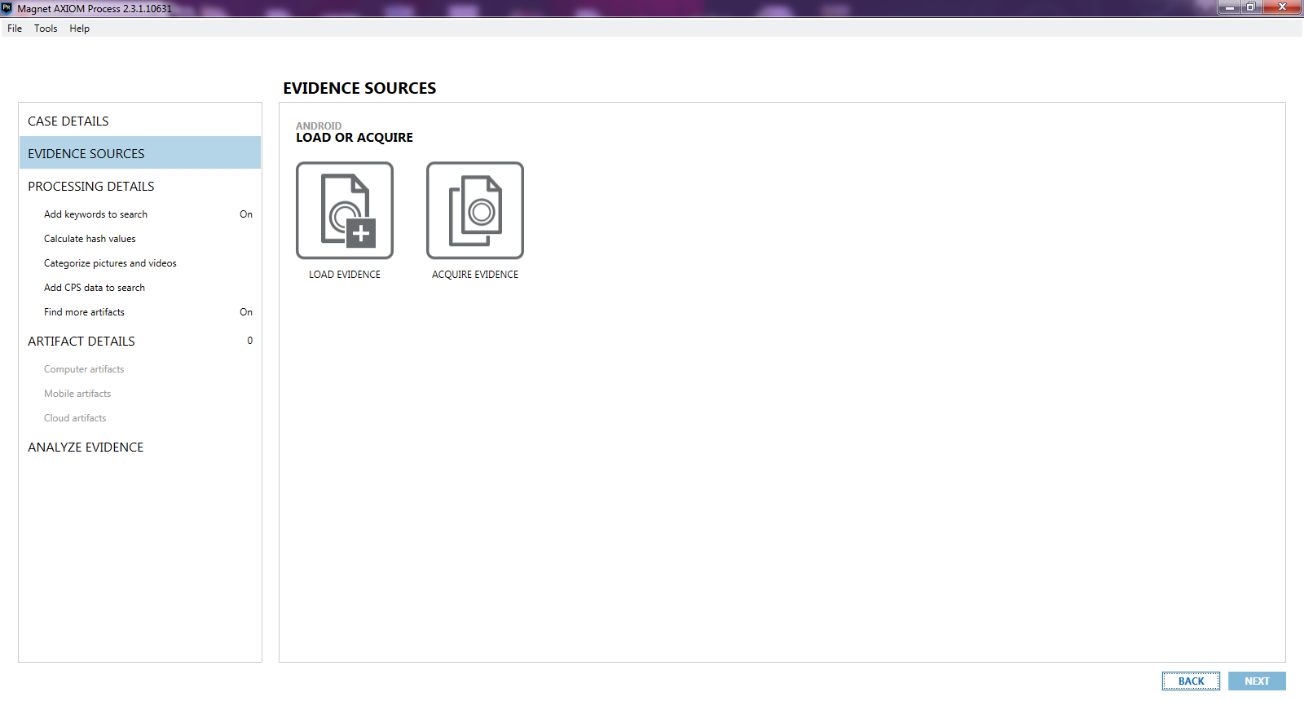

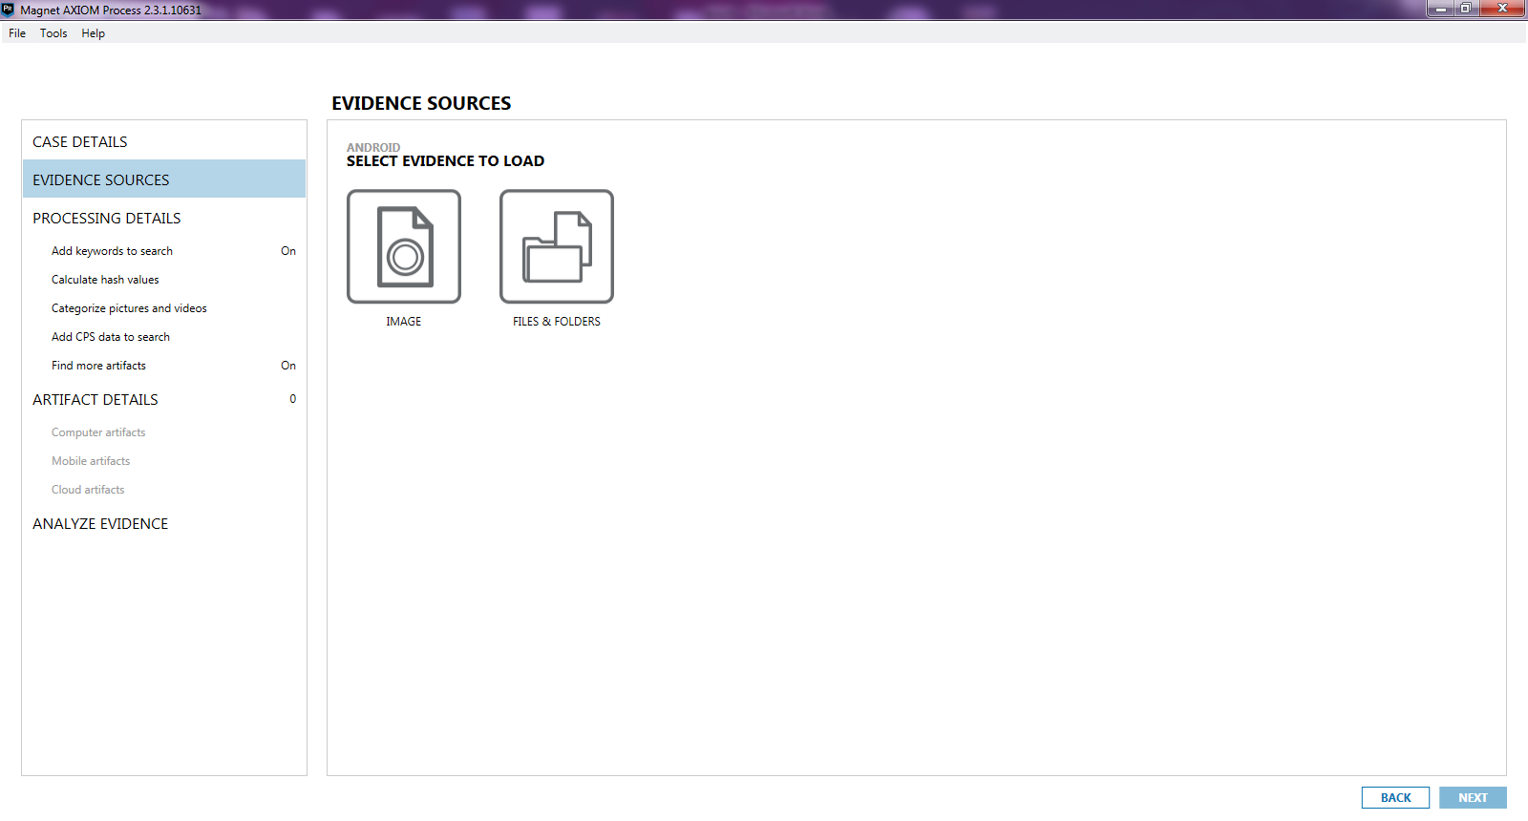

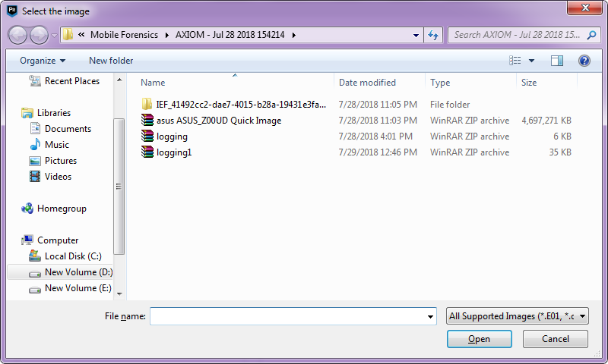

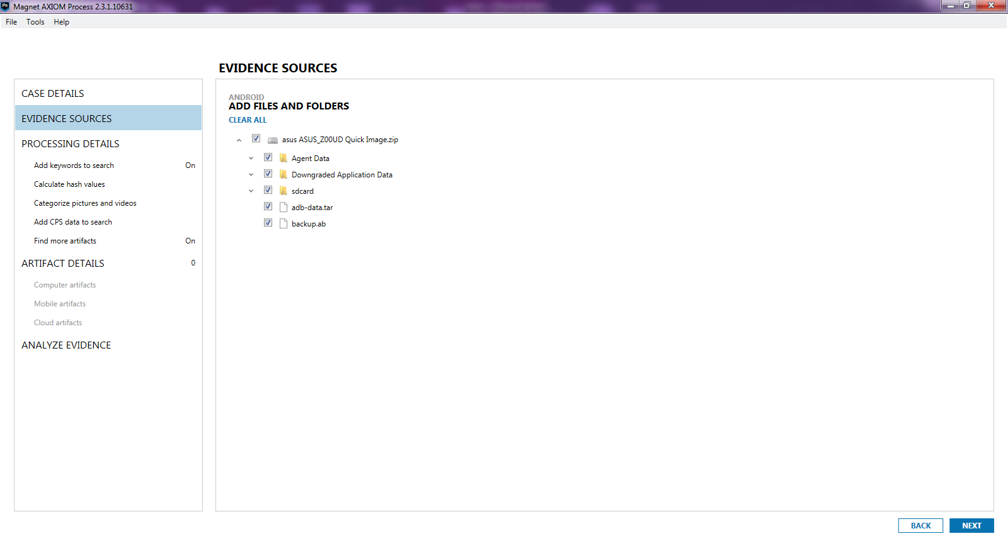

5)Examine Evidence

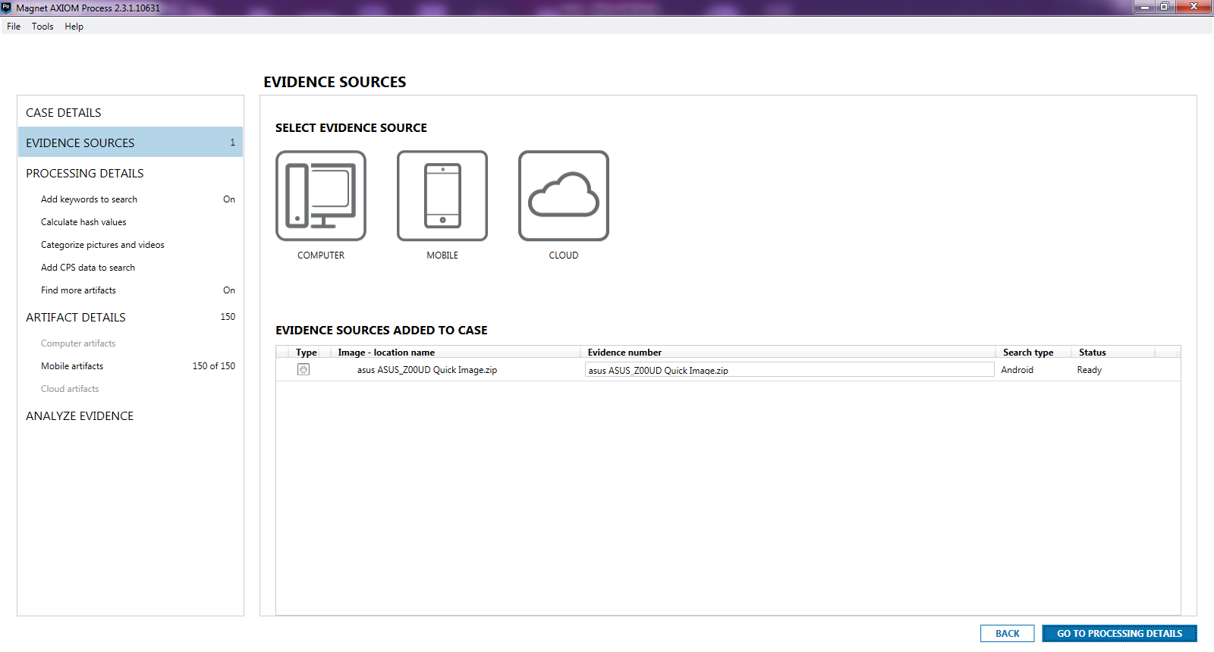

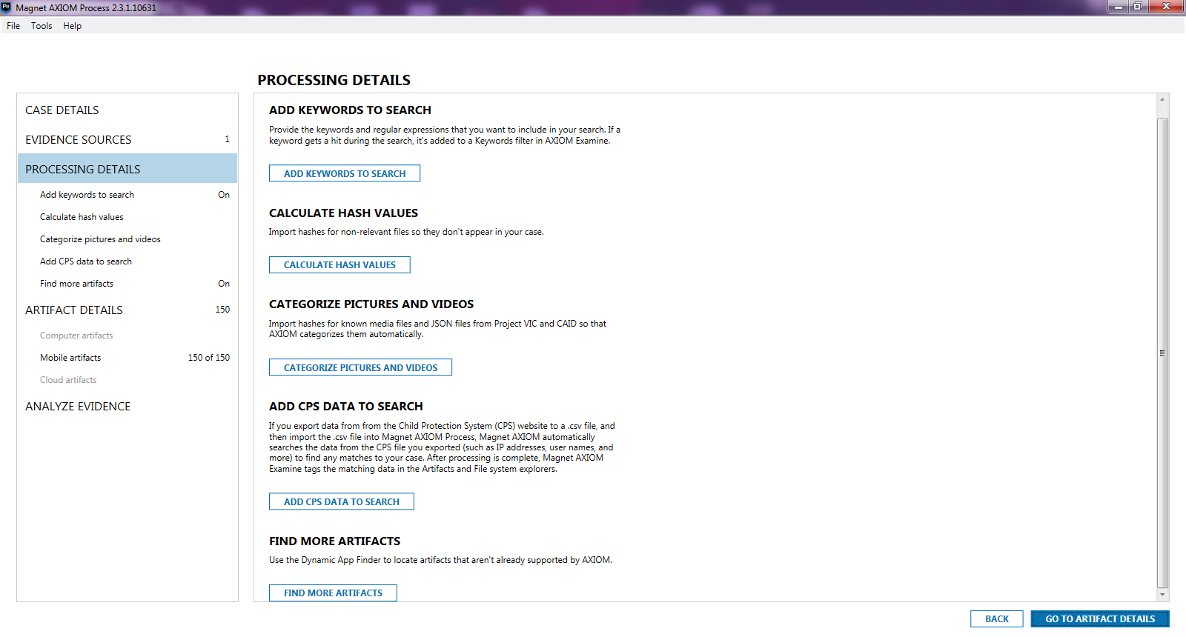

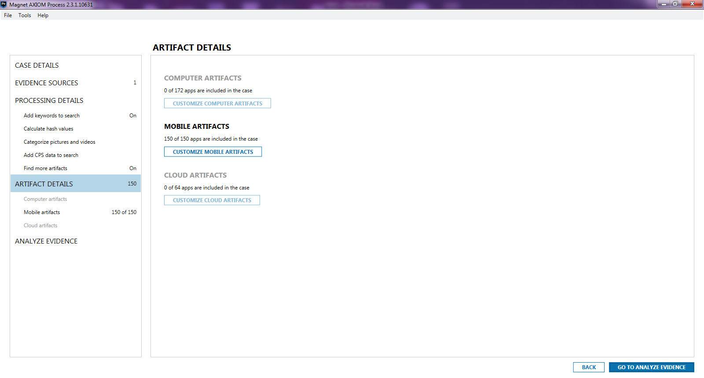

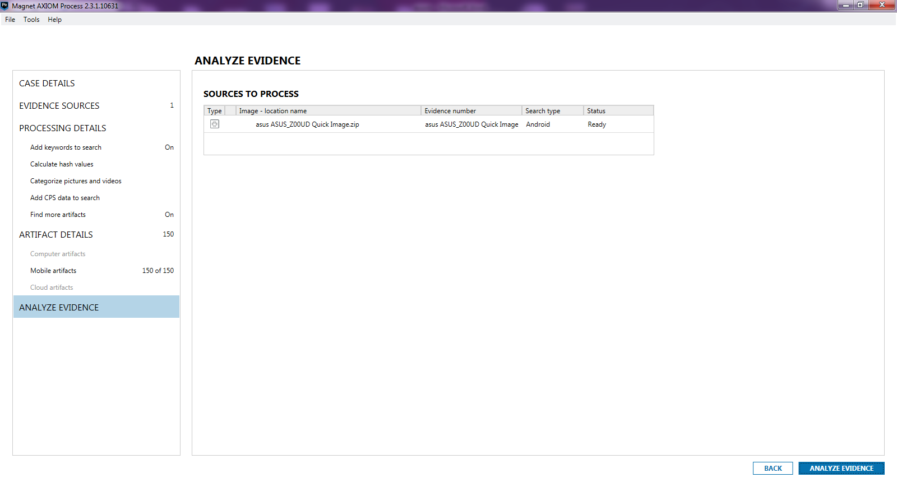

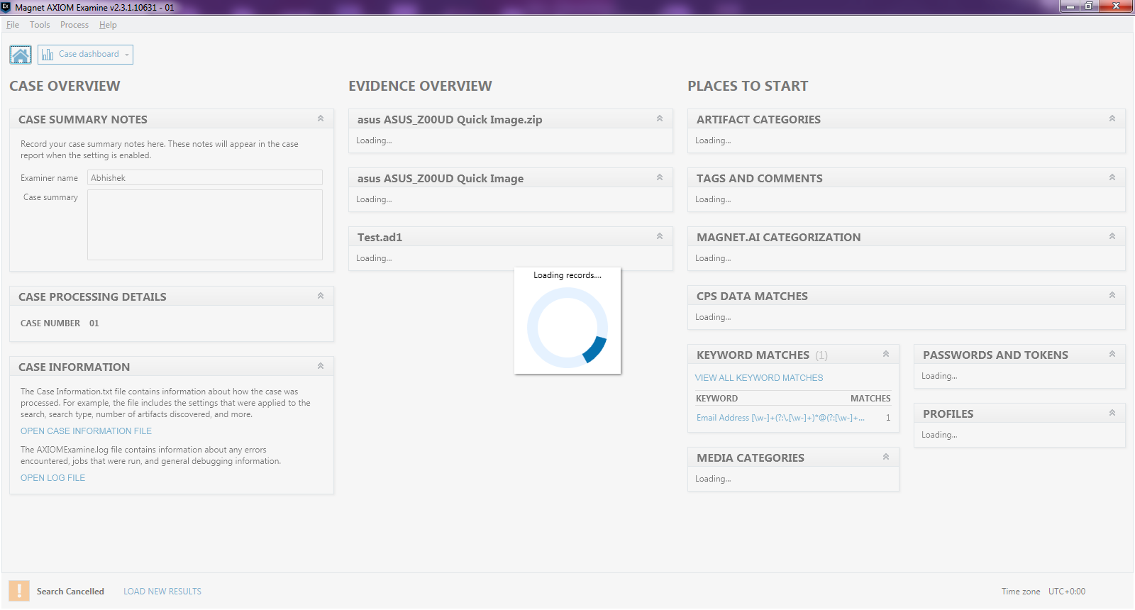

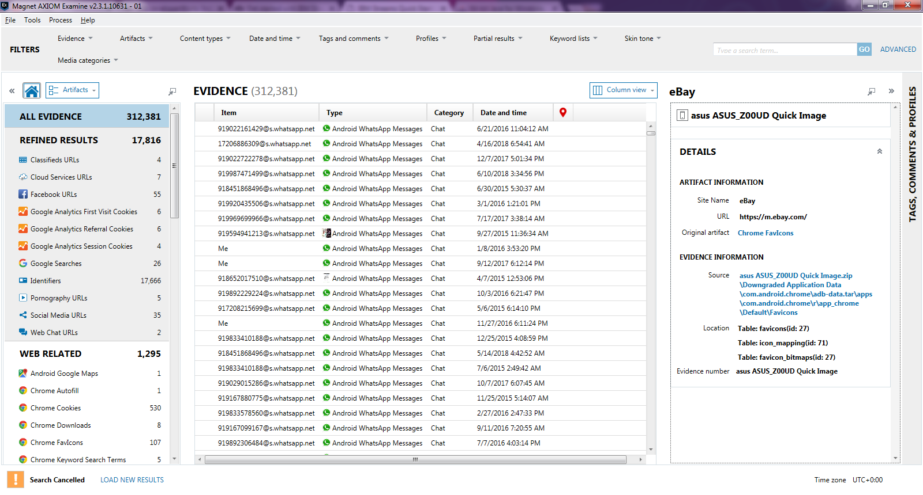

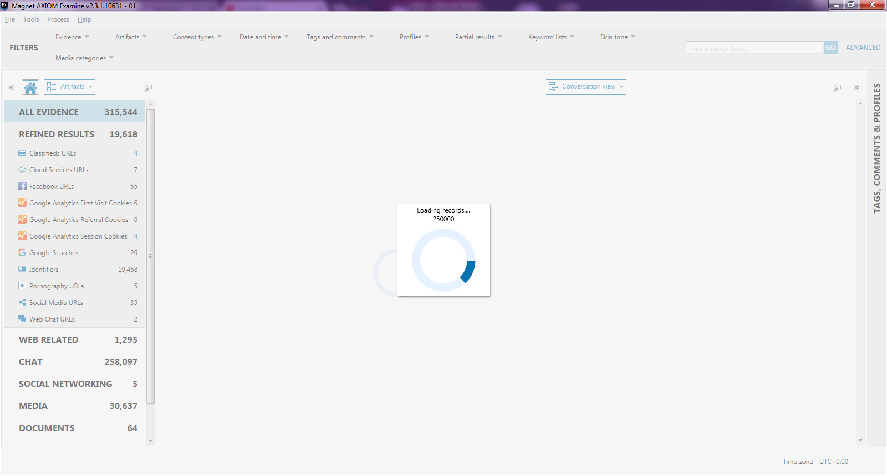

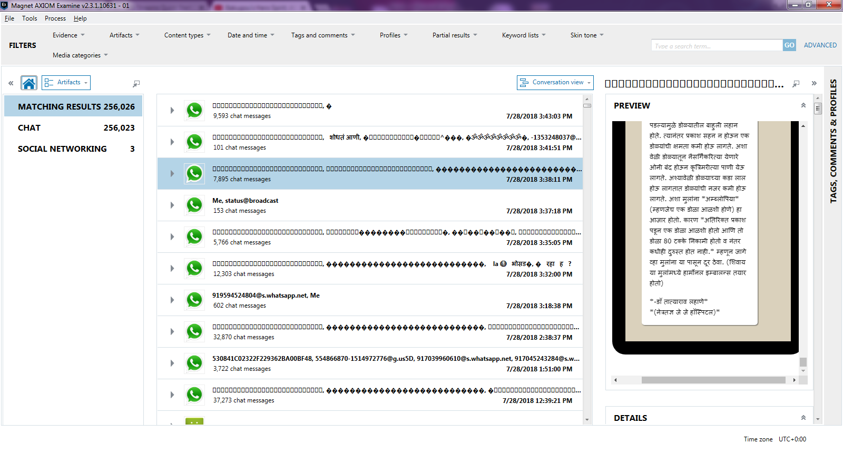

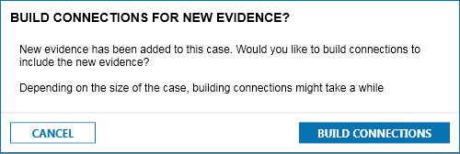

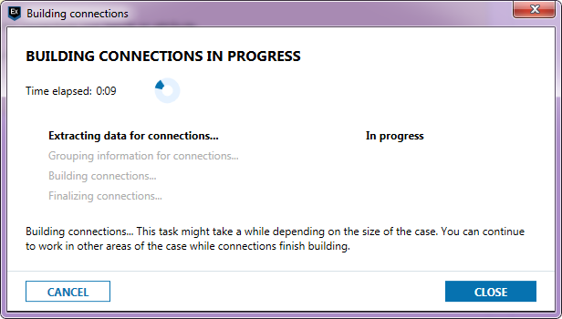

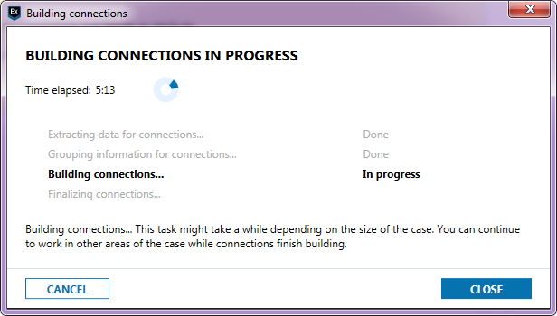

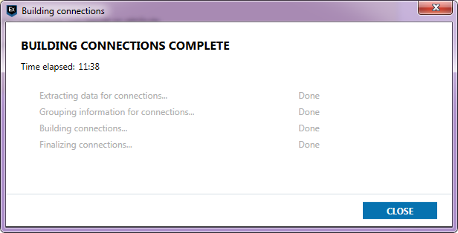

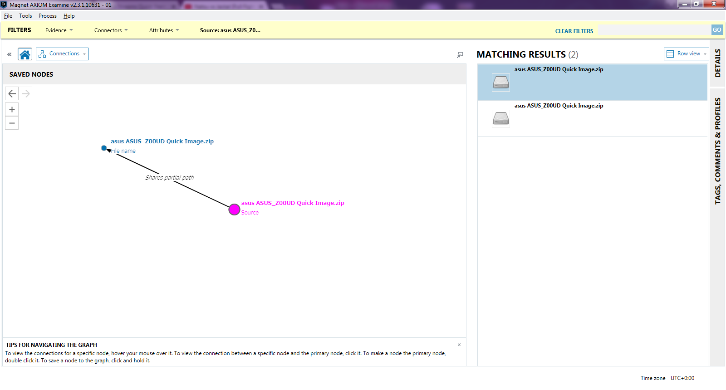

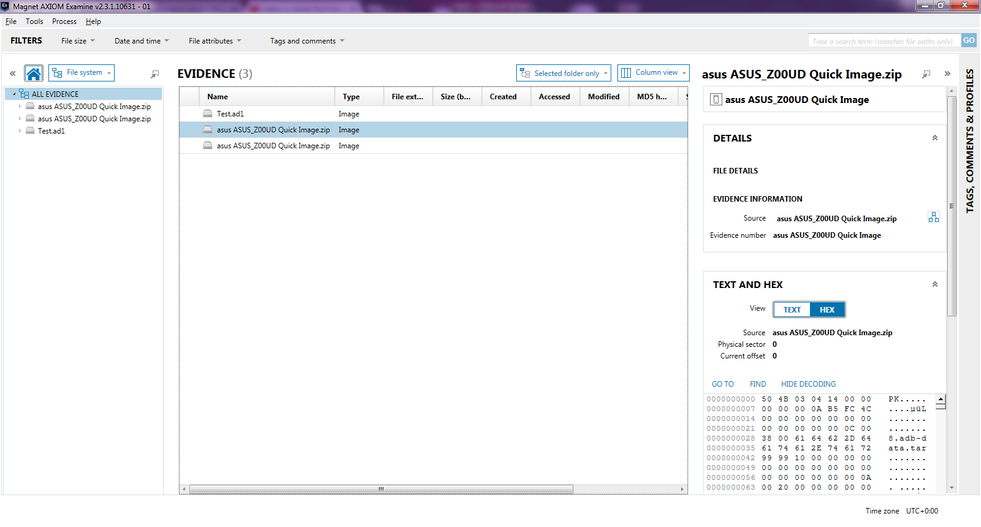

6)Bookmark

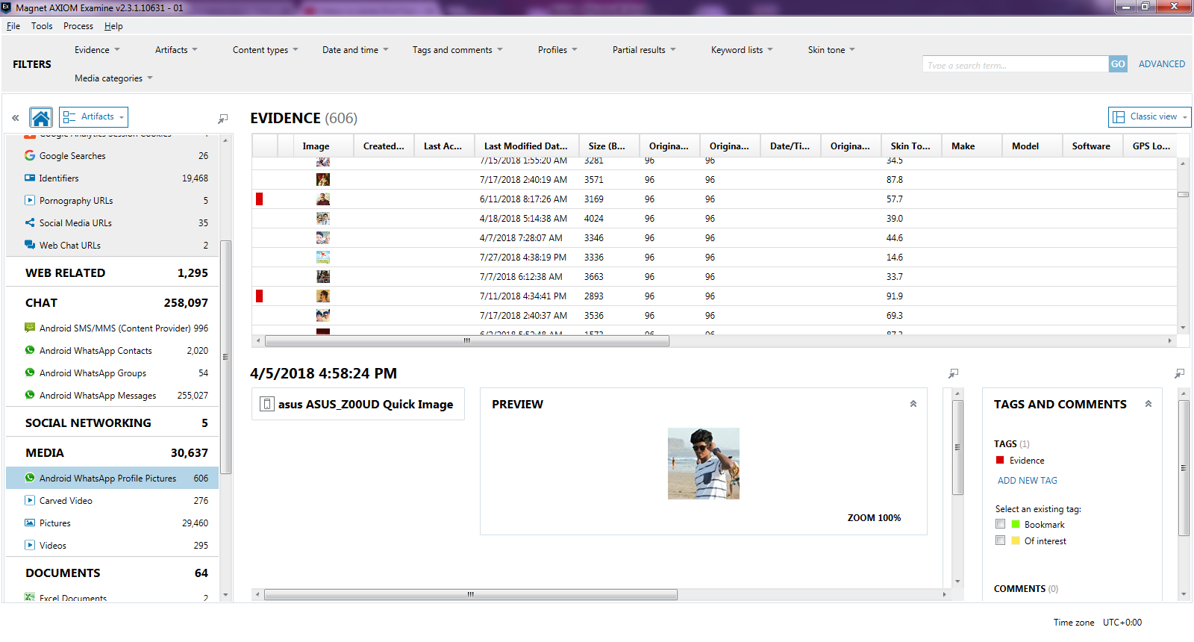

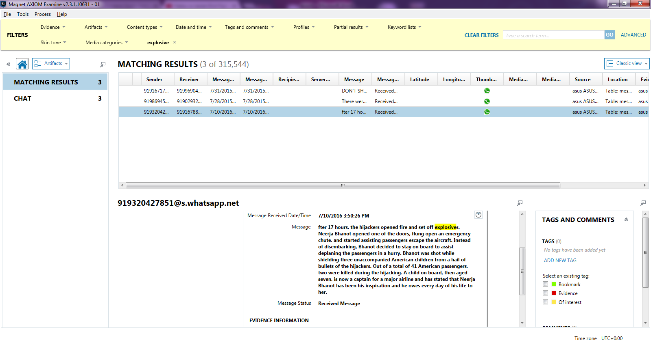

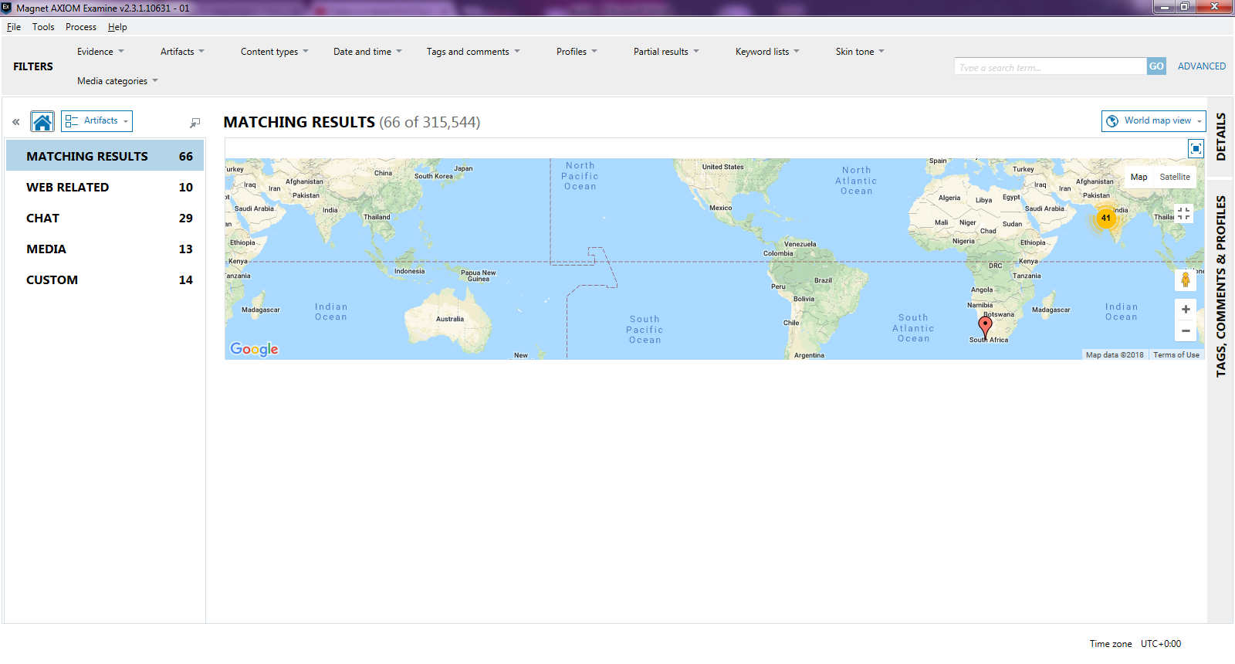

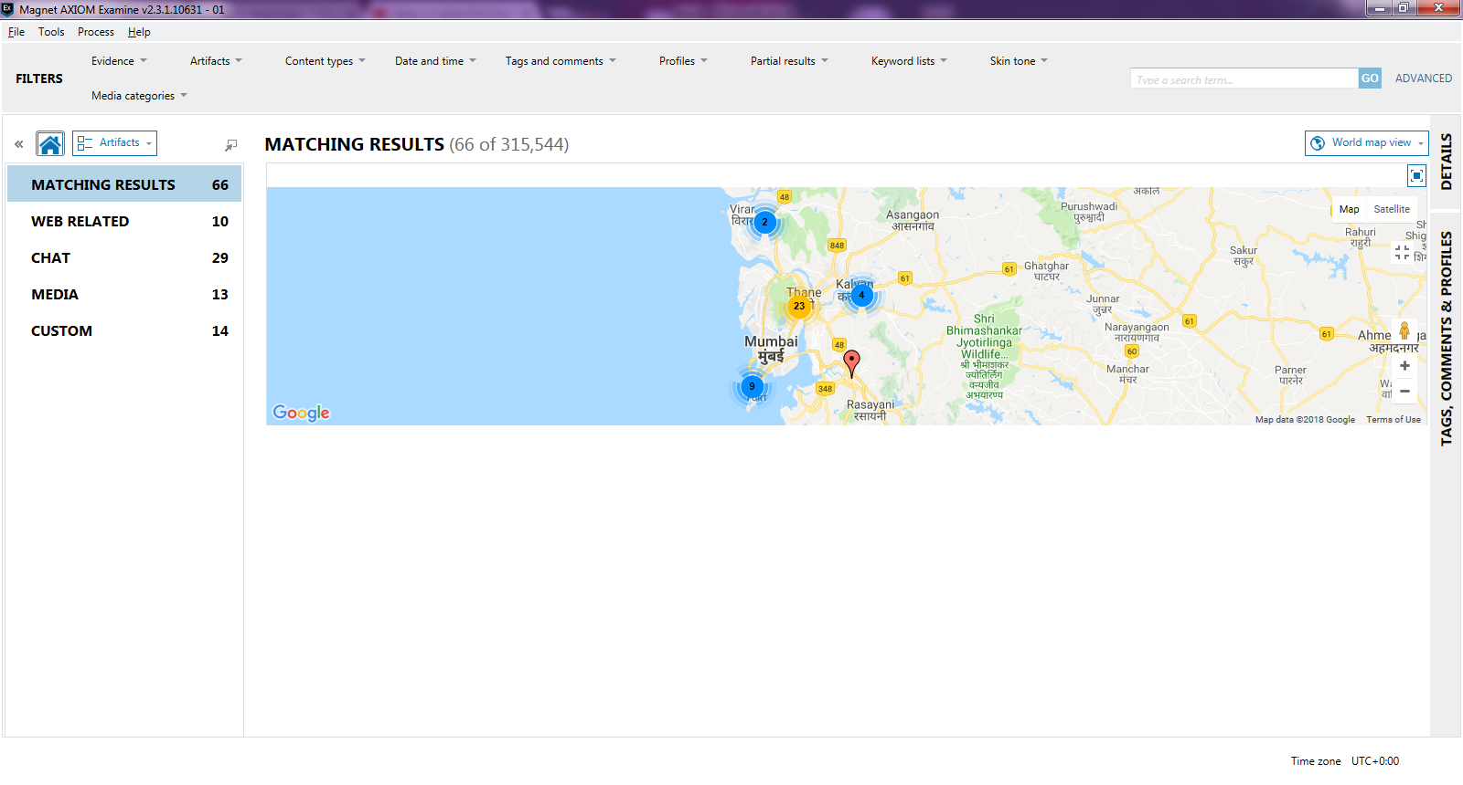

7)Report Creation

